AMPS Excel ADD-In

|  |  |
| --- | --- |
| User guide | Copyright © 2012, 60East Technologies, InC. |

# Introduction

This document describes how to install and use the AMPS Excel Add-In. With the AMPS Excel Add-In, you can use Microsoft Excel to work with real-time topics in your AMPS server, browse topics, and filter data. With your real-time data in Excel, you can turn Excel into a real-time dashboard for your business’s most important information.

# Prerequisites

Before installing the AMPS Excel Add-In, verify that you have installed the following prerequisites:

On your client computer:

* Microsoft Windows XP Service Pack 3, Windows Vista, or Windows 7
* Microsoft Excel 2010 or greater

On your AMPS server:

* AMPS 3.0.5 or greater
* One or more Transports configured for connectivity to the network where your client computer is connected
* Optional: For optimal Excel performance, configure a SOW cache for the /AMPS/SOWStats topic, e.g.

<TopicDefinition>

<Topic>/AMPS/SOWStats</Topic>

<Key>/20066</Key>

<MessageType>nvfix</MessageType>

</TopicDefinition>

# INSTALLATION

From your client computer, ensure that Excel is not running; close all running instances of Excel and all open workbooks. Locate and launch the “setup.exe” file included in your distribution media. The installer displays a dialog box:

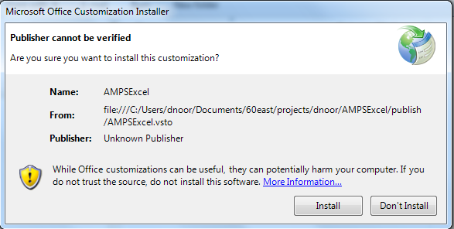

Click “Install” to continue. Click “Close” to close the dialog once installation is complete.

To verify installation, open Microsoft Excel, and look for the AMPS ribbon:

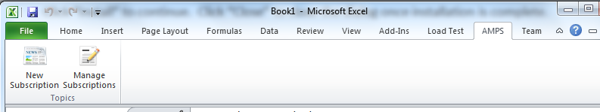

# CREATE A SUBSCRIPTION

To begin, open an Excel workbook that you would like to use for subscribing to AMPS data. You can create a new workbook or worksheet for your AMPS data or you can load AMPS data into an existing workbook. Highlight a cell that you would like to use to retrieve AMPS data:

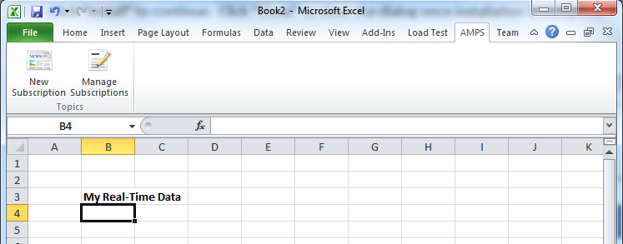

When the add-in makes a subscription to AMPS, it uses this cell as the upper-left-hand corner of the region where it places your data. With a cell highlighted, click **New Subscription**.

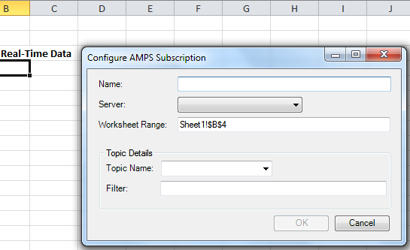

In this dialog, the add-in presents you with options for your new AMPS subscription. For **Name**, choose any unique name you prefer to identify this subscription. For **Server**, if this is your first subscription, choose the “**< New… >**” entry to configure a new server connection:

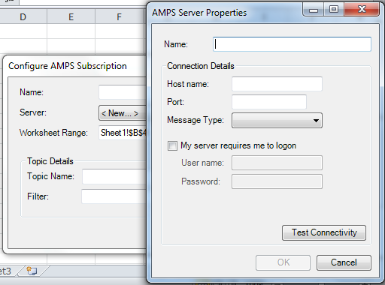

In this dialog, choose a unique name for the server, and then enter the **Host name**, **Port**, **Message Type**, and any authentication information required to connect to your AMPS server. Click **Test Connectivity** to verify that your connection works; consult your AMPS administrator and configuration file if you are unsure what settings to use.

Click **OK** to exit this dialog, and you will return to the subscription settings. In the **Topic** field, select a topic from the drop-down list of SOW topics available on your server, or type a topic name or topic regular expression in the box.

**Note:** After choosing a new server from the **Server** drop-down, the dialog resets the list of topics obtains an up-to-date list of topics from the new server. You may notice a delay while these new topics are populated, resulting in an empty drop-down list for a few seconds. Create a SOW cache for the “/AMPS/SOWStats” topic to expedite this step – see the *Prerequisites* section for details.

If you would like to apply a server-side content filter to the retrieved data, type a filter expression in the **Filter** field as well:

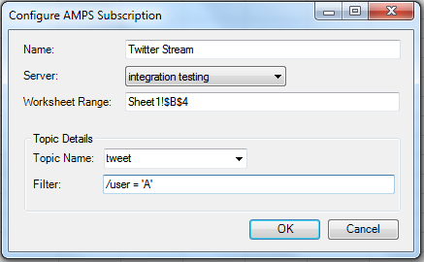

If you are satisfied with your settings, click **OK**. AMPS will begin to retrieve data into your worksheet.

# Manage Subscriptions

The **Manage Subscriptions** button in the AMPS ribbon lets you work with existing subscriptions in your workbook. Once you’ve created one or more subscriptions, click **Manage Subscriptions**:

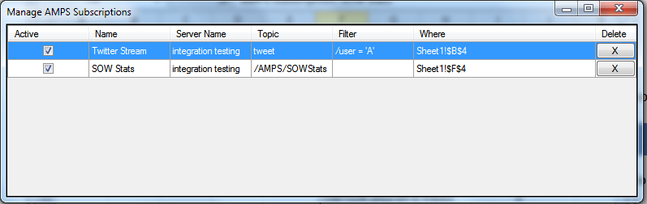

This list shows each subscription configured in this workbook, along with two additional controls:

* The **Active** column lets you *activate* and *deactivate* a subscription. Inactive subscriptions are subscriptions that are stored in the workbook but not currently receiving data. Active subscriptions re subscriptions that are both configured in this workbook and receiving data.

If the Active checkbox is checked, clicking it will deactivate the subscription, and AMPS stops modifying data in the workbook range associated with that subscription. If the Active checkbox is unchecked, clicking it will activate the subscription. If successful, AMPS re-establishes a connection to the server, and begins updating the specified range in your workbook.

**Note:** Deactivating a subscription always succeeds, but errors may occur when activating a subscription. If your server is unavailable, or if your subscription is misconfigured, the AMPS Excel Add-In will display an error, and the subscription will not be re-activated.

* Use the **X** button in the **Delete** column to delete a subscription. Deleting a subscription deletes all of the configuration data, such as the topic and filter, and deactivates the subscription. Deleting a subscription does not remove data that the add-in previously placed into your worksheet.

In addition to activating, deactivating, and deleting subscriptions, you can use **Manage Subscriptions** to modify an existing subscription. Double-click on the row associated with the subscription to modify:

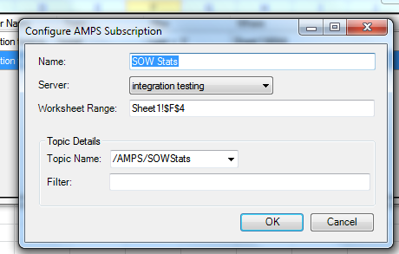

Once you are finished, click OK. If the subscription was previously active, AMPS deactivates the old subscription, applies your new settings, and attempts to activate the new subscription. If the subscription was previously inactive, it remains inactive.

# SAVING AND LOADING

You can save, load and share workbooks with AMPS subscriptions just like regular Excel workbooks. The AMPS Excel Add-In stores server and subscription configuration data in the workbook. When you open a workbook previously saved, **Manage Subscriptions** will show each of the subscriptions you had placed previously.

**Note**: The AMPS Excel Add-In stores all information required to connect to the topic and server, including hostnames, usernames, and passwords typed in configuring servers and subscriptions. Recipients of this workbook will be able to both see data you retrieved and re-establish connectivity to an AMPS server with the credentials you supplied. If you used a password to connect to AMPS, consider this workbook sensitive data.

When you open a workbook that contains AMPS subscriptions, every subscription is initially inactive. AMPS Excel Add-In does not attempt to activate subscriptions automatically when a workbook is loaded. Once you have loaded a workbook, use **Manage Subscriptions** to activate subscriptions.

Users without the AMPS Excel Add-In can still use your workbook. If you share a workbook that has AMPS subscriptions, a user without the add-in can still see the data you have retrieved from AMPS and make changes to the workbook. Their changes will not erase or corrupt the AMPS subscriptions you have already configured: if they send the workbook back to you, you will still be able to activate your previous subscriptions. They will not be able to activate AMPS subscriptions, however, without first installing the AMPS Excel Add-In.