Vellacombe Discovery Ltd

CVL azaheterocycle programme: route scout and first analogue delivery
Chemistry report to Corvenlea Pharma
Programme: VD-05-064
Report ref: A-R-2005-064-A
Date: 07/11/2005
Prepared by: Dr R. Calderwood, Head of Medicinal Chemistry

1 Summary
Corvenlea Pharma asked Vellacombe to establish a reliable route to the CVL aminopyrimidine amide analogue set and to deliver 32 analogues for their kinase biology. The original route stalled at a late-stage heteroaryl coupling whose crude product needed two chromatographic purifications.
We moved the heteroaryl coupling earlier in the sequence and introduced the amide last. The revised route removed the problematic purification, and all 32 analogues were delivered in three delivery lots between September and November 2005.

2 Route scout
Hypothesis: the aminopyrimidine nitrogen was coordinating the catalyst in the late coupling, giving incomplete conversion and a close-running by-product.
- Route A (original): amide formation, then heteroaryl coupling. Conversion stalled at 60-70%; by-product co-eluted.
- Route B: heteroaryl coupling on the protected aminochloropyrimidine, then deprotection and amide formation. Clean conversion; simple crystallisation of the intermediate.
- Route C: one-pot coupling and amidation. Abandoned after two runs; impurity profile worse than Route A.
Route gate (02/09/2005): Route B selected with Corvenlea Pharma's agreement. Route risk: the deprotection must be run cold to avoid amide cleavage.

3 Analogue delivery
Analogues were prepared in parallel from the common intermediate. Each compound card records isolated yield, identity (1H NMR and LCMS) and area-percent purity at 254 nm. Isolated yields are from the final step.
Table 1 Compounds delivered (compound cards)
Compound | SMILES | MW | Yield (%) | Purity LCMS (%) | Amount (mg)
CVL-08810 | Cc1ccc(-c2cc(NC(=O)c3ccc(OC4CCN(C)CC4)cc3)nc(N)n2)nc1 | 418.5 | 47 | 99.3 | 24
CVL-08812 | CN1CCC(Oc2ccc(C(=O)Nc3cc(-c4ccc(C#N)cc4)nc(N)n3)cc2)CC1 | 428.5 | 49 | 94.9 | 43
CVL-08816 | Nc1nc(NC(=O)c2ccc(N3CCC(O)CC3)cc2)cc(-c2cccnc2)n1 | 390.4 | 42 | 98.9 | 54
CVL-08824 | CC(=O)Nc1ccc(-c2cc(NC(=O)c3ccc(N4CCC(N)CC4)cc3)nc(N)n2)cc1 | 445.5 | 34 | 99.0 | 31
CVL-08828 | COc1ccc(-c2cc(NC(=O)c3ccc(N4CCN(C)CC4)cc3)nc(N)n2)cc1 | 418.5 | 44 | 97.7 | 37
CVL-08834 | CN1CCC(Oc2ccc(C(=O)Nc3cc(-c4cc(F)cc(F)c4)nc(N)n3)cc2)CC1 | 439.5 | 70 | 98.6 | 30
CVL-08846 | CC(=O)Nc1ccc(-c2ccc(C(=O)Nc3cc(-c4cc(F)cc(F)c4)nc(N)n3)cc2)cc1 | 459.5 | 41 | 96.6 | 35
CVL-08848 | N#Cc1ccc(-c2cc(NC(=O)c3ccc(N4CCC(N)CC4)cc3)nc(N)n2)cc1 | 413.5 | 40 | 97.6 | 49
CVL-08852 | Nc1nc(NC(=O)c2ccc(N3CCOCC3)cc2)cc(-c2ccc(F)cc2)n1 | 393.4 | 31 | 98.2 | 19
CVL-08854 | Nc1nc(NC(=O)c2ccc(N3CCOCC3)cc2)cc(-c2ccncc2)n1 | 376.4 | 30 | 99.3 | 5
CVL-08866 | CC(=O)Nc1ccc(-c2ccc(C(=O)Nc3cc(-c4ccc(F)cc4)nc(N)n3)cc2)cc1 | 441.5 | 4 | 96.6 | 12
CVL-08876 | Nc1nc(NC(=O)c2ccc(N3CCC(O)CC3)cc2)cc(-c2cc(F)cc(F)c2)n1 | 425.4 | 36 | 96.2 | 21
CVL-08882 | COc1ccc(-c2cc(NC(=O)c3ccc(N4CCOCC4)cc3)nc(N)n2)cc1 | 405.5 | 57 | 96.8 | 48
CVL-08884 | CC(=O)Nc1ccc(-c2cc(NC(=O)c3ccc(N4CCN(C)CC4)cc3)nc(N)n2)cc1 | 445.5 | 26 | 97.0 | 18
CVL-08890 | N#Cc1ccc(-c2cc(NC(=O)c3ccc(NC4CCCCC4)cc3)nc(N)n2)cc1 | 412.5 | 37 | 99.8 | 23
CVL-08896 | Nc1nc(NC(=O)c2ccc(N3CCC(N)CC3)cc2)cc(-c2ccncc2)n1 | 389.5 | 51 | 97.6 | 12
CVL-08900 | CC(=O)Nc1ccc(-c2cc(NC(=O)c3ccc(N4CCOCC4)cc3)nc(N)n2)cc1 | 432.5 | 66 | 96.7 | 37
CVL-08906 | CC(=O)Nc1ccc(-c2cc(NC(=O)c3ccc(-c4ccncc4)cc3)nc(N)n2)cc1 | 424.5 | 40 | 96.6 | 19
CVL-08914 | CN1CCC(Oc2ccc(C(=O)Nc3cc(-c4ccncc4)nc(N)n3)cc2)CC1 | 404.5 | 71 | 98.3 | 27
CVL-08918 | Nc1nc(NC(=O)c2ccc(NC3CCCCC3)cc2)cc(-c2ccncc2)n1 | 388.5 | 27 | 96.7 | 8
CVL-08926 | Nc1nc(NC(=O)c2ccc(-c3ccncc3)cc2)cc(-c2cc(F)cc(F)c2)n1 | 403.4 | 37 | 98.0 | 50
CVL-08936 | CN1CCN(c2ccc(C(=O)Nc3cc(-c4ccc(C#N)cc4)nc(N)n3)cc2)CC1 | 413.5 | 50 | 96.6 | 45
CVL-08938 | Cc1ccc(-c2cc(NC(=O)c3ccc(N4CCC(O)CC4)cc3)nc(N)n2)nc1 | 404.5 | 42 | 98.6 | 18
CVL-08942 | Nc1nc(NC(=O)c2ccc(N3CCC(O)CC3)cc2)cc(-c2ccc(F)cc2)n1 | 407.4 | 44 | 96.5 | 18
CVL-08944 | COc1ccc(-c2cc(NC(=O)c3ccc(NC4CCCCC4)cc3)nc(N)n2)cc1 | 417.5 | 41 | 97.7 | 36
CVL-08948 | Nc1nc(NC(=O)c2ccc(NC3CCCCC3)cc2)cc(-c2cccnc2)n1 | 388.5 | 22 | 96.0 | 39
CVL-08962 | Nc1nc(NC(=O)c2ccc(NC3CCCCC3)cc2)cc(-c2cc(F)cc(F)c2)n1 | 423.5 | 37 | 97.6 | 39
CVL-08974 | CN1CCN(c2ccc(C(=O)Nc3cc(-c4ccc(F)cc4)nc(N)n3)cc2)CC1 | 406.5 | 41 | 99.8 | 28
CVL-08978 | Nc1nc(NC(=O)c2ccc(NC3CCCCC3)cc2)cc(-c2ccc(F)cc2)n1 | 405.5 | 43 | 99.4 | 20
CVL-08980 | CN1CCN(c2ccc(C(=O)Nc3cc(-c4cccnc4)nc(N)n3)cc2)CC1 | 389.5 | 4 | 99.0 | 12
CVL-08984 | N#Cc1ccc(-c2cc(NC(=O)c3ccc(-c4ccncc4)cc3)nc(N)n2)cc1 | 392.4 | 10 | 97.5 | 30
CVL-08990 | COc1ccc(-c2cc(NC(=O)c3ccc(N4CCC(O)CC4)cc3)nc(N)n2)cc1 | 419.5 | 5 | 98.7 | 37

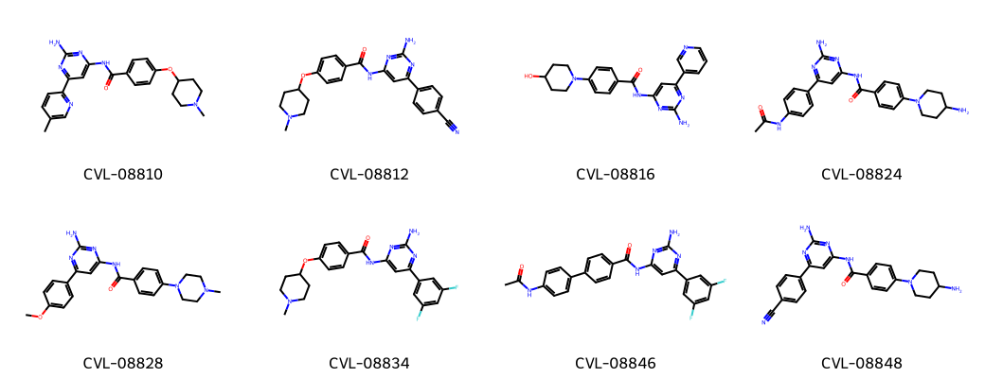

4 Delivery lots
- Lot 1, 14/09/2005: first twelve analogues (interim chemistry note issued)
- Lot 2, 12/10/2005: ten analogues
- Lot 3, 07/11/2005: final ten analogues and this report
Solid samples were shipped at ambient temperature with compound cards. Retained samples (5 mg each) are held at Vellacombe for twelve months.

5 Conclusions and next analogue
Route B is robust at 50-100 mg scale and suits further analogue work. All delivered material met the agreed purity threshold. Proposed next set: vary the amide aryl ring while holding the best heteroaryl groups from this delivery, once Corvenlea Pharma's biology data are available.

Name | Role | Signature | Date
Ruth Calderwood | Head of Medicinal Chemistry | Calderwood | 07/11/2005
Clara Fenwick | Analytical Release Lead | Fenwick | 07/11/2005

