Demo: Creating a Pull Request in Git

Objective: To create a pull request for merging the local changes into a remote Git repository
Tools required: Git and GitHub
Prerequisites: You need to have Git installed to proceed with this demo.
Steps to be followed:
- Create a fork
- Clone the fork
- Sync the fork with the original repository
- Push changes to the GitHub fork
- Create a pull request

Step 1: Create a fork

  - Open the browser in your lab, go to github.com, and log in to your account
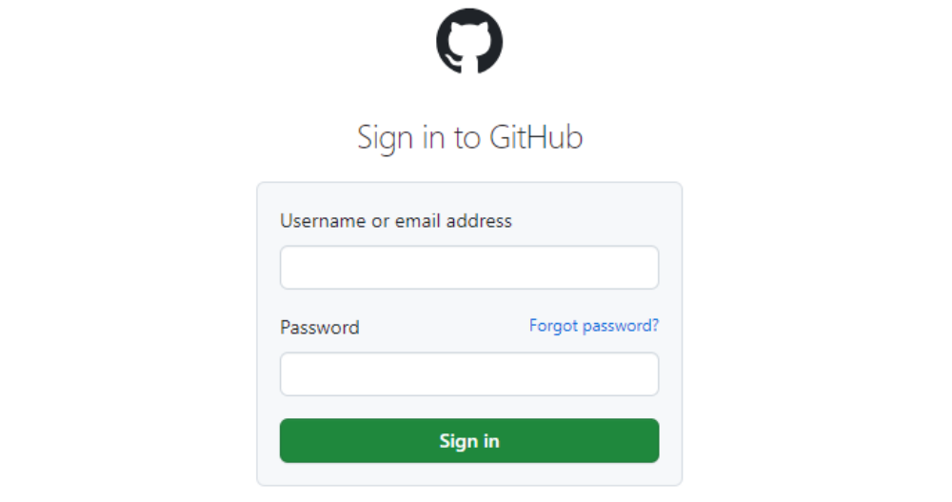
Note: If you do not have a GitHub account, visit the official website at https://github.com/signup and create a new account

  - Navigate to the following repository in your browser: https://github.com/GithubResources1/Chat-Application

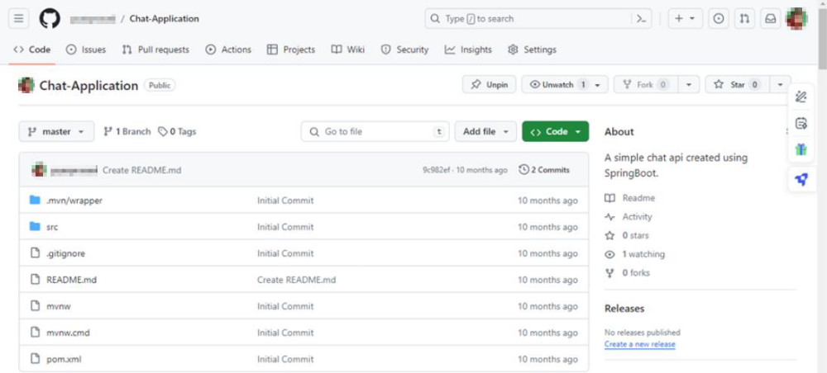

  - Click the Fork button in the top-right corner of the page
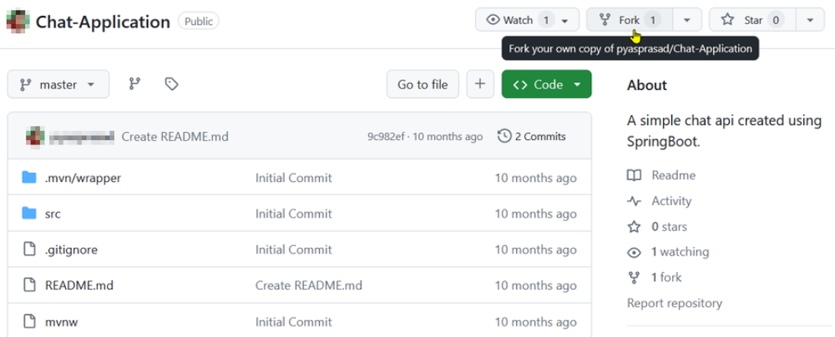

  - In the Create a new fork page, enter the name and description of the forked repository, then click on Create fork
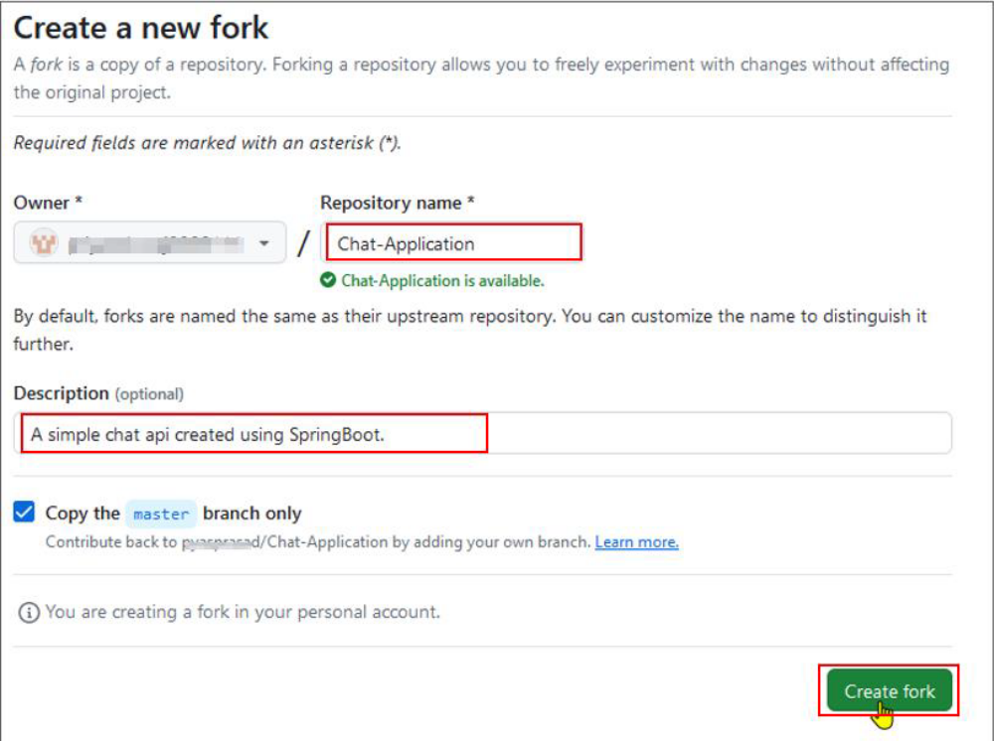

Step 2: Clone the Fork
2.1 Click on the Code button in the forked repository page
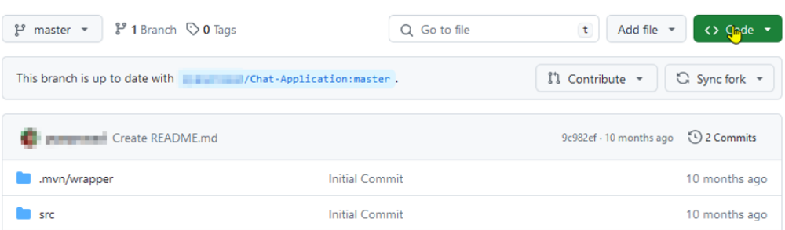

2.2 Click on the copy icon to copy the HTTPS URL of the forked repository to clone it
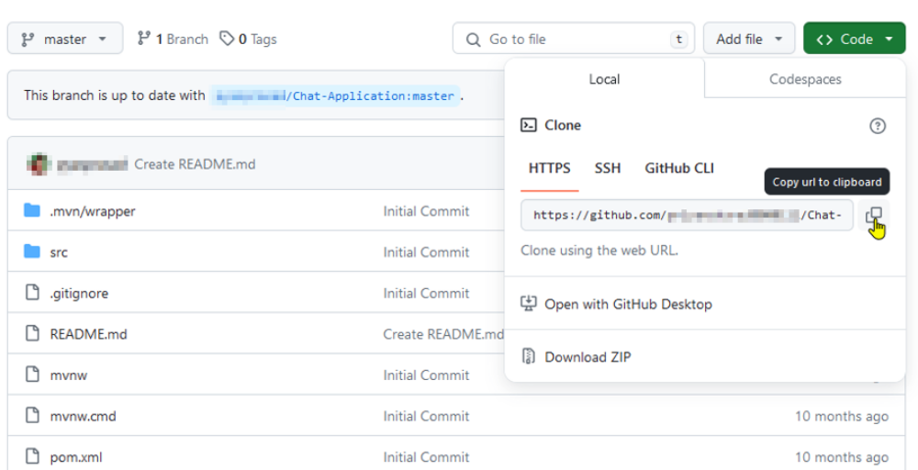

2.3 Open the terminal tab on your lab and use the following command to clone the forked repository inside the local project directory: git clone <URL>
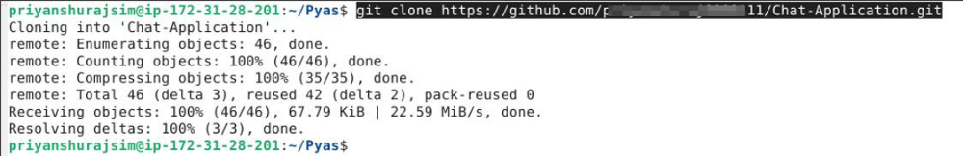
Note: Replace the URL with the copied HTTPS URL from the repository
Step 3: Sync the fork with the original repository
3.1 Navigate to the directory where the fork has been cloned using the following command in the terminal: cd Chat-Application
3.2 Run the following command to view the configured remote repository for your fork: git remote -v
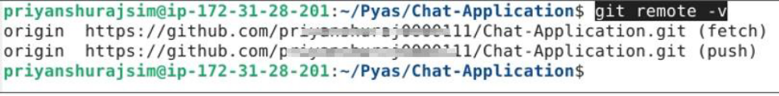
3.3 Add the original repository as a remote upstream using the following command: git remote add upstream <URL>
Note: Replace the URL with the copied URL from the repository
3.4 Execute the following command to verify the new upstream repository: git remote -v
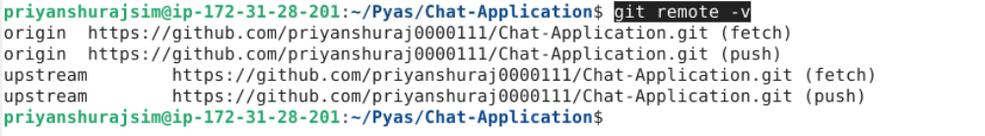
Step 4: Push changes to the GitHub fork
4.1 After making changes in the local code repository, execute the following command to push the changes to your GitHub fork: git push
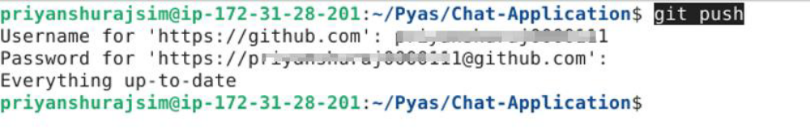
Note: After executing the Git push command, you will be asked to enter the username and password for your GitHub account.
Step 5: Create a pull request
5.1 Click the Pull requests button on your GitHub fork’s page
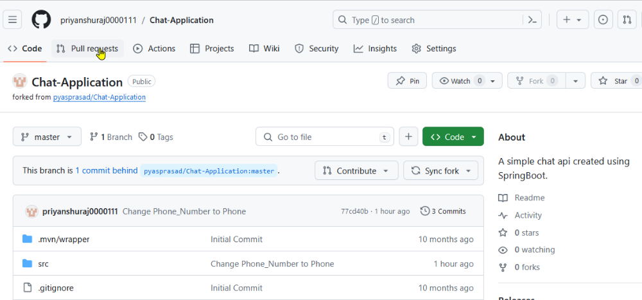

5.2 Click the New pull request button
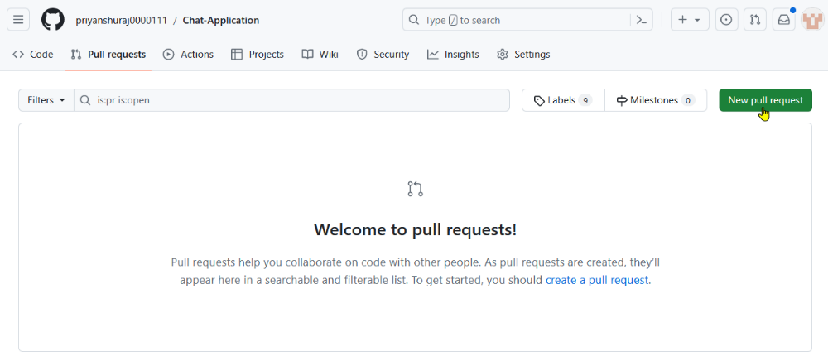

5.3 Select the Create pull request button and resolve the merge comments
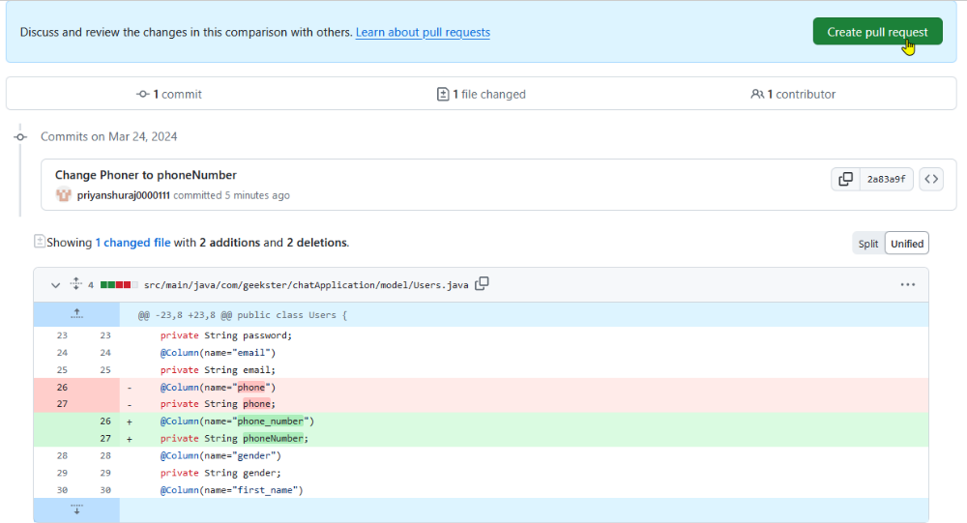
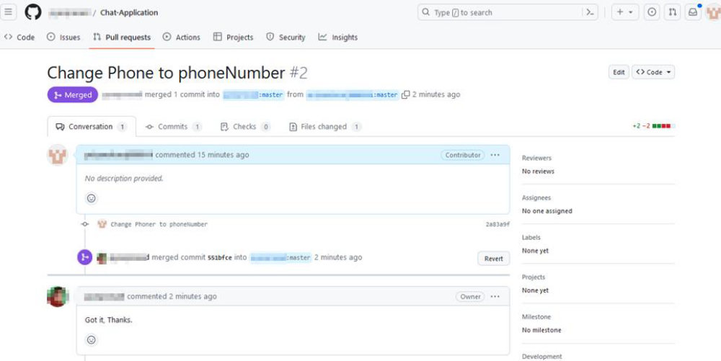
By following these steps, you have successfully created a pull request for merging the local changes into a remote Git repository.

