|  |  |
| --- | --- |
| Ex.No.12  23/09/2024 | **IMPLEMENTATION OF SECURE HASH ALGORITHM** |

|  |
| --- |
| **AIM:** |

To implement one step in one round of Secure Hash Algorithm -1

|  |
| --- |
| **THEORY** |

**Properties of Hash Functions:**

The properties of hash functions are,

Deterministic: The same input always produces the same hash output.

Fixed Output Length: Hash output is always the same length, regardless of input size.

Collision Resistant: Different inputs are unlikely to produce the same hash value.

**Schematic diagram for one step:**

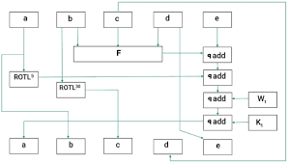

**Online Calculator – SHA1 – Screenshots**

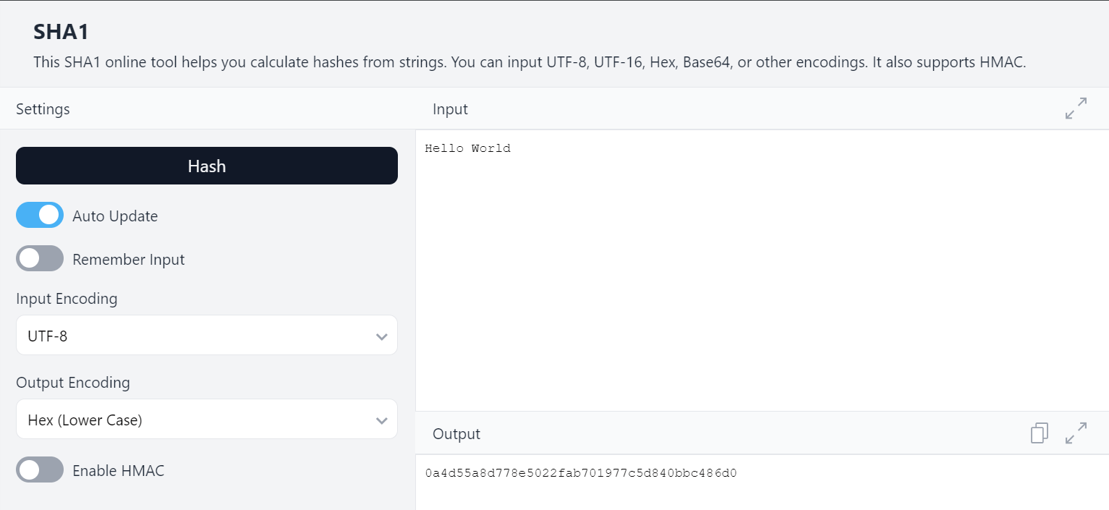

|  |
| --- |
| **ALGORITHM:** |

1. Preprocessing:

Padding:

Append a single '1' bit to the message.

Append '0' bits until the length is 448 mod 512 (making the total length 64 bits shy of a multiple of 512).

Append the original message length as a 64bit integer.

2. Initialize Hash Values:

Set initial hash values (five 32bit words):

h_0 = 0x67452301

h_1 = 0xEFCDAB89

h_2 = 0x98BADCFE

h_3 = 0x10325476

h_4 = 0xC3D2E1F0

3. Process the Message in 512bit Chunks:

Divide the padded message into 512bit blocks.

For each block:

Break it into sixteen 32bit words W[0], W[1],..., W[15].

Extend the sixteen words into eighty 32bit words:

For t = 16 to 79:

W[t] = (W[t3] +W[t8] + W[t14] + W[t16]) left rotated by 1

4. Initialize Working Variables:

Set working variables:

a = h_0

b = h_1

c = h_2

d = h_3

e = h_4

|  |
| --- |
| **CODING:** |

import java.util.Scanner;  
  
public class SHA1 {  
 private static final int *H0* = 0x67452301;  
 private static final int *H1* = 0xEFCDAB89;  
 private static final int *H2* = 0x98BADCFE;  
 private static final int *H3* = 0x10325476;  
 private static final int *H4* = 0xC3D2E1F0;  
  
 private static int leftRotate(int value, int shift) {  
 return (value << shift) | (value >>> (32 - shift));  
 }  
  
 private static byte[] padMessage(byte[] message) {  
 int originalLength = message.length;  
 long originalLengthBits = (long) originalLength * 8;  
 int paddingLength = (56 - (originalLength + 1) % 64 + 64) % 64;  
 byte[] paddedMessage = new byte[originalLength + paddingLength + 9];  
   
 System.*arraycopy*(message, 0, paddedMessage, 0, originalLength);  
 paddedMessage[originalLength] = (byte) 0x80;  
   
 for (int i = 0; i < 8; i++) {  
 paddedMessage[paddedMessage.length - 1 - i] = (byte) (originalLengthBits >>> (i * 8));  
 }  
 return paddedMessage;  
 }  
  
 public static void main(String[] args) {  
 Scanner scanner = new Scanner(System.*in*);  
   
 System.*out*.print("Enter the text to hash: ");  
 String inputText = scanner.nextLine();  
   
 byte[] paddedMessage = *padMessage*(inputText.getBytes());  
   
 System.*out*.print("Enter the round number (1-4): ");  
 int round = scanner.nextInt();  
 System.*out*.print("Enter the step number (1-79): ");  
 int step = scanner.nextInt();  
   
 if (round < 1 || round > 4 || step < 0 || step > 79) {  
 System.*out*.println("Invalid round or step number. Please enter valid values.");  
 return ;  
 }  
   
 int[] w = new int[80];  
   
 for (int i = 0; i < 16; i++) {  
 w[i] = ((paddedMessage[i * 4] & 0xFF) << 24) |   
 ((paddedMessage[i * 4 + 1] & 0xFF) << 16) |  
 ((paddedMessage[i * 4 + 2] & 0xFF) << 8) |   
 (paddedMessage[i * 4 + 3] & 0xFF);  
 }  
  
 // Extend the sixteen 32-bit words into eighty 32-bit words  
 for (int i = 16; i < 80; i++) {  
 w[i] = *leftRotate*(w[i - 3] ^ w[i - 8] ^ w[i - 14] ^ w[i - 16], 1);  
 }  
  
 // Initial hash values  
 int a = *H0*, b = *H1*, c = *H2*, d = *H3*, e = *H4*;  
  
 // Determine the value of f and k based on the round number  
 int f, k;  
 if (round == 1) {  
 f = (b & c) | (~b & d); // First 20 rounds  
 k = 0x5A827999;  
 } else if (round == 2) {  
 f = b ^ c ^ d; // 20 to 39 rounds  
 k = 0x6ED9EBA1;  
 } else if (round == 3) {  
 f = (b & c) | (b & d) | (c & d); // 40 to 59 rounds  
 k = 0x8F1BBCDC;  
 } else {  
 f = b ^ c ^ d; // 60 to 79 rounds  
 k = 0xCA62C1D6;  
 }  
  
 // Perform the specific step (for the given step in the block)  
 int temp = *leftRotate*(a, 5) + f + e + k + w[step];  
 e = d;  
 d = c;  
 c = *leftRotate*(b, 30);  
 b = a;  
 a = temp;  
 System.*out*.printf("After round %d and step %d:\n a = %08x\n b = %08x\n c = %08x\n d = %08x\n e = %08x\n", round, step, a, b, c, d, e);  
 scanner.close();  
 }  
}

|  |
| --- |
| **SCREEN SHOTS:** |

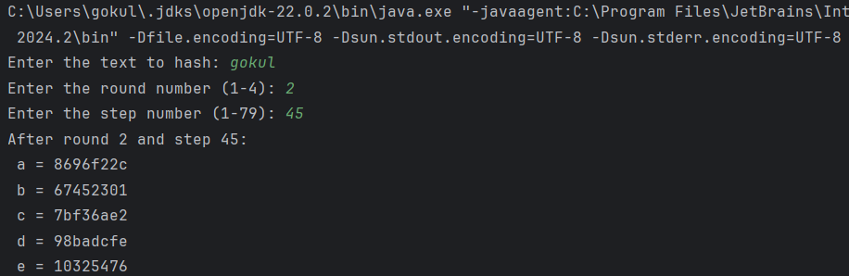

|  |
| --- |
| **RESULT:** |

Thus, we have implemented SHA1 algorithm Successfully.

|  |
| --- |
| **Evaluation** |

|  |  |  |
| --- | --- | --- |
| Parameter | Max Marks | Marks Obtained |
| Uniqueness of the Code | 50 |  |
| Completion of experiment on time | 10 |  |
| Documentation | 15 |  |
| Total | 75 |  |
| Signature of the faculty with Date |  |  |