**Import the Acadgild VM into the Oracle virtual box by following the steps shared from the below link document.**

**1. First open the oracle virtual box.**  
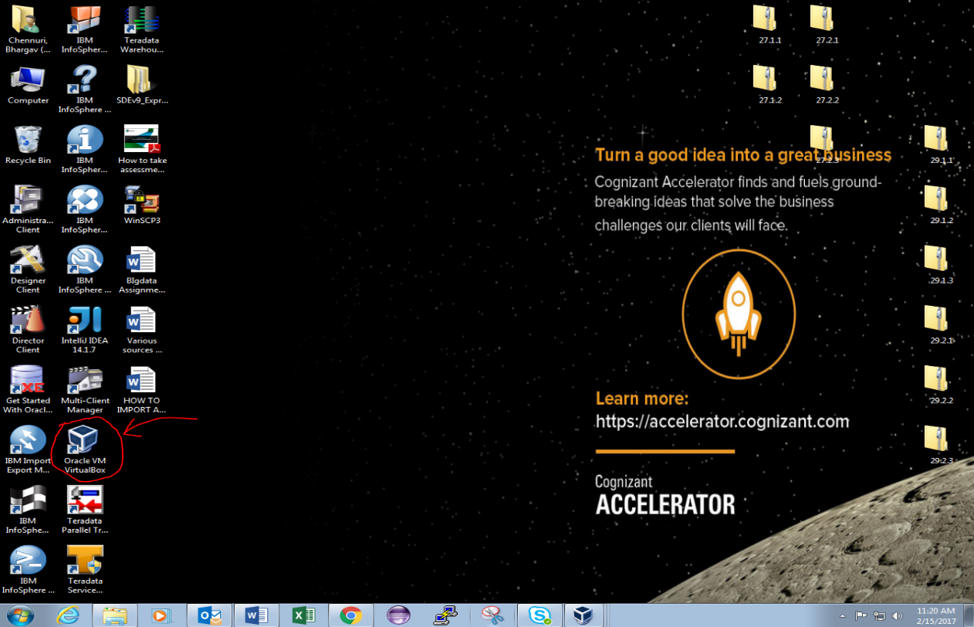

**2. Click FILE .**  
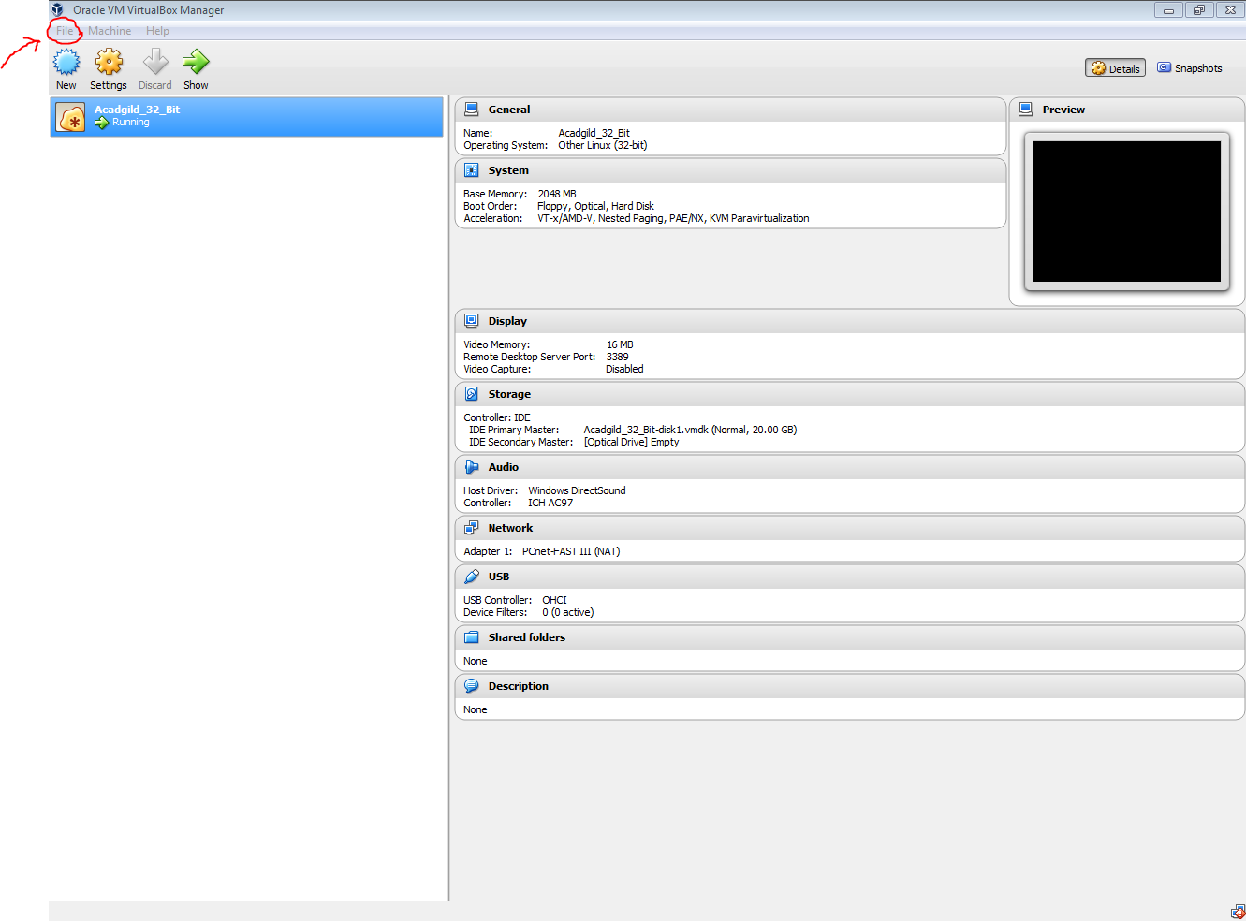

**3. Click on *IMPORT APPLICATION* in file.**  
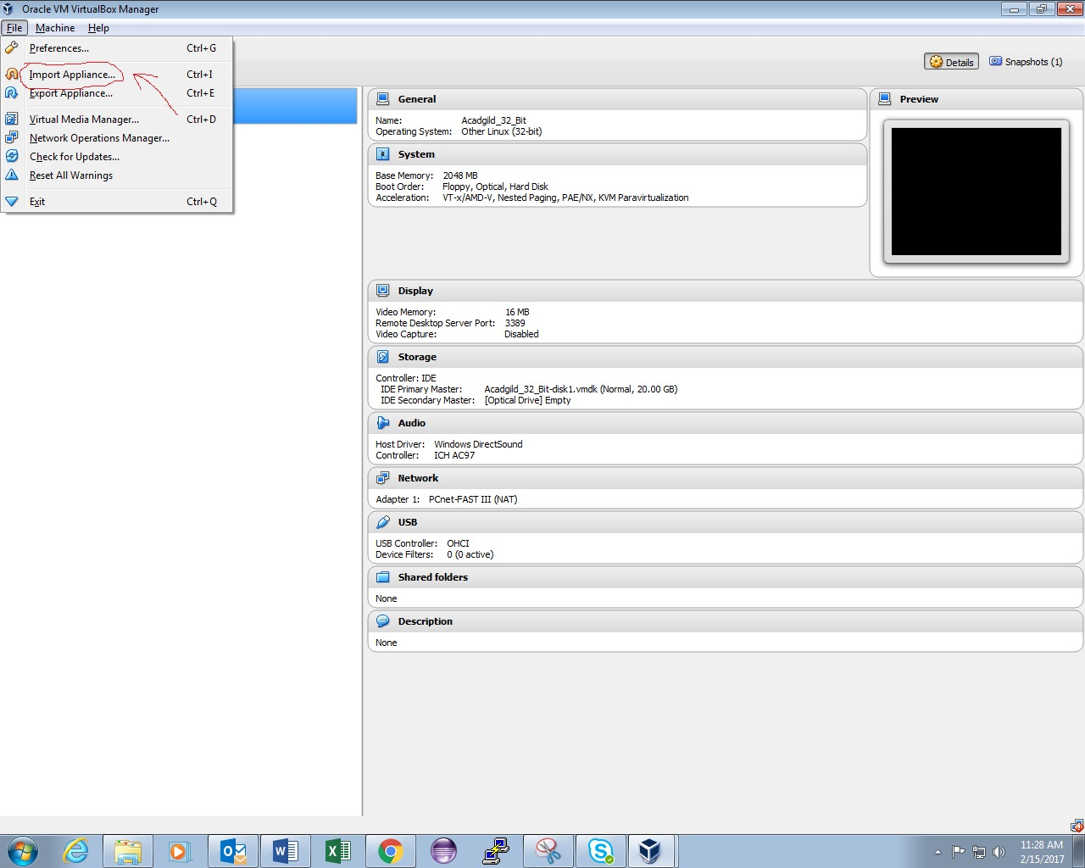

**4. We are directed to the browse pop up tab, Browse where the Acadgild file is and import.**  
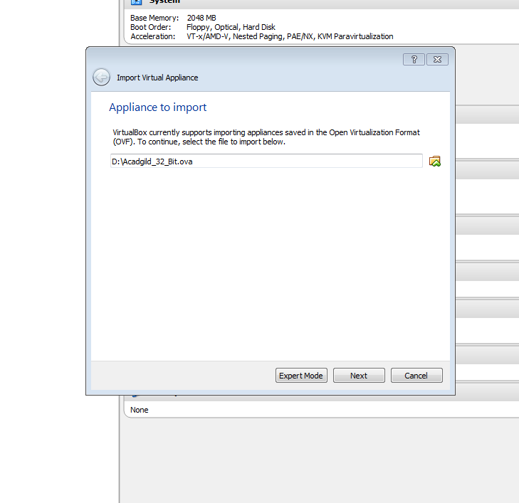

**5. Click next and then uncheck the USB controller and then check the reinitialize the mac address.**  
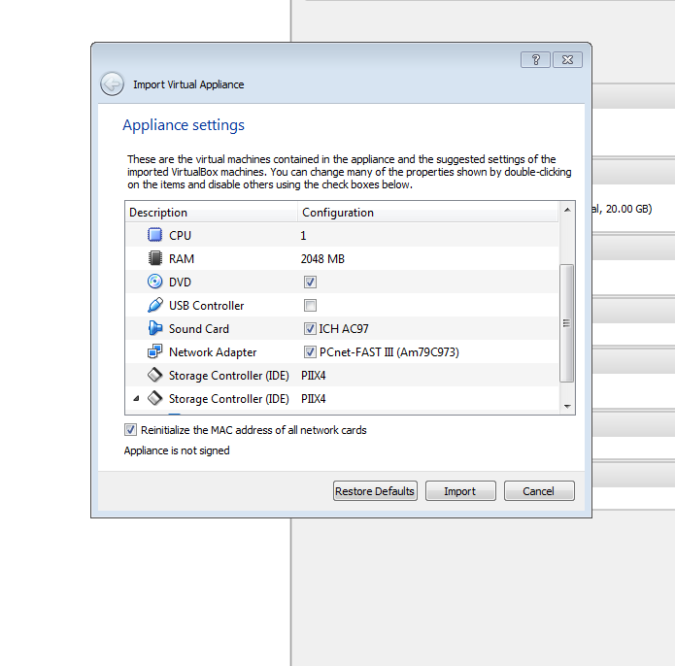  
**6. It will take few minutes to import.**  
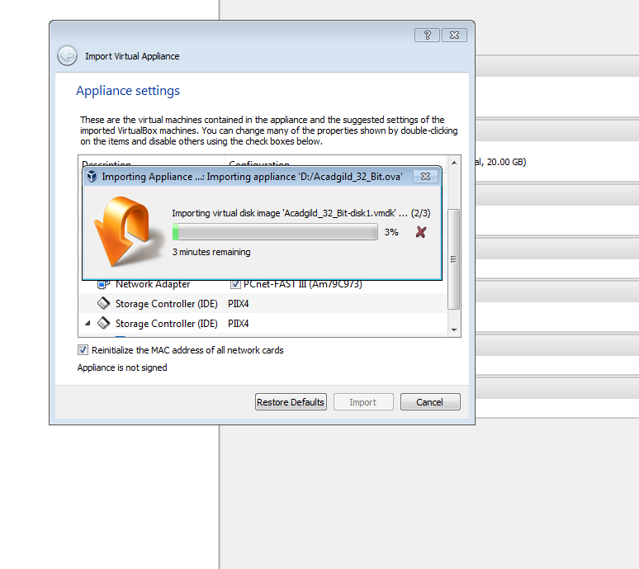

**7. And then click start to start the Acadgild and type user name, password to login.**  
  
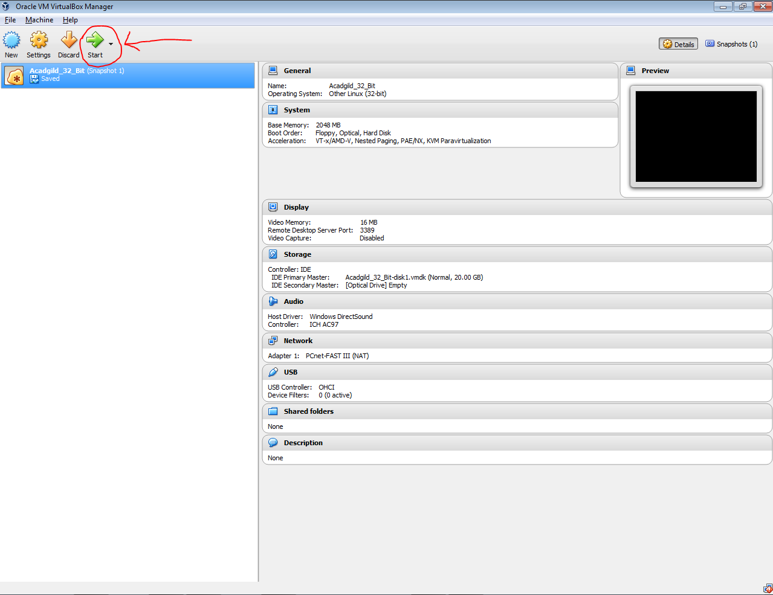  
  
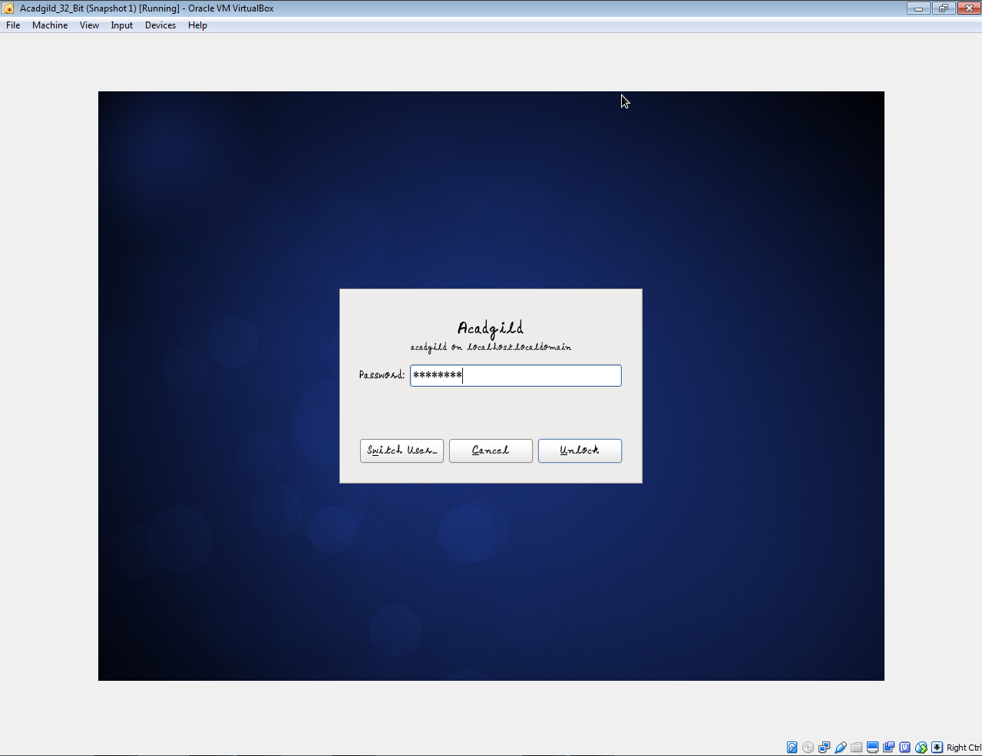

**8. After installing it looks like this.**

