Q1) Write a java code with the class named ‘acad’ and a method ‘main’. Hardcode the program with two integers and print the sum of those two.

public class acad{

public static void main(string [] args)

{int a=10,b=12;

Int sum=a+b;

System.out.println(sum);

}

}

**OUTPUT:**

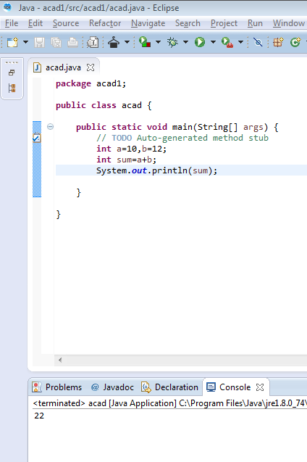

Q2) Rewrite the above code, where, inputs are provided by the user at runtime and the output is printed.

public class acad{

public static void main(string [] args)

{Scanner s=new Scanner(System.in);

int a=s.nextint();

int b=s.nextint();

int sum=a+b;

System.out.println(sum);

}

}

**OUTPUT:**

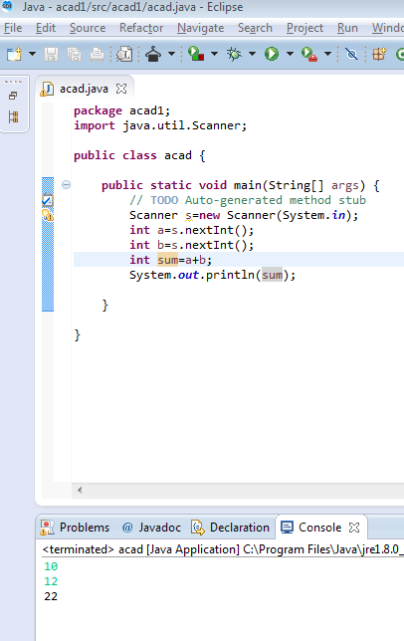

Q3) Write a program with method name sum() that accepts two parameters from user and print the sum two numbers. Output format should be as:

public class acad {

public static void main{

Scanner s=new Scanner(System.in);

int a=s.nextInt();

int b=s.nextInt();

int sum=a+b;

System.out.println(“first number is: “+a);

System.out.println(“Second number is: “+b);

System.out.println(“Sum is: “+sum);}

public static void main(String[] args){

acad.a=new acad();

a.sum();}}

