1. Write a pig script to find the top 20 destination people travel the most: Based on the given data

**Code:**

A = load ‘travel.txt’ using PigStorage(‘\t’) as (citypair:chararray,from:chararray,to:chararray);

B = DISTINCT A;

C = group B by to;

D = foreach C generate group, COUNT($1);

E = order D by $1 desc;

F = limit E 20;

dump F;

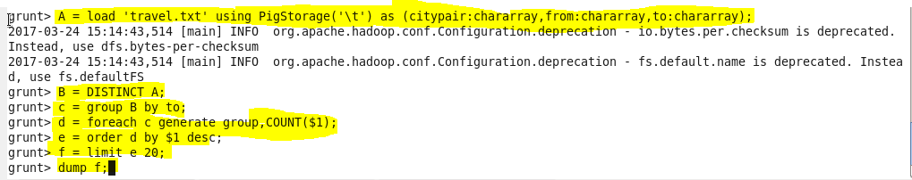

**Output:**

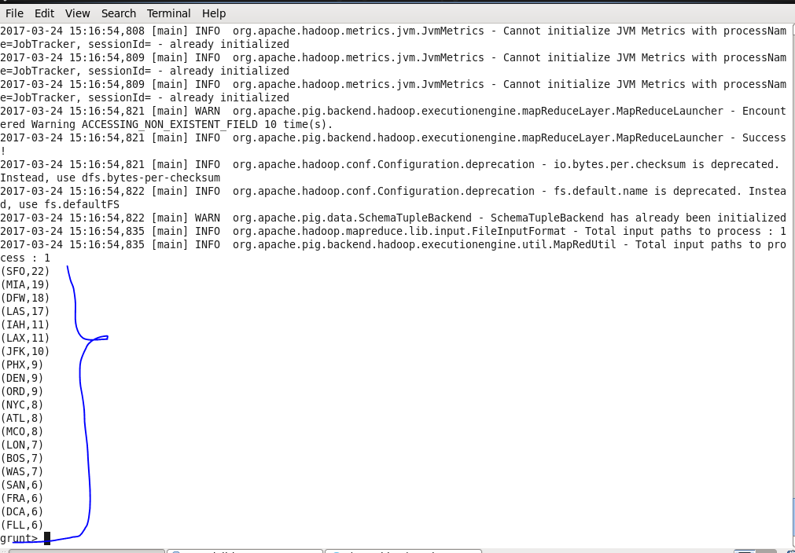

1. Write a pig script to find the top 20 locations from where people travel the most

**Code:**

A = load ‘travel.txt’ using PigStorage(‘\t’) as (citypair:chararray,from:chararray,to:chararray);

B = DISTINCT A;

C = group B by from;

D = foreach C generate group, COUNT($1);

E = order D by $1 desc;

F = limit E 20;

dump F;

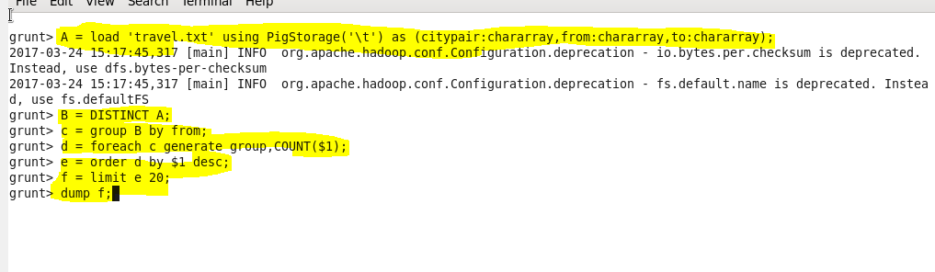

**Output:**

