1. Write a program to accepts two numbers from stdin and find all the odd as well as even numbers present in between them.

Import java.util.Scanner;

public class acad{

public static void main(String[] args){

Scanner s=new Scanner(System.in);

int a=s.nextInt();

int b=s.nextInt();

for(int i=a+1;i<b;i++){

System.out.println(i);}}}

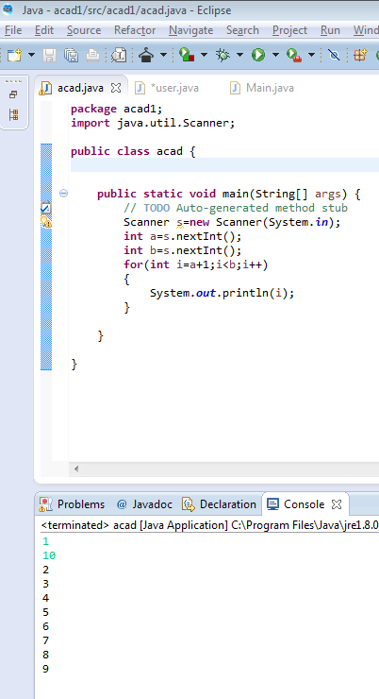

1. Joe is scared to go to school. When her dad asked the reason, joe said she is unable to complete the task given by her teacher. The task was to find the “first 10 multiples” of the number entered from stdin

Import java.util.Scanner;

public class acad{

public static void main(String[] args){

Scanner s=new Scanner(System.in);

int a=s.nextInt();

for(int i=1;i<=10;i++){

System.out.println(a+”\*”+i+”=”+a\*i);

}}}

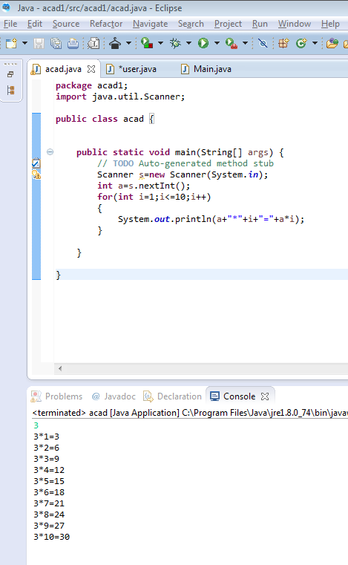

1. Write a program consisting method sum() and demonstrate the concept of method overloading using this method.

import java.util.Scanner;

public class acad{

int sum(int n1,int n2){

return n1+n2;}

int sum(int n1,int n2,int n3){

return n1+n2+n3;}

public static void main(String[] args){

acad a=new acad();

System.out.println(“Sum of two numbers: “+a.sum(5,12));

System.out.println(“Sum of three numbers: “+a.sum(5,7,12));}}

