Create a database named 'custom'.

Create a table named temperature_data inside custom having below fields:

1. Date (mm-dd-yyyy) format

2. Zip code

3. Temperature

The table will be loaded from comma-delimited file.

Load the dataset.txt (which is ',' delimited) in the table.

Solution:

Creating Database **“custom”.**

After creating the database we cas see the databases available by the command show databases.

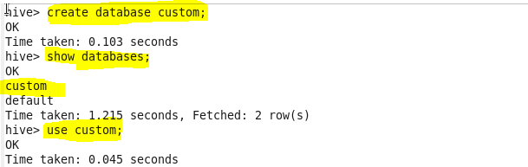

we can use this custom database and create a table as shown below.

Created the table **temperature_data** as shown below.

Loaded the data into the table as shown below.

To check the output we can use the command select * from temperature_data.

