**Explain Primary data types and complex data types in Hive with an example in brief.**

**Primary Datatypes:**

Primary Data Types are classified into four categories. They are:

1. Numeric/Integral Types
2. String Types
3. Date/Time Types
4. Miscellaneous Types

**Numeric/Integral Data Types:**

Integer type data can be specified using integral data types, INT. When the data range exceeds the range of INT, you need to use BIGINT and if the data range is smaller than the INT, you use SMALLINT. TINYINT is smaller than SMALLINT.

Floating types are – FLOAT, DOUBLE & DECIMAL.

DECIMAL(5,2) represents total of 5 digits, out of which 2 are decimal digits.

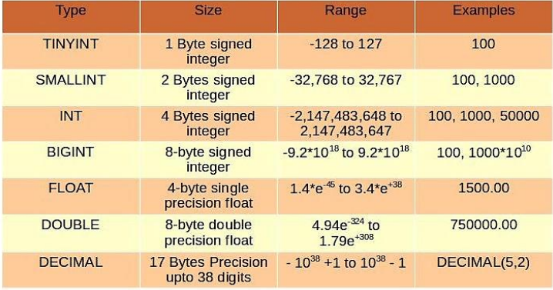

**String Data Types:**

*String:*

String literals can be expressed with either single quotes (') or double quotes (").

*Varchar:*

Varchar types are created with a length specifier (between 1 and 65355), which defines the maximum number of characters allowed in the character string.

*Char:*

Char types are similar to Varchar but they are fixed-length meaning that values shorter than the specified length value are padded with spaces but trailing spaces are not important during comparisons.

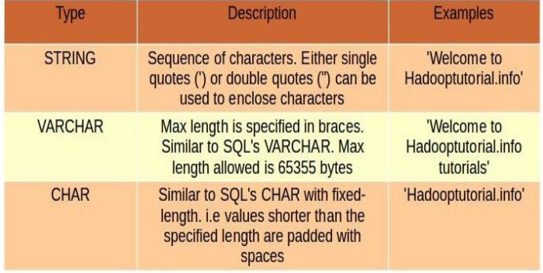

**Date/Time Data Types:**

Hive provides DATE and TIMESTAMP data types in traditional UNIX time stamp format for date/time related fields in hive.

DATE values are represented in the form YYYY-MM-DD. Example: DATE ‘2014-12-07’. Date ranges allowed are 0000-01-01 to 9999-12-31.

TIMESTAMP use the format yyyy-mm-dd hh:mm:ss[.f...].

We can also cast the String, Time-stamp values to Date format if they match format.

**Miscellaneous Data Types:**

Hive supports two more primitive data types, BOOLEAN and BINARY. Similar to Java’s Boolean, BOOLEAN in hive stores true or false values only.

BINARY is an array of Bytes and similar to VARBINARY in many RDBMSs.

**Complex Datatypes:**

Complex Types can be built up from primitive types and other composite types. Data type of the fields in the collection are specified using an angled bracket notation. Currently Hive supports four complex data types. They are:

**Array:**

Syntax: ARRAY<datatype>

An Ordered sequences of similar type elements that are indexable using zero-based integers.

It is similar to arrays in Java.

Example – array (‘siva’, ‘bala’, ‘praveen’);

**Map:**

Syntax: MAP<primitive_type, data_type>.

Collection of key-value pairs.

Fields are accessed using array notation of keys (e.g., [‘key’]).

**Struct:**

Syntax: STRUCT<col_name:data_type [COMMENT col_element], ..>.

It is similar to STRUCT in C language.

It is a record type which encapsulates a set of named fields that can be any primitive data type.

Elements in STRUCT type are accessed using the DOT (.) notation.

**Eg**: For a column c of type STRUCT {a INT; b INT} the a field is accessed by the expression c.a

**Uniontype:**

Syntax: UNIONTYPE<data_type, data_type, …>

It is similar to Unions in C.

At any point of time, an Union Type can hold any one (exactly one) data type from its specified data types.