Fetch date and temperature from temperature_data where zip code is greater than 300000 and less than 399999.

**Solution:** Selecting the data and temperature from temperature_data and filtering it by zip code where zip code lies between 300000 and 399999.

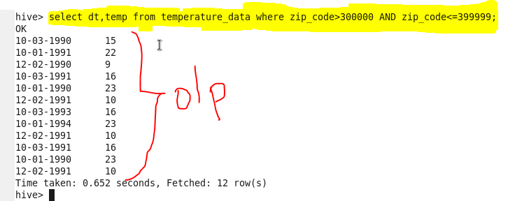

Calculate maximum temperature corresponding to every year from temperature_data table.

**Solution:** selecting year and temperature and grouping the records for year.

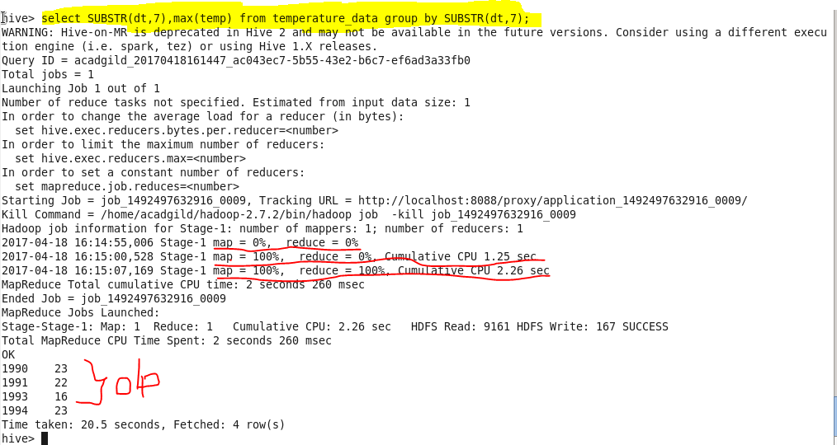

Calculate maximum temperature from temperature_data table corresponding to those years which have at least 2 entries in the table.

**Solution:** selecting the year and temperature where the maximum temperature for corresponding year and filtering the records by considering only the year which has at least 2 entries.

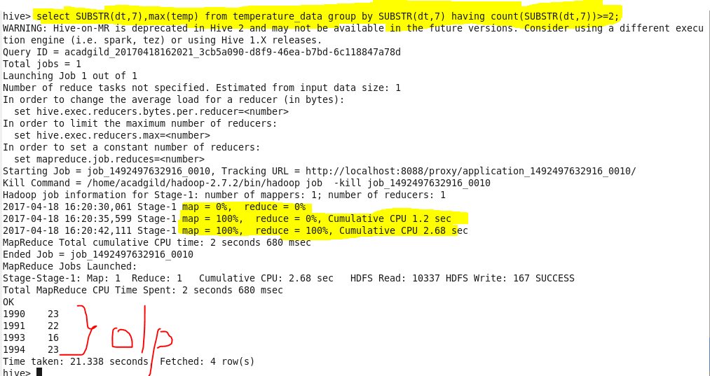

Create a view on the top of last query, name it temperature_data_vw.

Solution: creating a view named as temperature_data_vw which contains the records of year and maximum temperature corresponding to that year and filtering the records by considering only the year which has at least two entries.



Export contents from temperature_data_vw to a file in local file system, such that each file is '|' delimited.

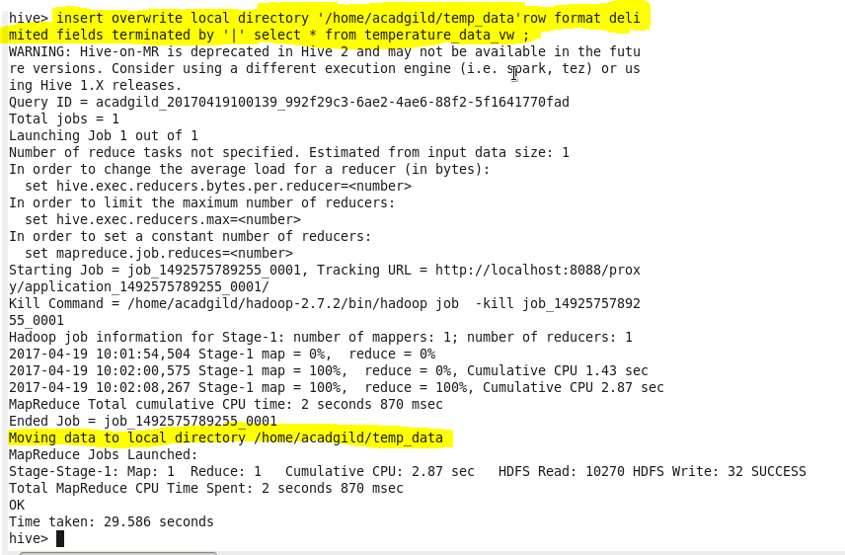

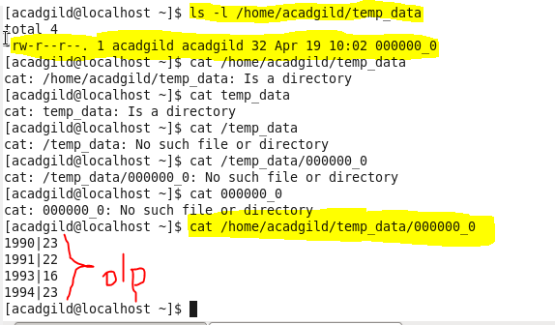

Exporting the contents of the view temperature_data to the local file system and delimiting the records by the **“|”** symbol as shown in the screenshot.