Calculate the number of employees corresponding to each skill from the table 'employee' which is loaded in the Demo.

**Input:**

Creating the table employee and inserting the columns like name,skill,rating,category and they are delimited by “,” as shown in the screen shot.

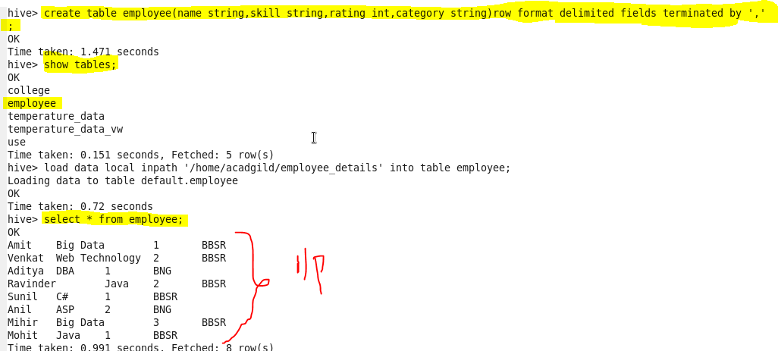

Solution:

selecting the skill and number of persons present in the corresponding skill from the table “**employee**” as shown in the screen shot.

