Write a Hive program to find the number of medals won by each country in swimming.

**Input:**

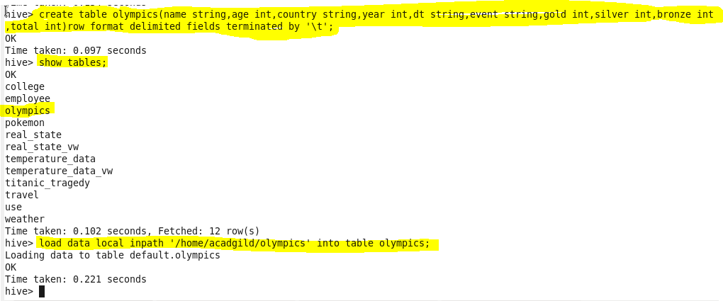

**Code:** 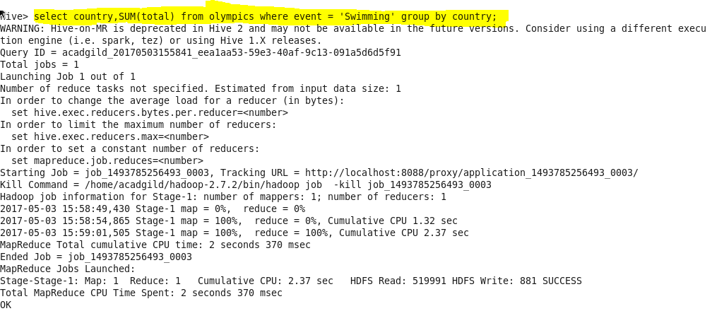

**Output:**

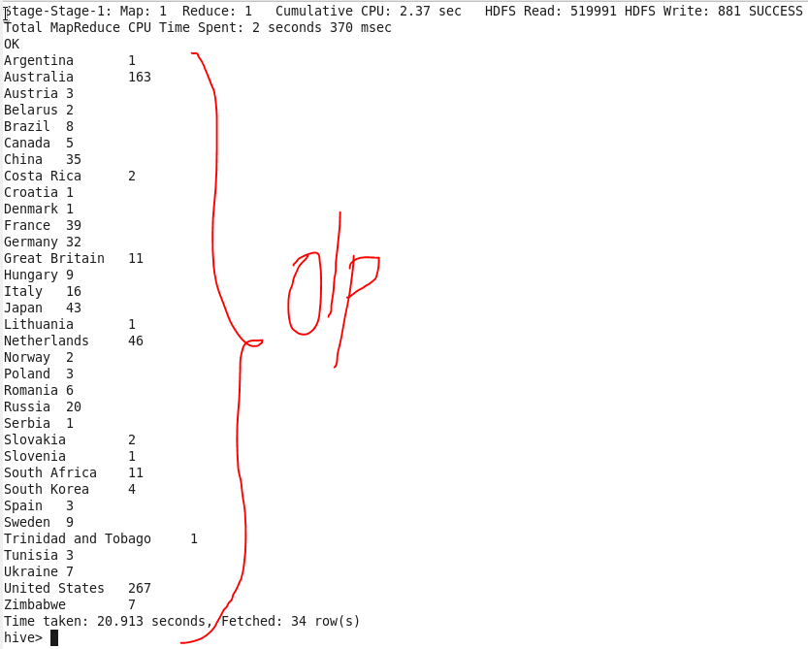

Write a Hive program to find the number of medals that India won year wise.

**Code:**

