1. Write a hive query to find the top 20 destination people travel the most: Based on the given data

**Creating table:**

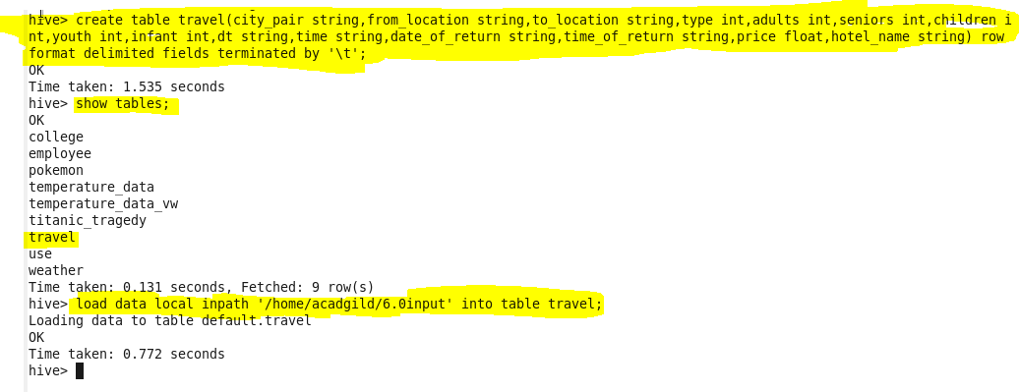

Code: 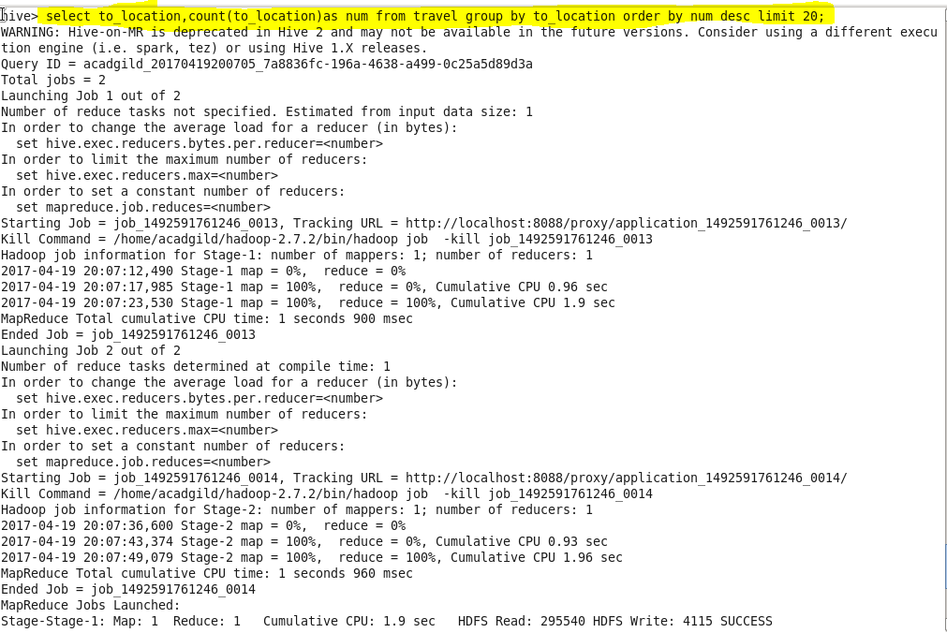

Output:

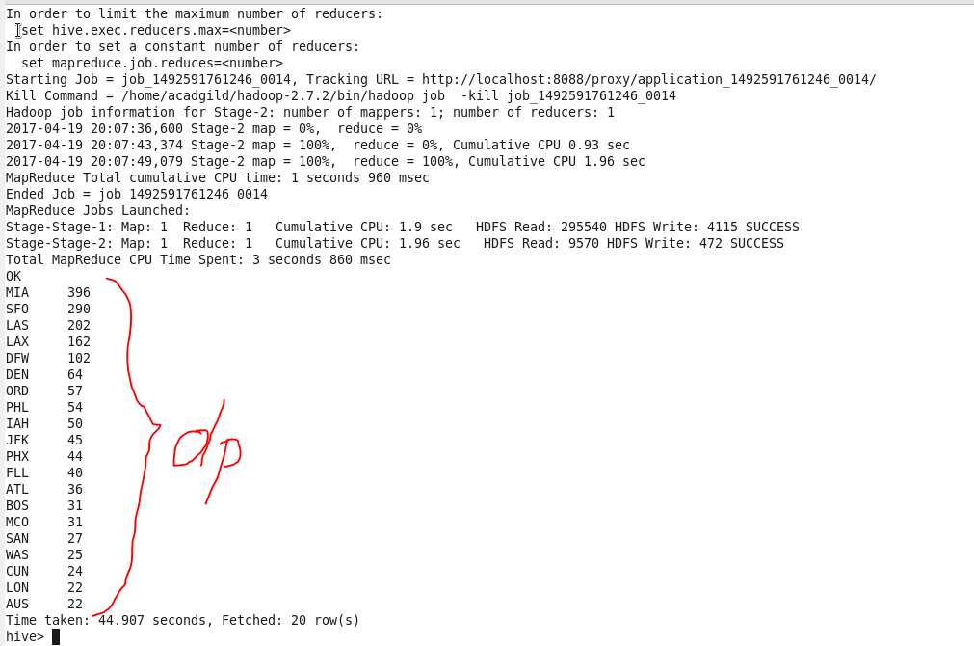

1. Write a hive query to find the top 20 locations from where people travel the most

**Query:**

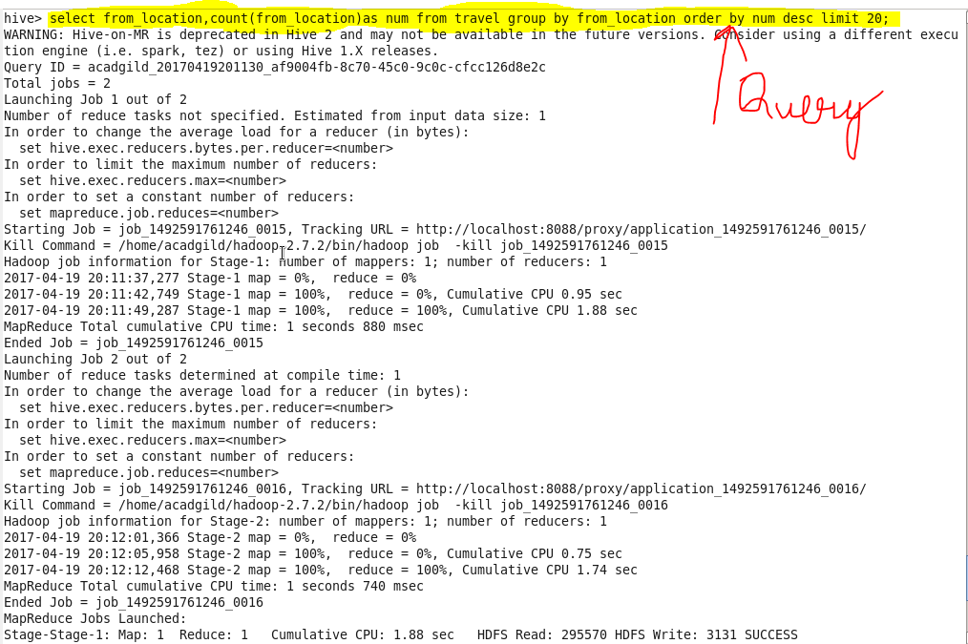

**Output:**

