**Run parallel jobs in hive by following the steps in the below blog link**

<https://acadgild.com/blog/hive-parallel-jobs/>

**Run parallel job in hive**

**Input file**

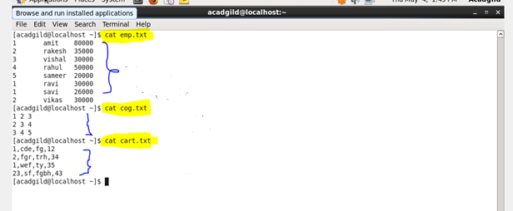

**Create and load the file emp**

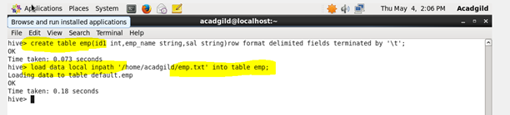

**Create and load the file cog**

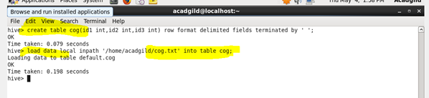

**Create and load the file cart**

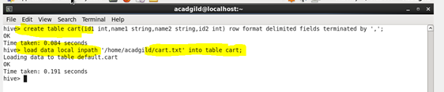

**Setting the parallel configuration in hive command line**

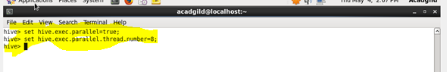

**Query**

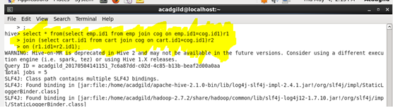

**Output**

