1. Explain the importance of Namenode in Hadoop cluster

An HDFS cluster has two types of nodes operating in a master-worker pattern, a ***Namenode*** (the master) and a number of datanodes (workers). The Namenode manages the filesystem namespace. It maintains the filesystem tree and the metadata for all the metadata for all the files and the directories in the tree. The information is stored persistently on the local disk in the form of two files: the namespace image and the edit log. The namenode also knows the datanodes on which all the blocks given for the file are located. However, it does not store block locations persistently, because this information is reconstructed from datanodes when the system starts.

1. Practice the beginners commands for HDFS from the below link:
2. **Put Command**

The **‘put’** command feeds the data in to the HDFS.

Syntax:**hadoop dfs –put </source path> </destination path>**

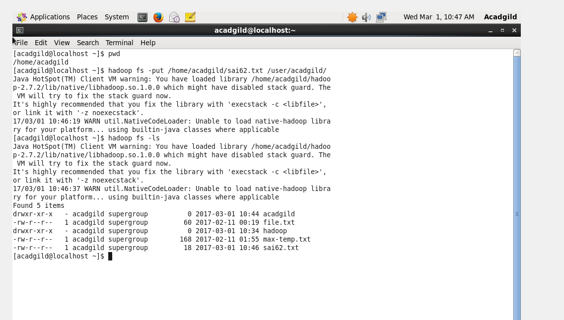

### ****List Command****

### The ‘list’ command displays all the available files inside a particular path.

### Syntax: ****hadoop dfs –ls </source path>****

### C:\Users\612932\Desktop\hadoop\assign3.4b.PNG

### ****Get Command****

### The ‘get’ command copies the entire contents of the mentioned file to the local drive.

### Syntax: ****hadoop dfs –get </source path> </destination path>****

### C:\Users\612932\Desktop\hadoop\assign3.4c.PNG

### ****Make Directory Command****

### The ‘mkdir’ command creates a new directory in the specified location.

### Syntax: ****hadoop dfs –mkdir </source path>****

### C:\Users\612932\Desktop\hadoop\assign3.4d.PNG

### ****View contents of particular file****

### The ‘cat’ command is used to display all the contents of a file.

### Syntax: ****hadoop dfs –cat </path[filename]>****

### C:\Users\612932\Desktop\hadoop\assign3.4e.PNG

### ****Duplicating a Complete File inside the HDFS.****

### The ‘copyfromlocal’ command will copy file from the local file system to the HDFS.

### Syntax: ****hadoop dfs –copyFromLocal </source path> </destination path>****

### C:\Users\612932\Desktop\hadoop\assign3.4f.PNG

### ****Duplicating a File from HDFS to the Local File System.****

### The ‘copytolocal’ command will copy files from the HDFS to the local file system.

### Syntax: ****hadoop dfs –copyToLocal </source path> </destination path>****

### C:\Users\612932\Desktop\hadoop\assign3.4g.PNG

### ****Removing the File****

### The command ‘rm’ will delete the file stored inside the HDFS.

### Syntax: ****hadoop dfs –rm </path[filename]>****

### C:\Users\612932\Desktop\hadoop\assign3.4h.PNG

### ****Run a DFS Filesystem to Check Utility****

### The command ‘fsck’ is used for checking the consistency of a file system

### Syntax: hadoop fsck </file path>

### C:\Users\612932\Desktop\hadoop\assign3.4ia.PNG

### C:\Users\612932\Desktop\hadoop\assign3.4ib.PNG

### ****Run a Cluster Balancing Utility****

### The command ‘balancer’ will check for work load on nodes in cluster and balance it.

### Syntax: ****hadoop balancer****

### C:\Users\612932\Desktop\hadoop\assign3.4j.PNG

### ****Check Directory Space in HDFS****

### The command will show the file size occupied by file inside cluster.

### Syntax: ****hadoop dfs -du -s -h </file path>****

### C:\Users\612932\Desktop\hadoop\assign3.4k.PNG

### List all the Hadoop File System Shell Commands

### The ‘fs’ command lists down all the shell commands of the Hadoop File System.

### Syntax: ****hadoop fs [options]****

### C:\Users\612932\Desktop\hadoop\assign3.4la.PNG

### C:\Users\612932\Desktop\hadoop\assign3.4lb.PNG

### ****Asking for Help****

### The ‘help’ command is for asking for help or querying a particular question.

### Command: ****hadoop fs –help****

### ****C:\Users\612932\Desktop\hadoop\assign3.4m.PNG****