Can you overload a method with the same return type? Explain your answer with proper logic.

Yes, we can overload a method with the same return type.

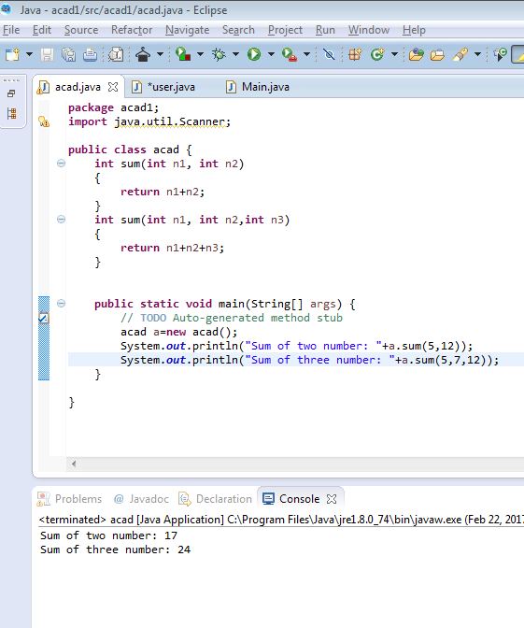

In the above example, the two method sum() has same data type as int but the method sum() can be overloaded based on the number of arguments –We have two definition of method sum(), one with two arguments and another with three arguments.

Write a program in Java using Arrays that sorts the element in a descending order.

import java.util.Arrays;

import java.util.Scanner;

public class acad{

public static void main(String[] args){

Scanner s=new Scanner(System.in);

int a[]={1,5,4,7,6,8};

Arrays.sort(a);

for(int i=a.length-1;i>=0;i--){

System.out.println(a[i]);}}}

