Explain in brief with their uses.

● Oozie Action and Decision Nodes

● Oozie Workflow Nodes

● Fork and Join

● Oozie Web Console

**Action nodes:**

An**action node** represents a workflow task, e.g., moving files into HDFS, running a MapReduce, Pig or[Hive](http://www.guru99.com/hive-tutorials.html)jobs, importing data using Sqoop or running a shell script of a program written in Java.

**Decision Nodes:**

We can add decision tags to check if we want to run an action based on the output of decision. If we already have the hive table we won’t need to create it again. In such a scenario, we can add a decision tag to not run the Create Table steps if the table already exists.

Decision nodes have a switch tag similar to switch case. If the EL translates to success, then that switch case is executed.

This node also has a default tag. In case switch tag is not executed, the control moves to action mentioned in the default tag.

**Workflow Nodes**:

Oozie workflow consists of **action nodes** and **control-flow nodes**.

An**action node** represents a workflow task, e.g., moving files into HDFS, running a MapReduce, Pig or[Hive](http://www.guru99.com/hive-tutorials.html)jobs, importing data using Sqoop or running a shell script of a program written in Java.

A**control-flow node** controls the workflow execution between actions by allowing constructs like conditional logic wherein different branches may be followed depending on the result of earlier action node.

**Start Node**, **End Node** and **Error Node** fall under this category of nodes.

**Start Node,** designates start of the workflow job.

**End Node,** signals end of the job.

**Error Node,** designates an occurrence of error and corresponding error message to be printed.

**Fork and Join:**

In scenarios where we want to run multiple jobs parallel to each other, we can use Fork. When fork is used we have to use Join as an end node to fork. Basically Fork and Join work together. For each fork there should be a join. As Join assumes all the node are a child of a single fork.

We also use fork and join for running multiple independent jobs for proper utilization of cluster.

**Oozie Web Console:**

Oozie web console is a web-based tool that gives a read-only view about the jobs.

In your web browser, open the URL http://127.0.0.1:11000/oozie, as shown in the following screenshot:

Oozie web console

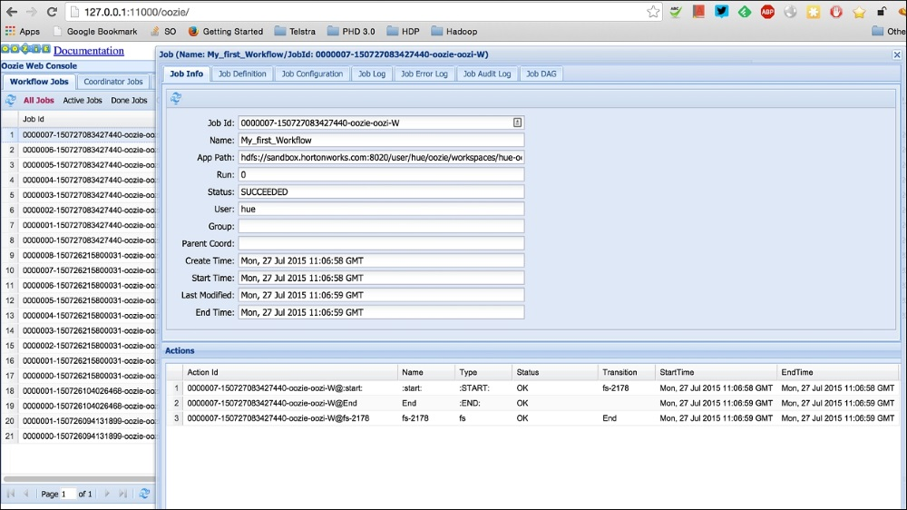

Click on our job ID My First Oozie Job; you can see we have many other jobs also run. You will have a different view. Click on your job and see that Oozie has divided the jobs as per tasks in the Workflow. Start the Fs action and end were the steps for the Workflow, so each of them is represented in the log.

Click on the last tab that says **Job DAG**. This shows the flow of the job. Since our job was simple, DAG is just a linear flow. In future jobs, we will see more complex DAG.

The important use of the console is when our job fails. Let's see an example of a job that has not completed successfully. We can click on the required action to see the logs and detailed error messages as shown in the following screenshot:

