**Explain and perform Sqoop Incremental Import operation to load data from Mysql To HDFS using Sqoop**

We start by creating a database in mysql and the table employee inside it.

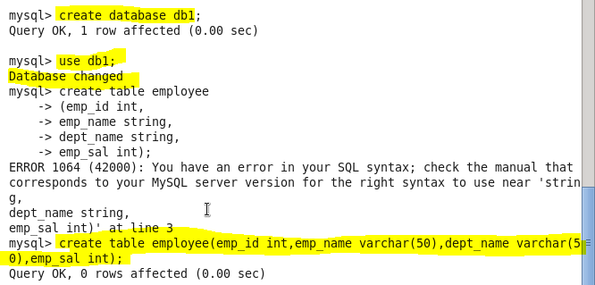

**Inserting data in the MySql table:**

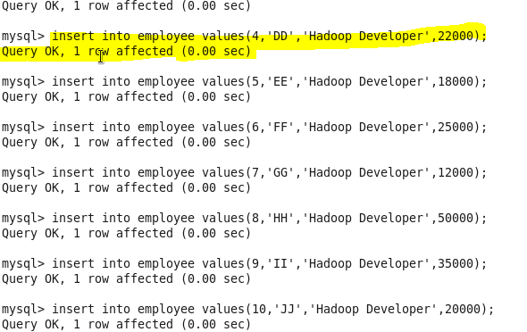

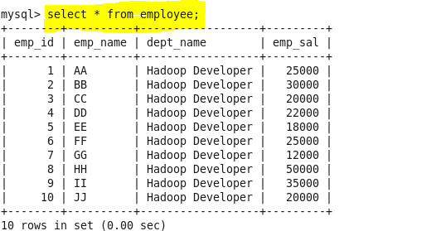

**Import the employee table contents into the HDFS directory using Sqoop**.

Sqoop tool ‘import’ is used to import table data from the table to the Hadoop file system as a text file or a binary file.

We first create our own directory in hdfs to store the data named sqoopoutput:

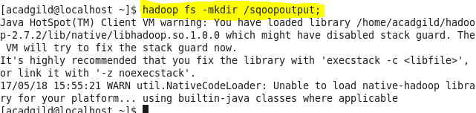

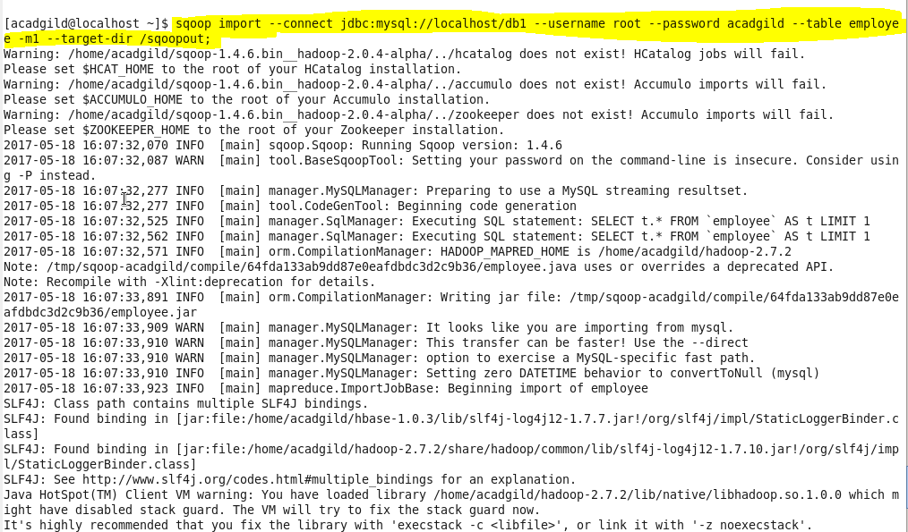

**COMMAND EXPLANATION**

--connect:It is used to give the JDBC Url of database

--Username:user name of database

--password:password of database

--table : give the table you want to copy from MySql

--target-dir: directory used by Sqoop Under which the data will be stored in Hdfs

The below screenshot shows the successful import of data:

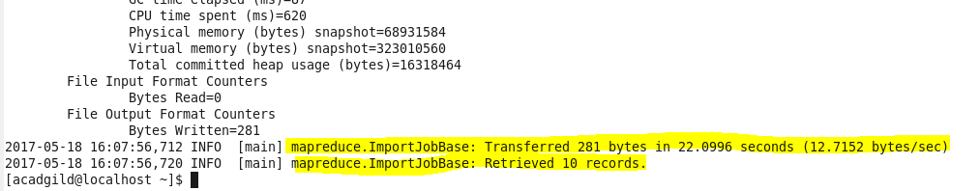

Here is the output directory where the data is stored on HDFS

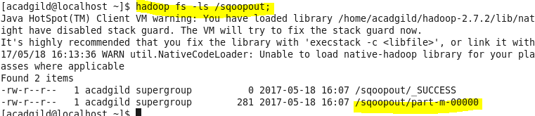

**Output:**

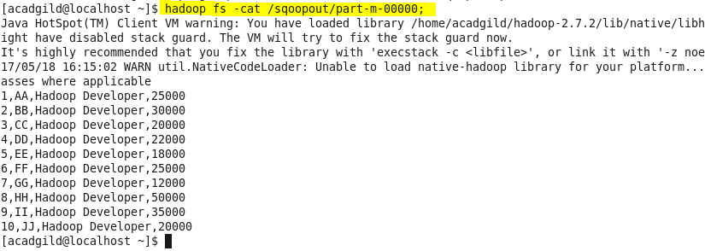

We now append more data to the table employee for incremental import:

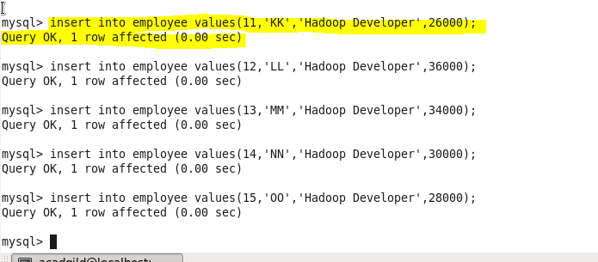

Here we should use an --incremental append with --check-column which specifies the column to be examined when determining which rows to import.

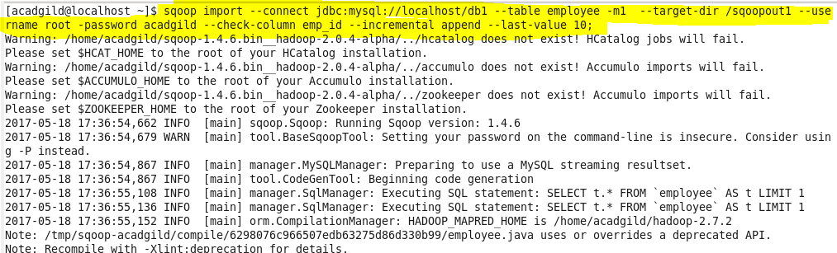

This shows that the incremental import is completed

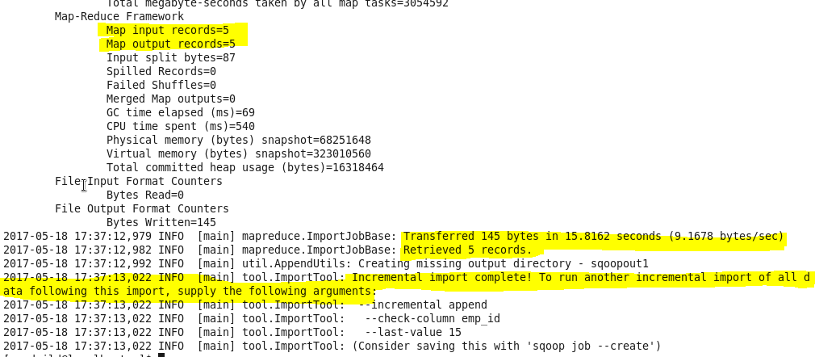

**Updated output:**

