Write a MapReduce program to filter out the invalid records. The output of this program will act as input for subsequent tasks. Map only job will fit for this context.

import org.apache.hadoop.fs.Path;  
import org.apache.hadoop.conf.*;  
import org.apache.hadoop.mapreduce.Job;  
import org.apache.hadoop.mapreduce.lib.input.TextInputFormat;  
import org.apache.hadoop.mapreduce.lib.input.FileInputFormat;  
import org.apache.hadoop.mapreduce.lib.output.TextOutputFormat;  
import org.apache.hadoop.mapreduce.lib.output.FileOutputFormat;  
import org.apache.hadoop.io.IntWritable;  
import org.apache.hadoop.io.NullWritable;  
import org.apache.hadoop.io.Text;  
public class TvDriver{  
    @SuppressWarnings("deprecation")  
    public static void main(String[] args)throws Exception  
    {  
  
        Configuration conf=new Configuration();  
        Job job=new Job(conf,"Tv sales");  
        job.setJarByClass(TvDriver.class);  
        FileInputFormat.addInputPath(job, new Path(args[0]));  
        Path outputPath =new Path(args[1]);  
        FileOutputFormat.setOutputPath(job, outputPath);  
        outputPath.getFileSystem(conf).delete(outputPath, true);  
        job.setMapperClass(TvMapper.class);  
        job.setNumReduceTasks(0);  
        job.setInputFormatClass(TextInputFormat.class);  
        job.setOutputFormatClass(TextOutputFormat.class);  
        job.setOutputKeyClass(NullWritable.class);  
        job.setOutputValueClass(Text.class);  
        job.waitForCompletion(true);  
        }  
  
  
  
}

import java.io.IOException;  
import java.util.StringTokenizer;  
  
import org.apache.hadoop.io.IntWritable;  
import org.apache.hadoop.io.LongWritable;  
import org.apache.hadoop.io.NullWritable;  
import org.apache.hadoop.io.Text;  
import org.apache.hadoop.mapreduce.*;  
  
public class TvMapper extends Mapper<LongWritable, Text, NullWritable, Text>{  
    public void map(LongWritable key, Text value, Context context)  
    throws IOException, InterruptedException{  
        String[] lineArray =value.toString().split("\\|");  
        if((lineArray.length  
>1)&&(!lineArray[0].equalsIgnoreCase("NA"))&&(!lineArray[1].equalsIgnoreCase("NA")))  
        {  
            context.write(NullWritable.get(), value);  
        }  
  
    }  
**Driver**:  
}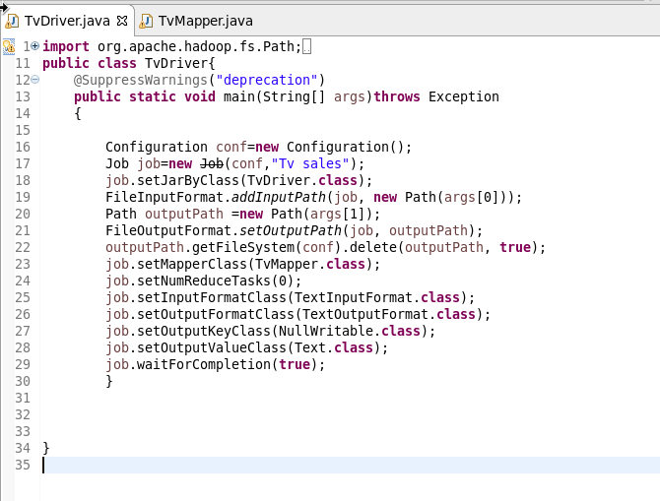

**Mapper**:

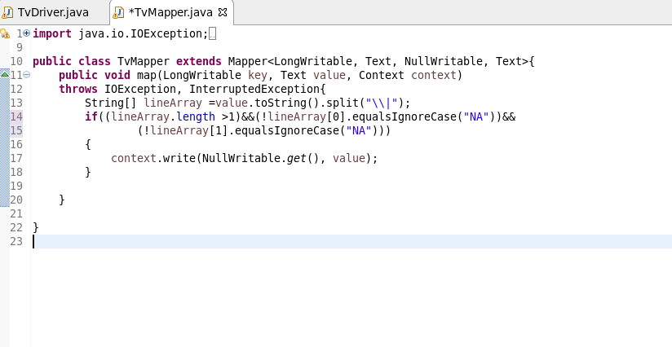

**Output:** 