Find the number of ratings given by each user.

import org.apache.hadoop.fs.Path;  
import org.apache.hadoop.conf.\*;  
import org.apache.hadoop.mapreduce.Job;  
import org.apache.hadoop.mapreduce.lib.input.TextInputFormat;  
import org.apache.hadoop.mapreduce.lib.input.FileInputFormat;  
import org.apache.hadoop.mapreduce.lib.output.TextOutputFormat;  
import org.apache.hadoop.mapreduce.lib.output.FileOutputFormat;  
import org.apache.hadoop.io.IntWritable;  
import org.apache.hadoop.io.NullWritable;  
import org.apache.hadoop.io.Text;  
public class MovieDriver{  
    @SuppressWarnings("deprecation")  
    public static void main(String[] args)throws Exception  
    {  
        Configuration conf=new Configuration();  
        Job job=new Job(conf,"Tv sales");  
        job.setJarByClass(MovieDriver.class);  
        FileInputFormat.addInputPath(job, new Path(args[0]));  
        Path outputPath =new Path(args[1]);  
        FileOutputFormat.setOutputPath(job, outputPath);  
        outputPath.getFileSystem(conf).delete(outputPath, true);  
        job.setMapperClass(MovieMapper.class);  
        job.setReducerClass(MovieReducer.class);  
        job.setInputFormatClass(TextInputFormat.class);  
        job.setOutputFormatClass(TextOutputFormat.class);  
        job.setMapOutputKeyClass(Text.class);  
        job.setMapOutputValueClass(IntWritable.class);  
        job.setOutputKeyClass(Text.class);  
        job.setOutputValueClass(IntWritable.class);  
        job.waitForCompletion(true);  
  
    }  
}  
    import java.io.IOException;  
  
  
import org.apache.hadoop.io.IntWritable;  
import org.apache.hadoop.io.LongWritable;  
import org.apache.hadoop.io.Text;  
import org.apache.hadoop.mapreduce.\*;  
  
public class MovieMapper extends Mapper<LongWritable, Text,Text,IntWritable>{  
    Text outkey=new Text();  
    IntWritable outvalue=new IntWritable();  
    public void map(LongWritable key, Text value, Context context)  
    throws IOException, InterruptedException{  
        String[] lineArray = value.toString().split("    ");  
        if(lineArray.length >1)  
        {  
            outkey.set(lineArray[0]);  
            outvalue.set(Integer.parseInt(lineArray[2]));  
            context.write(outkey,outvalue);  
        }  
  
    }  
  
}  
import java.io.IOException;  
import java.util.StringTokenizer;  
  
import org.apache.hadoop.io.IntWritable;  
import org.apache.hadoop.io.LongWritable;  
import org.apache.hadoop.io.NullWritable;  
import org.apache.hadoop.io.Text;  
import org.apache.hadoop.mapreduce.\*;  
import org.apache.hadoop.mapreduce.Mapper.Context;  
public class MovieReducer extends Reducer<Text,IntWritable,Text,IntWritable>{  
    public void reduce(Text key, Iterable<IntWritable>values, Context context)  
            throws IOException, InterruptedException{  
  
        for(IntWritable value: values)  
        {  
            context.write(key,value);  
        }  
  
    }  
  
}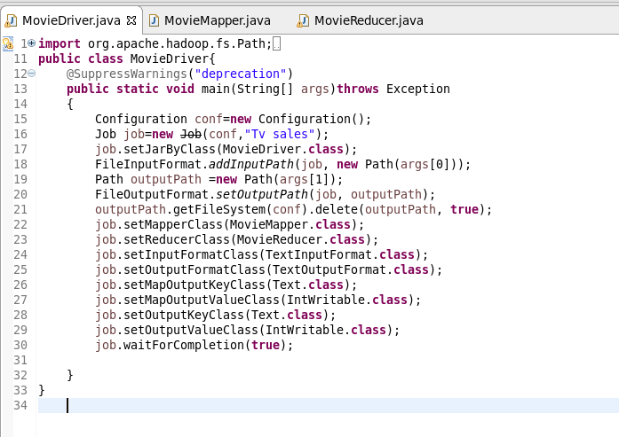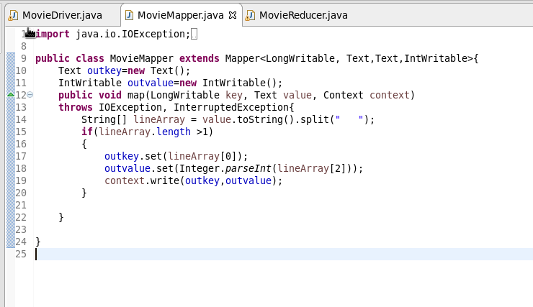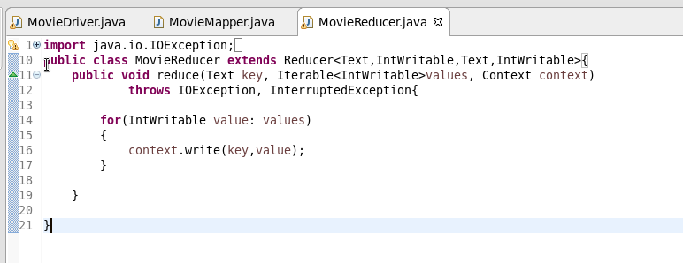

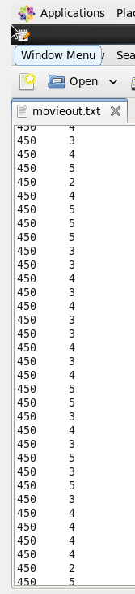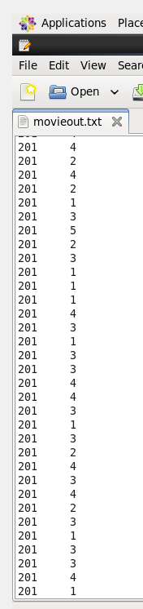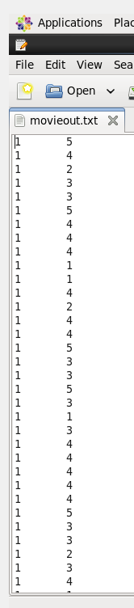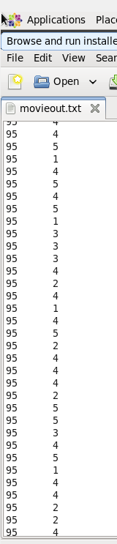

Find the number of ratings received by each movie.

import org.apache.hadoop.fs.Path;  
import org.apache.hadoop.conf.\*;  
import org.apache.hadoop.mapreduce.Job;  
import org.apache.hadoop.mapreduce.lib.input.TextInputFormat;  
import org.apache.hadoop.mapreduce.lib.input.FileInputFormat;  
import org.apache.hadoop.mapreduce.lib.output.TextOutputFormat;  
import org.apache.hadoop.mapreduce.lib.output.FileOutputFormat;  
import org.apache.hadoop.io.IntWritable;  
import org.apache.hadoop.io.NullWritable;  
import org.apache.hadoop.io.Text;  
public class MovieDriver{  
    @SuppressWarnings("deprecation")  
    public static void main(String[] args)throws Exception  
    {  
        Configuration conf=new Configuration();  
        Job job=new Job(conf,"Tv sales");  
        job.setJarByClass(MovieDriver.class);  
        FileInputFormat.addInputPath(job, new Path(args[0]));  
        Path outputPath =new Path(args[1]);  
        FileOutputFormat.setOutputPath(job, outputPath);  
        outputPath.getFileSystem(conf).delete(outputPath, true);  
        job.setMapperClass(MovieMapper.class);  
        job.setReducerClass(MovieReducer.class);  
        job.setInputFormatClass(TextInputFormat.class);  
        job.setOutputFormatClass(TextOutputFormat.class);  
        job.setMapOutputKeyClass(Text.class);  
        job.setMapOutputValueClass(IntWritable.class);  
        job.setOutputKeyClass(Text.class);  
        job.setOutputValueClass(IntWritable.class);  
        job.waitForCompletion(true);  
  
    }  
}  
    import java.io.IOException;  
  
  
import org.apache.hadoop.io.IntWritable;  
import org.apache.hadoop.io.LongWritable;  
import org.apache.hadoop.io.Text;  
import org.apache.hadoop.mapreduce.\*;  
  
public class MovieMapper extends Mapper<LongWritable, Text,Text,IntWritable>{  
    Text outkey=new Text();  
    IntWritable outvalue=new IntWritable();  
    public void map(LongWritable key, Text value, Context context)  
    throws IOException, InterruptedException{  
        String[] lineArray = value.toString().split("    ");  
        if(lineArray.length >1)  
        {  
            outkey.set(lineArray[1]);  
            outvalue.set(Integer.parseInt(lineArray[2]));  
            context.write(outkey,outvalue);  
        }  
  
    }  
  
}import java.io.IOException;  
import java.util.StringTokenizer;  
  
import org.apache.hadoop.io.IntWritable;  
import org.apache.hadoop.io.LongWritable;  
import org.apache.hadoop.io.NullWritable;  
import org.apache.hadoop.io.Text;  
import org.apache.hadoop.mapreduce.\*;  
import org.apache.hadoop.mapreduce.Mapper.Context;  
public class MovieReducer extends Reducer<Text,IntWritable,Text,IntWritable>{  
    public void reduce(Text key, Iterable<IntWritable>values, Context context)  
            throws IOException, InterruptedException{  
  
        for(IntWritable value: values)  
        {  
            context.write(key,value);  
        }  
  
    }  
  
}

