Use key value output format to save the output of Session 6 – Assignment 1(Travel Data analysis) and save the output as comma (,) separated instead of tab(\t) separated.

1. Find out how many people has chosen their destination as MIA and MCO

import org.apache.hadoop.fs.Path;  
import org.apache.hadoop.conf.*;  
import org.apache.hadoop.mapreduce.Job;  
import org.apache.hadoop.mapreduce.lib.input.TextInputFormat;  
import org.apache.hadoop.mapreduce.lib.input.FileInputFormat;  
import org.apache.hadoop.mapreduce.lib.output.TextOutputFormat;  
import org.apache.hadoop.mapreduce.lib.output.FileOutputFormat;  
import org.apache.hadoop.io.IntWritable;  
import org.apache.hadoop.io.NullWritable;  
import org.apache.hadoop.io.Text;  
public class TravelDriver{  
    @SuppressWarnings("deprecation")  
    public static void main(String[] args)throws Exception  
    {  
        Configuration conf=new Configuration();  
        conf.set("mapred.textoutputformat.separator",",");  
        Job job=new Job(conf,"Tv sales");  
        job.setJarByClass(TravelDriver.class);  
        FileInputFormat.addInputPath(job, new Path(args[0]));  
        Path outputPath =new Path(args[1]);  
        FileOutputFormat.setOutputPath(job, outputPath);  
        outputPath.getFileSystem(conf).delete(outputPath, true);  
        job.setMapperClass(TravelMapper.class);  
        job.setReducerClass(TravelReducer.class);  
        job.setInputFormatClass(TextInputFormat.class);  
        job.setOutputFormatClass(TextOutputFormat.class);  
        job.setMapOutputKeyClass(Text.class);  
        job.setMapOutputValueClass(IntWritable.class);  
        job.setOutputKeyClass(Text.class);  
        job.setOutputValueClass(IntWritable.class);  
        job.waitForCompletion(true);  
  
    }  
}import java.io.IOException;  
  
  
import org.apache.hadoop.io.IntWritable;  
import org.apache.hadoop.io.LongWritable;  
import org.apache.hadoop.io.NullWritable;  
import org.apache.hadoop.io.Text;  
import org.apache.hadoop.mapreduce.*;  
  
public class TravelMapper extends Mapper<LongWritable,Text,Text,IntWritable>{  
    Text outkey=new Text();  
    IntWritable outvalue=new IntWritable();  
    public void map(LongWritable key, Text value, Context context)  
    throws IOException, InterruptedException{  
        String[] lineArray = value.toString().split("    ");  
        if((lineArray.length >  
1)&&(lineArray[2].equalsIgnoreCase("MIA")||(lineArray[2].equalsIgnoreCase("MCO"))))  
        {  
            outkey.set(lineArray[2]);  
            outvalue.set(1);  
            context.write(outkey,outvalue);  
        }  
  
    }  
  
}import java.io.IOException;  
import java.util.StringTokenizer;  
  
import org.apache.hadoop.io.IntWritable;  
import org.apache.hadoop.io.LongWritable;  
import org.apache.hadoop.io.NullWritable;  
import org.apache.hadoop.io.Text;  
import org.apache.hadoop.mapreduce.*;  
import org.apache.hadoop.mapreduce.Mapper.Context;  
public class TravelReducer extends Reducer<Text,IntWritable,Text,IntWritable>{  
    public void reduce(Text key, Iterable<IntWritable>values, Context context)  
            throws IOException, InterruptedException{  
        int sum=0;  
        for(IntWritable value: values)  
        {  
            sum=sum+value.get();  
        }  
        context.write(key, new IntWritable(sum));  
    }  
  
}

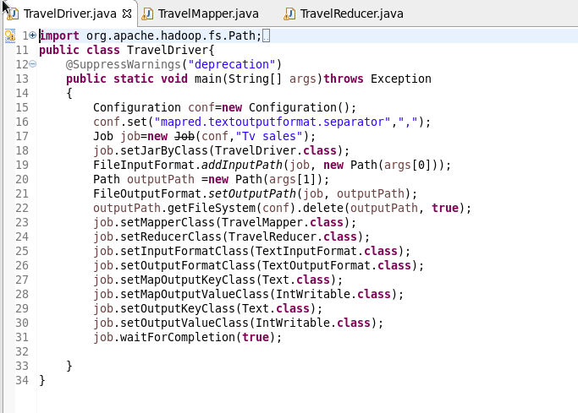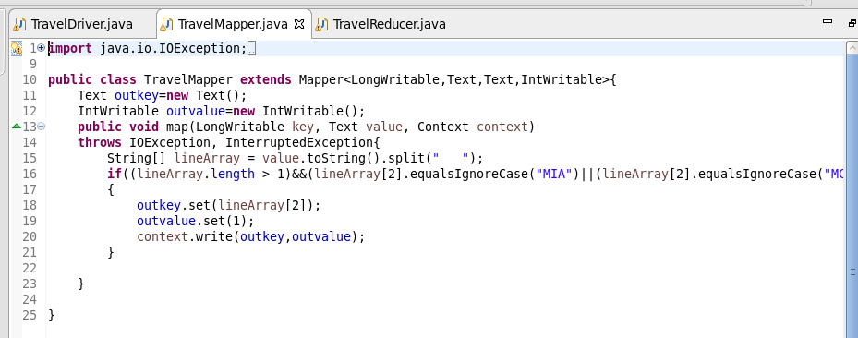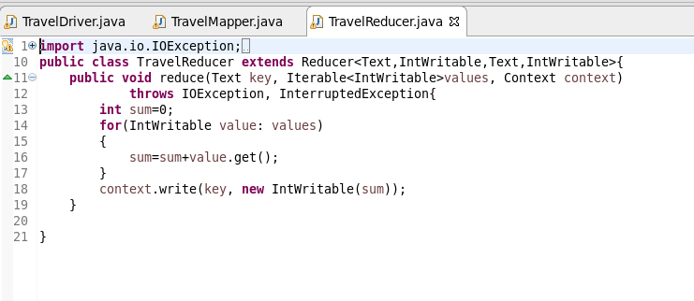

**Output:**

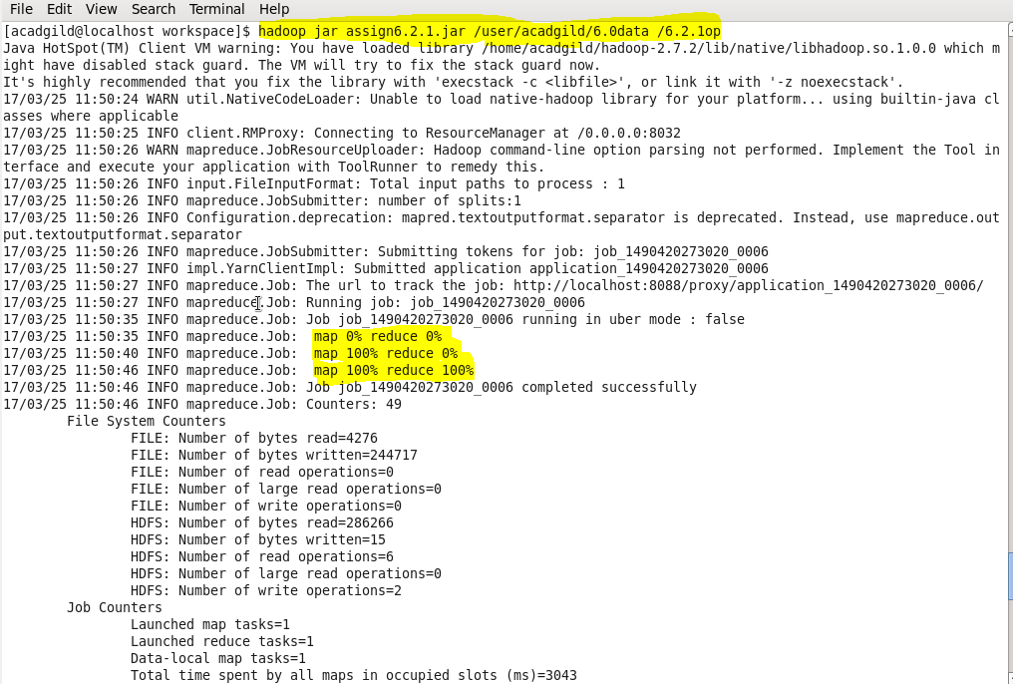

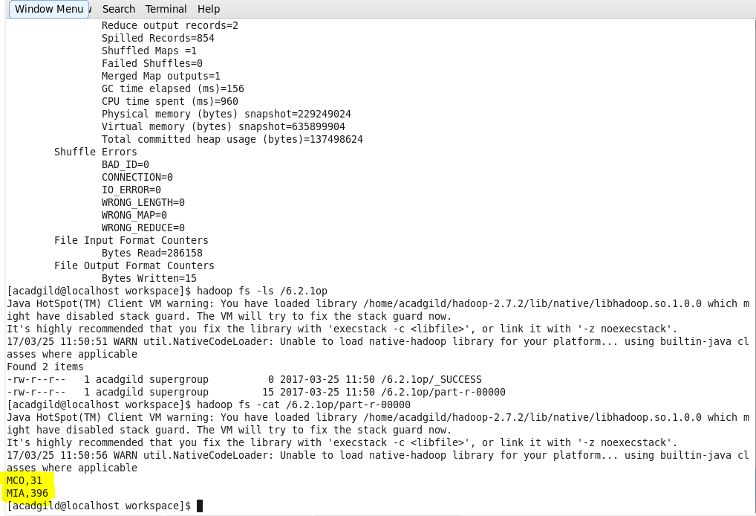

1. **Find out the number of people undertaken the trips from the places MIA and HOU**

import org.apache.hadoop.fs.Path;  
import org.apache.hadoop.conf.*;  
import org.apache.hadoop.mapreduce.Job;  
import org.apache.hadoop.mapreduce.lib.input.TextInputFormat;  
import org.apache.hadoop.mapreduce.lib.input.FileInputFormat;  
import org.apache.hadoop.mapreduce.lib.output.TextOutputFormat;  
import org.apache.hadoop.mapreduce.lib.output.FileOutputFormat;  
import org.apache.hadoop.io.IntWritable;  
import org.apache.hadoop.io.NullWritable;  
import org.apache.hadoop.io.Text;  
public class TravelDriver{  
    @SuppressWarnings("deprecation")  
    public static void main(String[] args)throws Exception  
    {  
        Configuration conf=new Configuration();  
        conf.set("mapred.textoutputformat.separator",",");  
        Job job=new Job(conf,"Tv sales");  
        job.setJarByClass(TravelDriver.class);  
        FileInputFormat.addInputPath(job, new Path(args[0]));  
        Path outputPath =new Path(args[1]);  
        FileOutputFormat.setOutputPath(job, outputPath);  
        outputPath.getFileSystem(conf).delete(outputPath, true);  
        job.setMapperClass(TravelMapper.class);  
        job.setReducerClass(TravelReducer.class);  
        job.setInputFormatClass(TextInputFormat.class);  
        job.setOutputFormatClass(TextOutputFormat.class);  
        job.setMapOutputKeyClass(Text.class);  
        job.setMapOutputValueClass(IntWritable.class);  
        job.setOutputKeyClass(Text.class);  
        job.setOutputValueClass(IntWritable.class);  
        job.waitForCompletion(true);  
  
    }  
}import java.io.IOException;  
  
  
import org.apache.hadoop.io.IntWritable;  
import org.apache.hadoop.io.LongWritable;  
import org.apache.hadoop.io.NullWritable;  
import org.apache.hadoop.io.Text;  
import org.apache.hadoop.mapreduce.*;  
  
public class TravelMapper extends Mapper<LongWritable,Text,Text,IntWritable>{  
    Text outkey=new Text();  
    IntWritable outvalue=new IntWritable();  
    public void map(LongWritable key, Text value, Context context)  
    throws IOException, InterruptedException{  
        String[] lineArray = value.toString().split("    ");  
        if((lineArray.length >  
1)&&(lineArray[1].equalsIgnoreCase("MIA")||(lineArray[1].equalsIgnoreCase("HOU"))))  
        {  
  
            outvalue.set(1);  
            outkey.set(lineArray[1]);  
            context.write(outkey,outvalue);  
        }  
    }  
}import java.io.IOException;  
import java.util.StringTokenizer;  
  
import org.apache.hadoop.io.IntWritable;  
import org.apache.hadoop.io.LongWritable;  
import org.apache.hadoop.io.NullWritable;  
import org.apache.hadoop.io.Text;  
import org.apache.hadoop.mapreduce.*;  
import org.apache.hadoop.mapreduce.Mapper.Context;  
public class TravelReducer extends  
Reducer<Text,IntWritable,Text,IntWritable>{  
    public void reduce(Text key, Iterable<IntWritable>values,  
Context context)  
            throws IOException, InterruptedException{  
        int sum=0;  
        for(IntWritable value: values)  
        {  
            sum=sum+value.get();  
        }  
        context.write(key, new IntWritable(sum));  
    }  
  
}

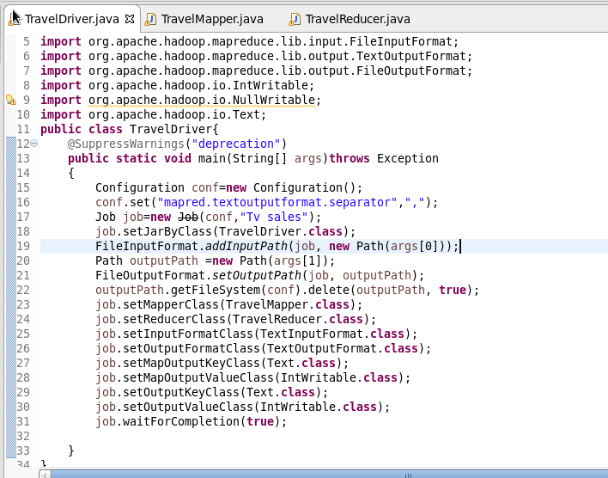

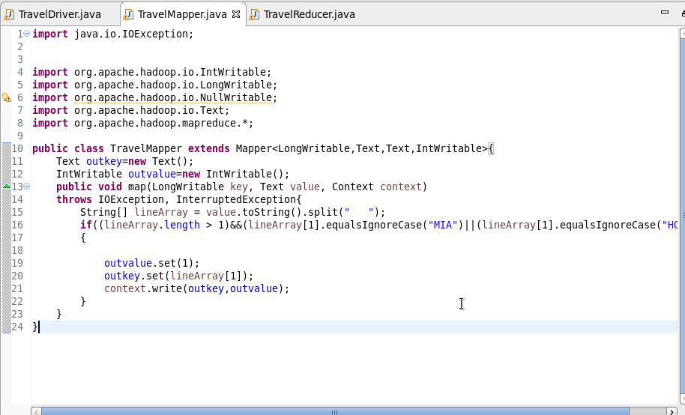

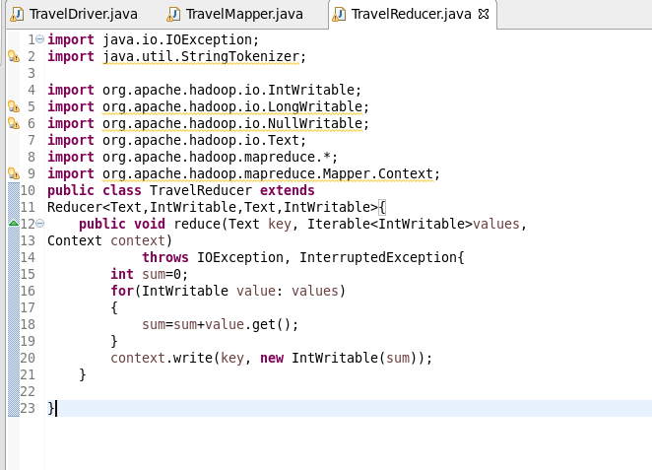

**Output:**

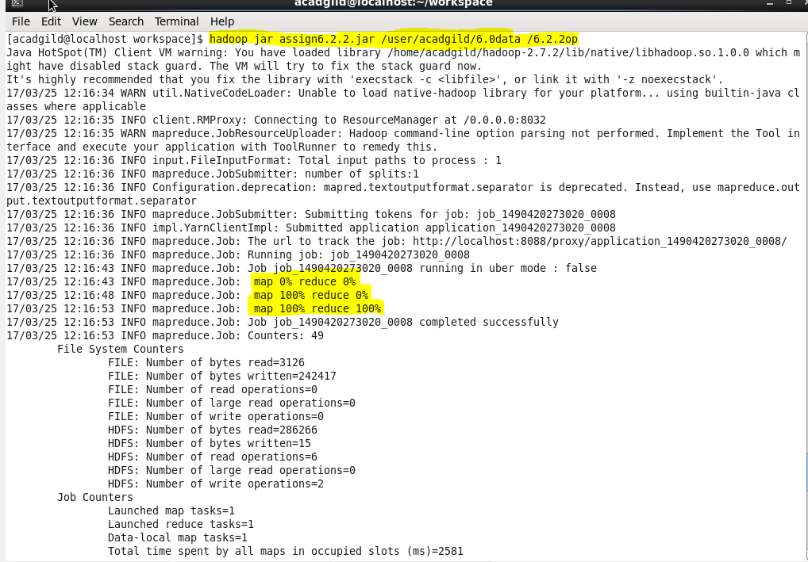

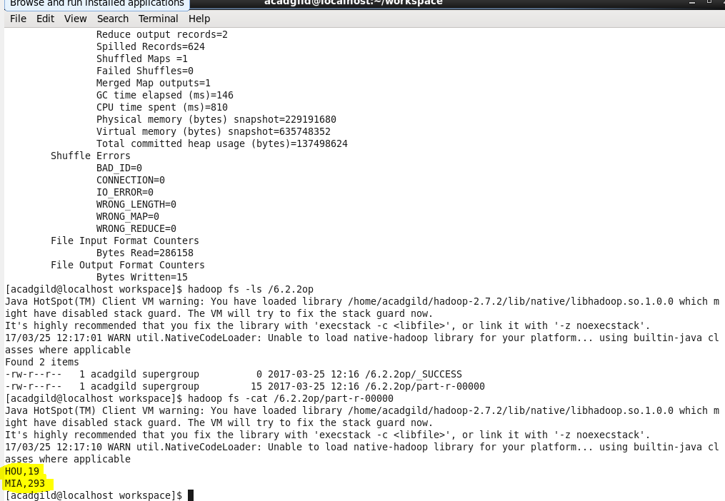

1. Find out how many people has chosen airline mode of travel for the places LAS and LAX

import org.apache.hadoop.fs.Path;  
import org.apache.hadoop.conf.*;  
import org.apache.hadoop.mapreduce.Job;  
import org.apache.hadoop.mapreduce.lib.input.TextInputFormat;  
import org.apache.hadoop.mapreduce.lib.input.FileInputFormat;  
import org.apache.hadoop.mapreduce.lib.output.TextOutputFormat;  
import org.apache.hadoop.mapreduce.lib.output.FileOutputFormat;  
import org.apache.hadoop.io.IntWritable;  
import org.apache.hadoop.io.NullWritable;  
import org.apache.hadoop.io.Text;  
public class TravelDriver{  
    @SuppressWarnings("deprecation")  
    public static void main(String[] args)throws Exception  
    {  
        Configuration conf=new Configuration();  
        conf.set("mapred.textoutputformat.separator",",");  
        Job job=new Job(conf,"Tv sales");  
        job.setJarByClass(TravelDriver.class);  
        FileInputFormat.addInputPath(job, new Path(args[0]));  
        Path outputPath =new Path(args[1]);  
        FileOutputFormat.setOutputPath(job, outputPath);  
        outputPath.getFileSystem(conf).delete(outputPath, true);  
        job.setMapperClass(TravelMapper.class);  
        job.setReducerClass(TravelReducer.class);  
        job.setInputFormatClass(TextInputFormat.class);  
        job.setOutputFormatClass(TextOutputFormat.class);  
        job.setMapOutputKeyClass(Text.class);  
        job.setMapOutputValueClass(IntWritable.class);  
        job.setOutputKeyClass(Text.class);  
        job.setOutputValueClass(IntWritable.class);  
        job.waitForCompletion(true);  
  
    }  
}import java.io.IOException;  
  
  
import org.apache.hadoop.io.IntWritable;  
import org.apache.hadoop.io.LongWritable;  
import org.apache.hadoop.io.NullWritable;  
import org.apache.hadoop.io.Text;  
import org.apache.hadoop.mapreduce.*;  
  
public class TravelMapper extends Mapper<LongWritable,Text,Text,IntWritable>{  
    Text outkey=new Text();  
    IntWritable outvalue=new IntWritable();  
    public void map(LongWritable key, Text value, Context context)  
    throws IOException, InterruptedException{  
        String[] lineArray = value.toString().split("    ");  
  
        if(lineArray.length > 1)  
                {  
            if((lineArray[2].equalsIgnoreCase("LAS"))||(lineArray[2].equalsIgnoreCase("LAX")))  
                    {  
  
  
                    if(Integer.parseInt(lineArray[3])==1)  
        {  
            outvalue.set(1);  
            outkey.set(lineArray[2]);  
            context.write(outkey,outvalue);  
        }  
                    }  
                }  
  
    }  
}import java.io.IOException;  
import java.util.StringTokenizer;  
  
import org.apache.hadoop.io.IntWritable;  
import org.apache.hadoop.io.LongWritable;  
import org.apache.hadoop.io.NullWritable;  
import org.apache.hadoop.io.Text;  
import org.apache.hadoop.mapreduce.*;  
import org.apache.hadoop.mapreduce.Mapper.Context;  
public class TravelReducer extends Reducer<Text,IntWritable,Text,IntWritable>{  
    public void reduce(Text key, Iterable<IntWritable>values, Context context)  
            throws IOException, InterruptedException{  
        int sum=0;  
        for(IntWritable value: values)  
        {  
            sum=sum+value.get();  
        }      context.write(key, new IntWritable(sum));  
    }}}

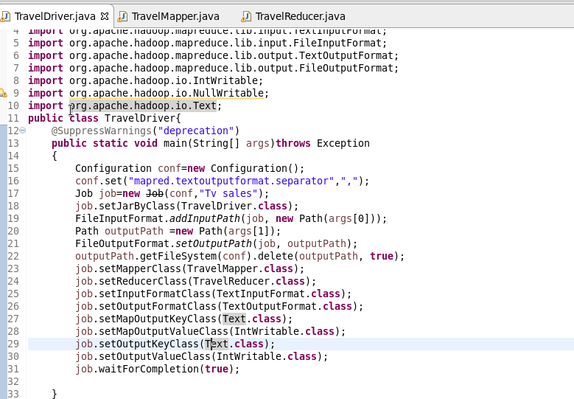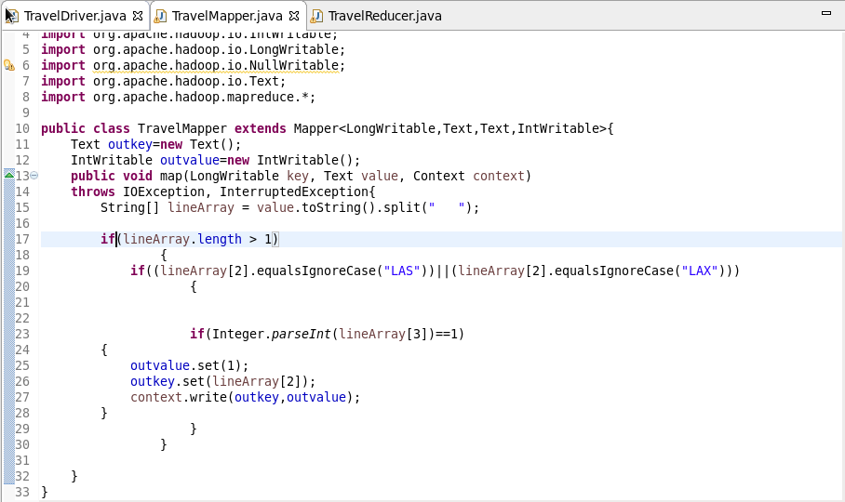

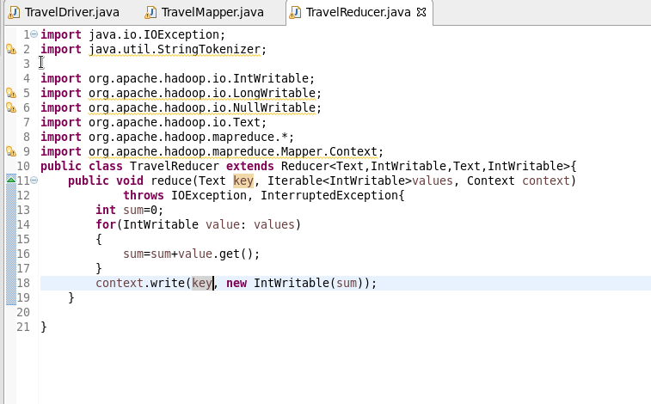

**Output:**

