Explain the working of below pig script commands with an example:

1. LOAD 2. STORE 3. DUMP 4. FOREACH 5. FILTER 6. GROUP BY 7. ORDER BY 8. DESCRIBE

LOAD:

We can load data into Pig from the file system (HDFS/ Local) using ***LOAD*** operator of Pig Latin.

**Syntax:**

***Relation_name = LOAD ‘Input file Path’ USING function as schema;***

The load statement consists of two parts divided by the “=” operator. On the left-hand side, we need to mention the name of the relation where we want to store the data, and on the right-hand side, we have to define how we store the data. Given below is the syntax of the Load operator.

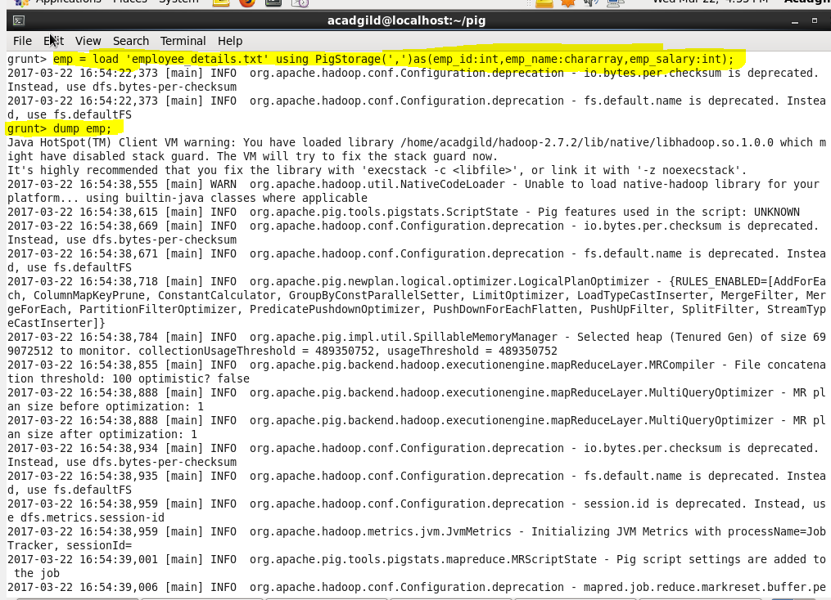

STORE:

We can store the loaded data in the file system using the ***store*** operator.

**Syntax:**

***STORE Relation_name INTO ‘required_directory_path’ [USING Function];***

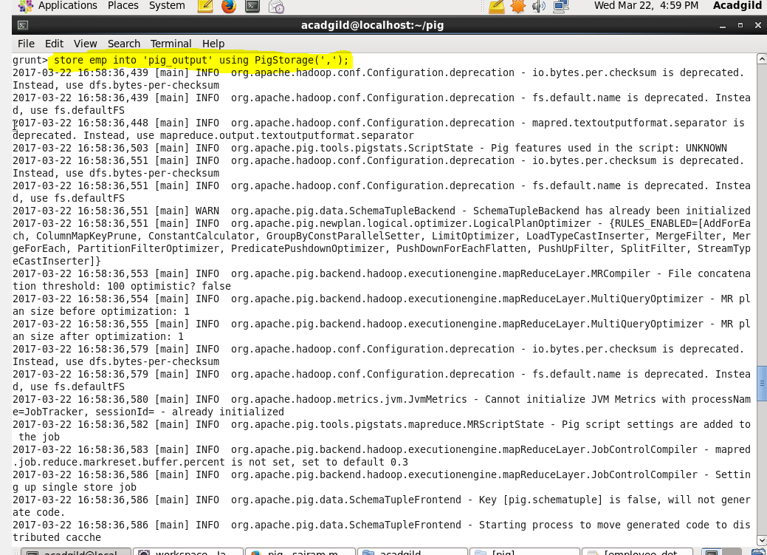

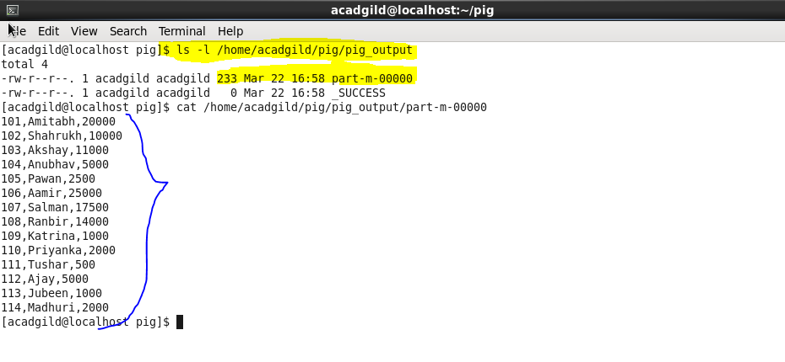

DUMP:

The ***Dump*** operator is used to run the Pig Latin statements and display the results on the screen.

**Syntax:**

***DUMP Relation_name;***



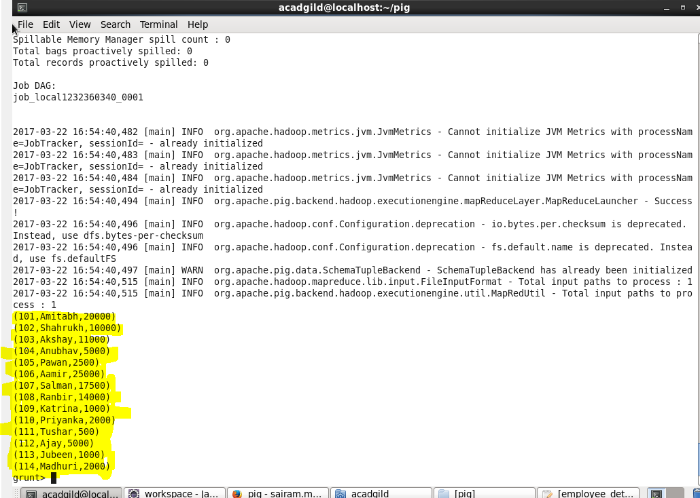

FOREACH:

The ***FOREACH*** operator is used to generate specified data transformations based on the column data.

**Syntax:**

***Relation_name2 = FOREACH Relation_name1 GENERATE (required data);***

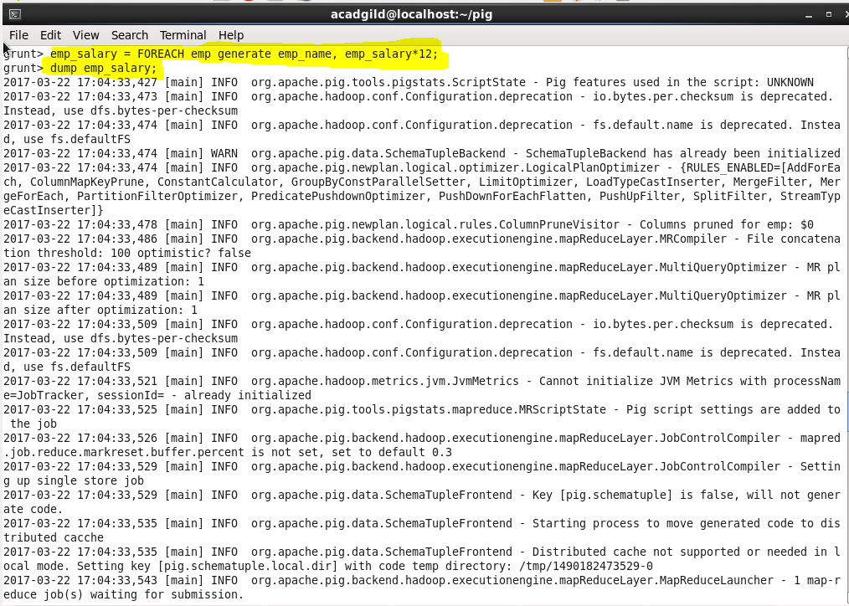

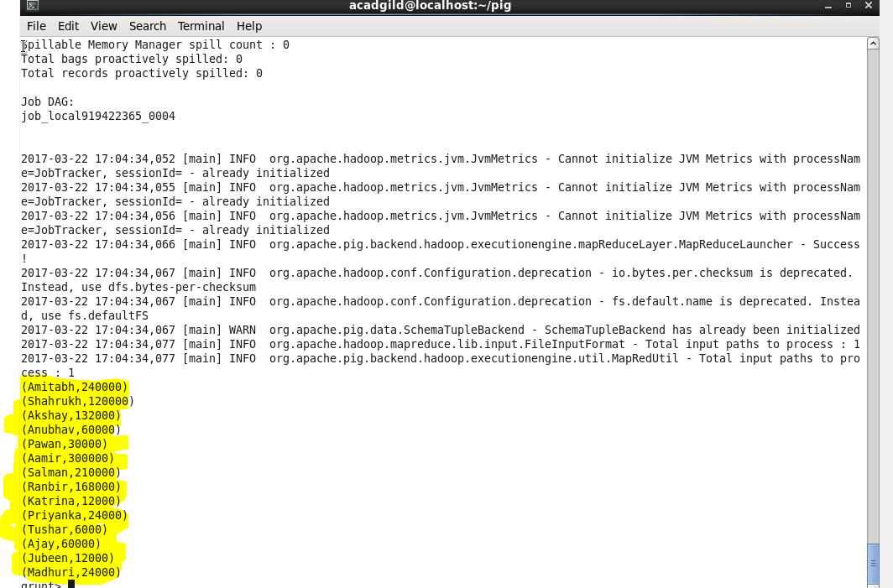

FILTER:

The ***FILTER*** operator is used to select the required tuples from a relation based on a condition.

**Syntax:**

***Relation_name2 = FILTER Relation_name1 BY (condition);***

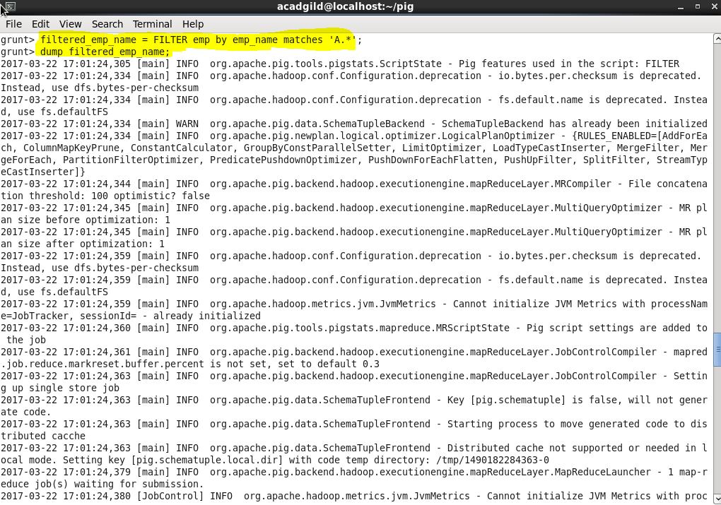

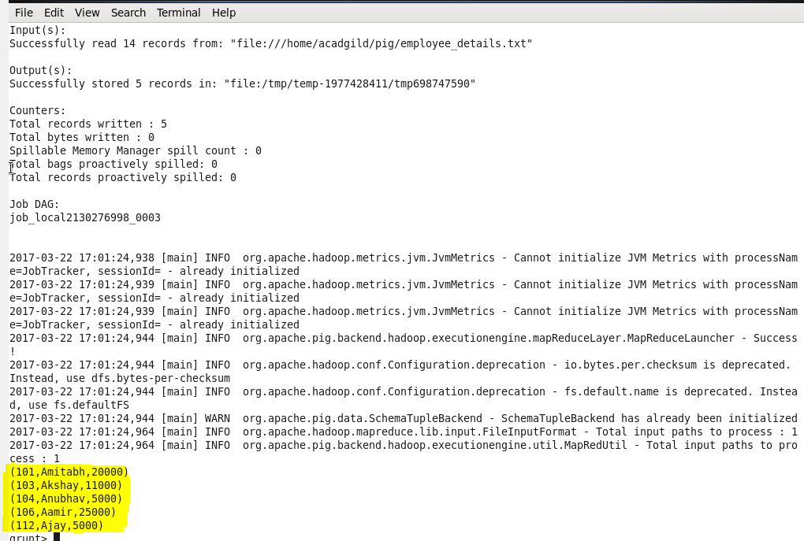

GROUP BY:

The ***GROUP*** operator is used to group the data in one or more relations. It collects the data having the same key.

**Syntax:**

***Group_data = GROUP Relation_name by column_name;***

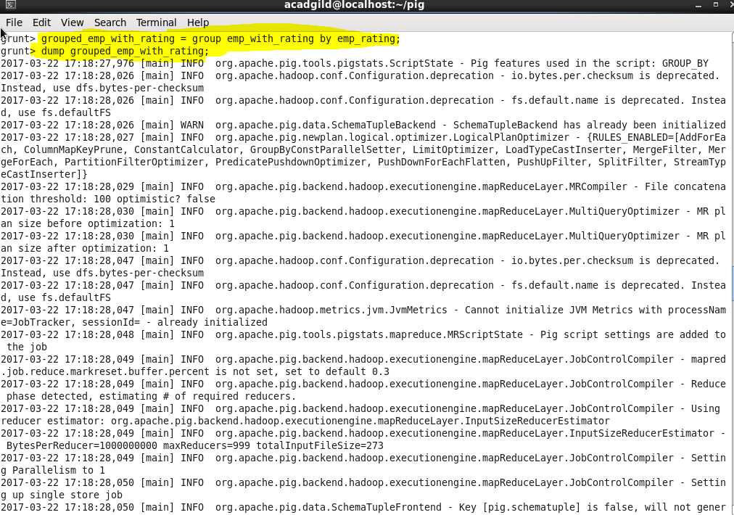

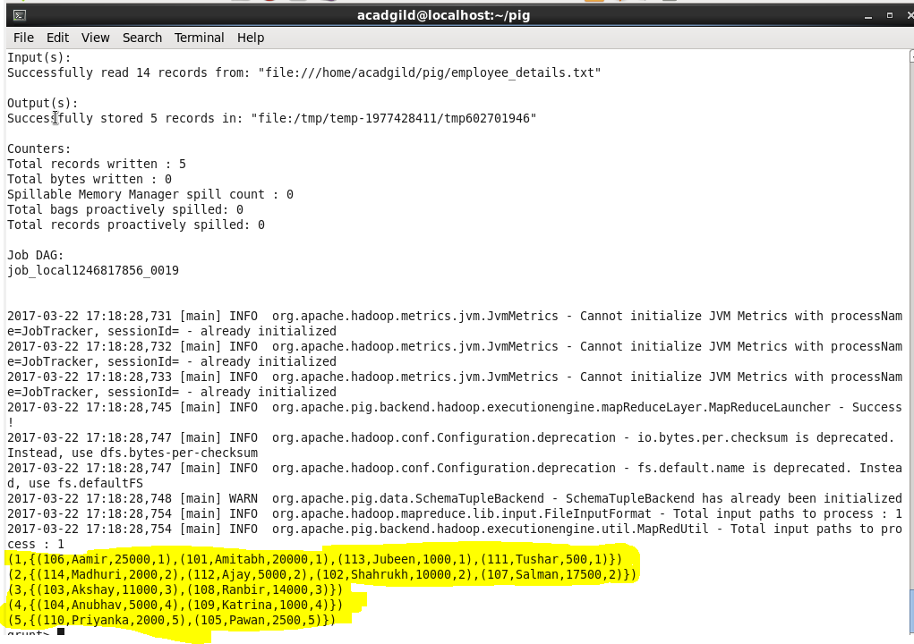

ORDER BY:

The ***ORDER BY*** operator is used to display the contents of a relation in a sorted order based on one or more fields.

**Syntax:**

***Relation_name2 = ORDER Relation_name1 BY (ASC/DESC);***

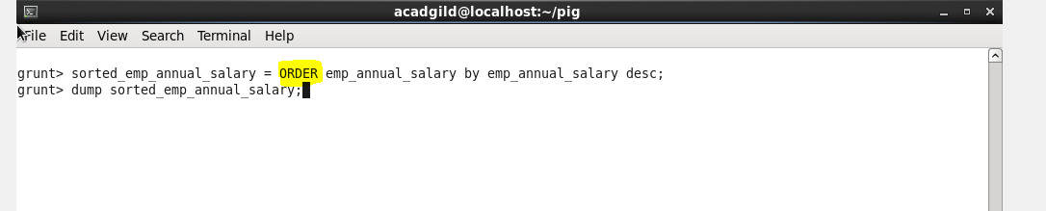

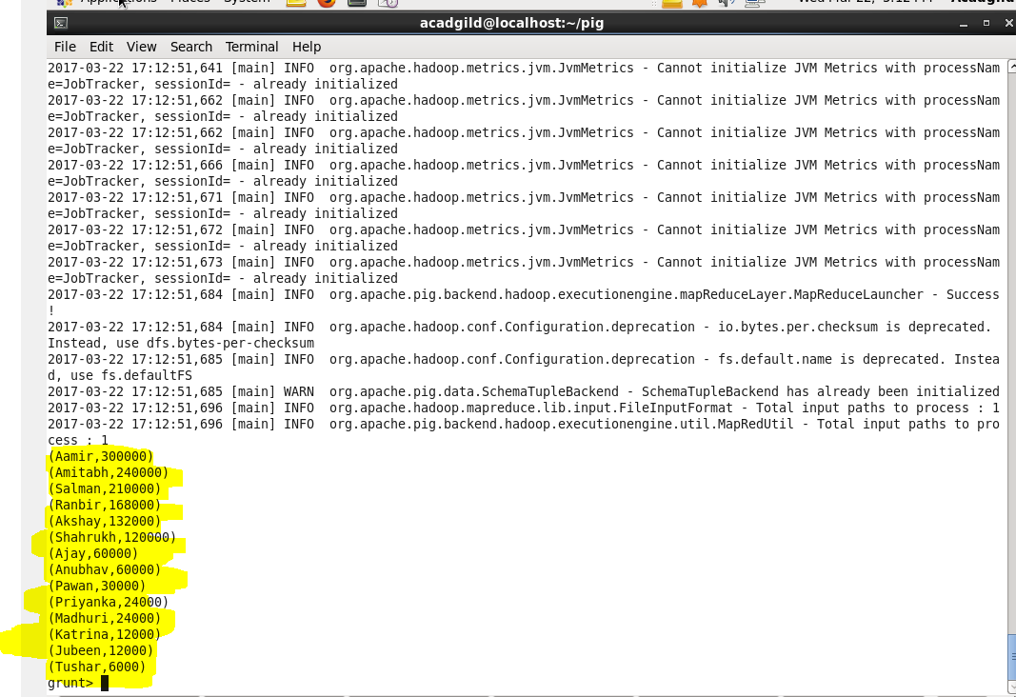

DESCRIBE:

The ***DESCRIBE*** operator is used to view the schema of a relation.

**Syntax:**

***DESCRIBE Relation_name;***

