1. Write a mapreduce program to remove commas present inside the double quotes.

Driver:

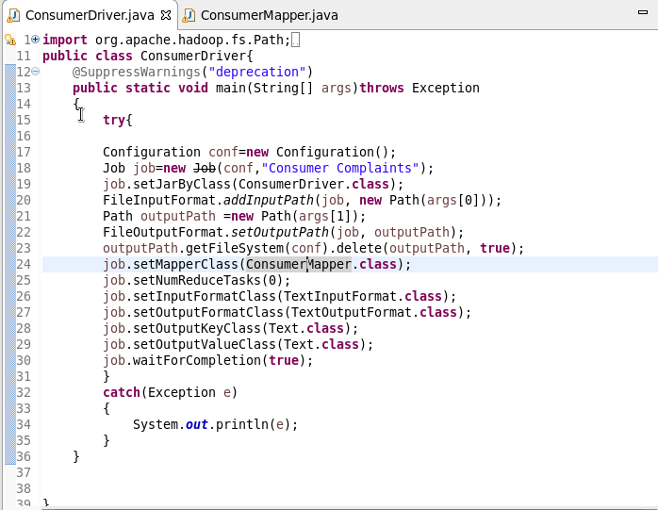

Mapper:

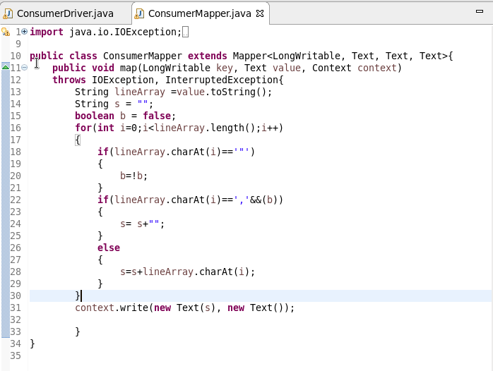

Running jar:

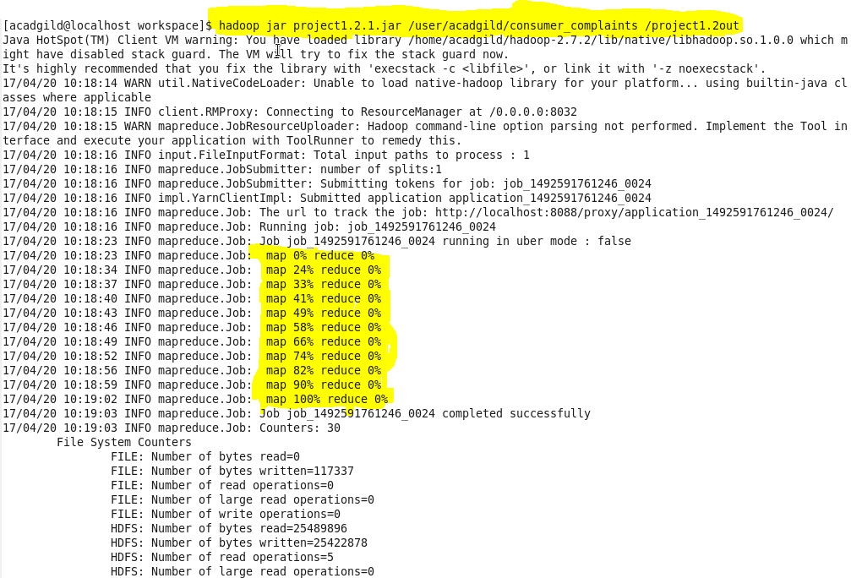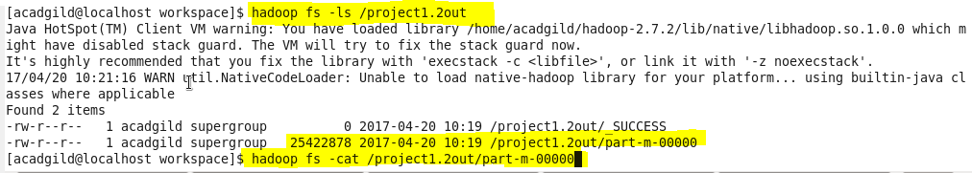

Output:

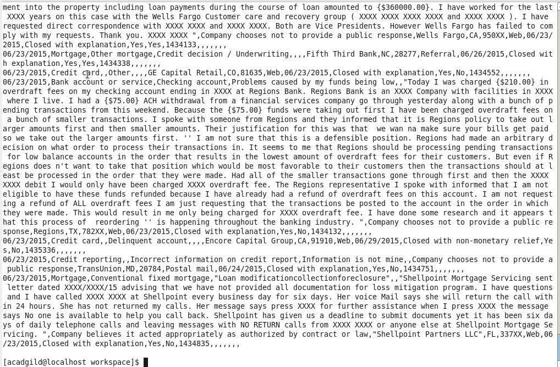

1. Write a pig script to find no of complaints which got timely response.

Pig Script:

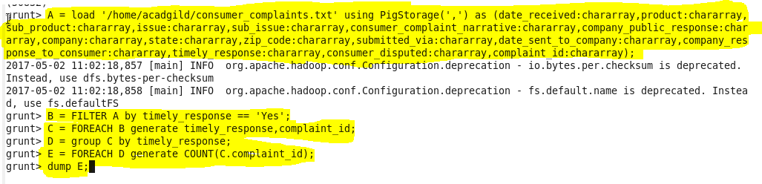

Output:

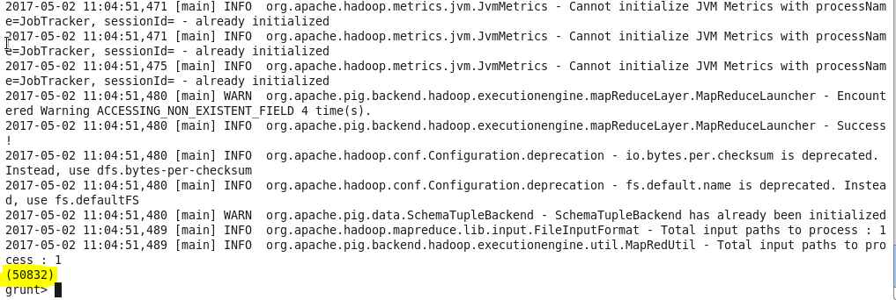

1. Write a pig script to find no of complaints where consumer forum forwarded the complaint same day they received to respective company

Pig Script:

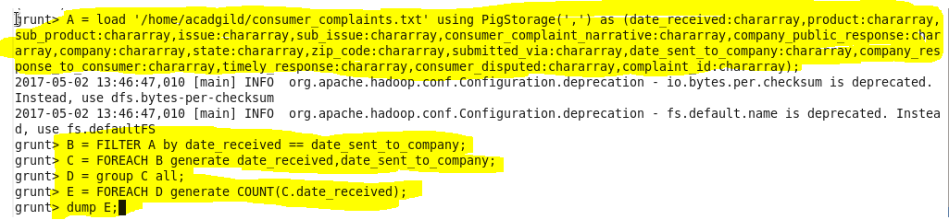

Output:

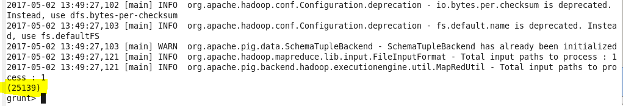

1. Write a pig script to find list of companies topping in complaint chart (companies with maximum number of complaints)

Pig Script:

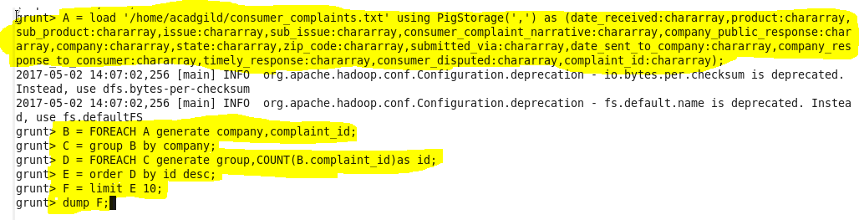

Output:

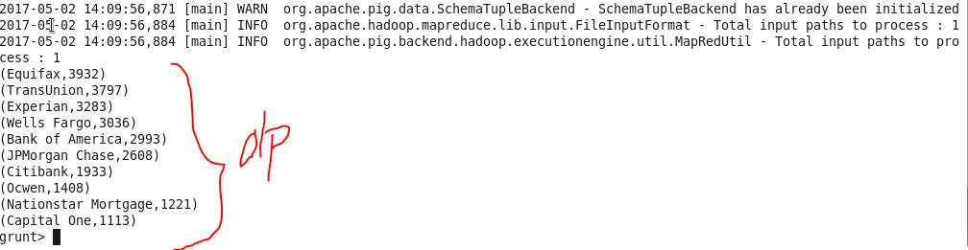

1. Write a pig script to find no of complaints filed with product type has "Debt collection" for the year 2015

Pig Script:

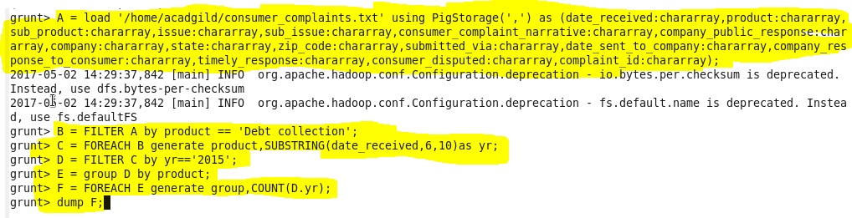

Output:

