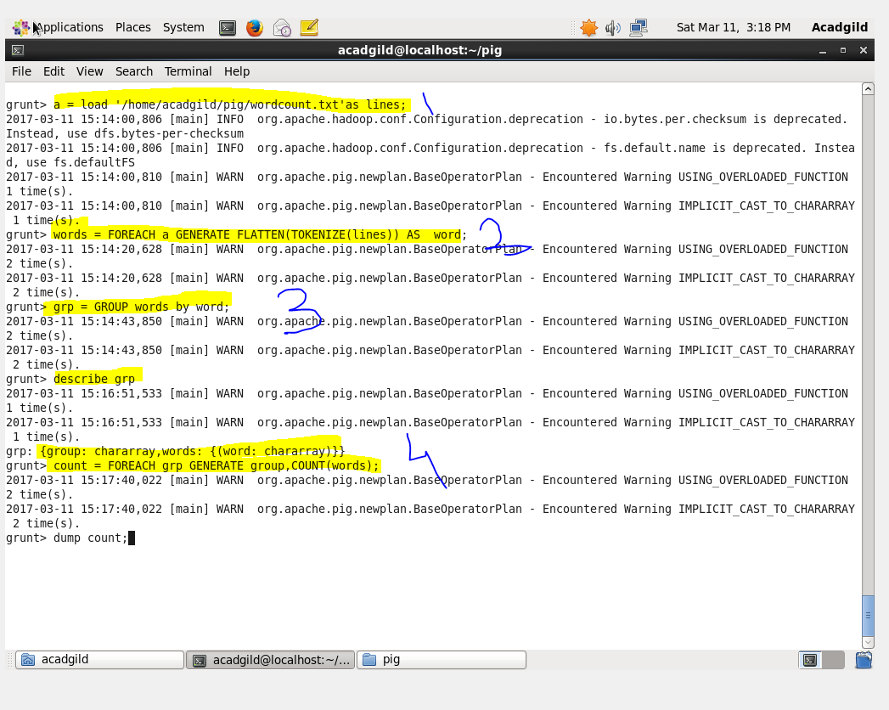

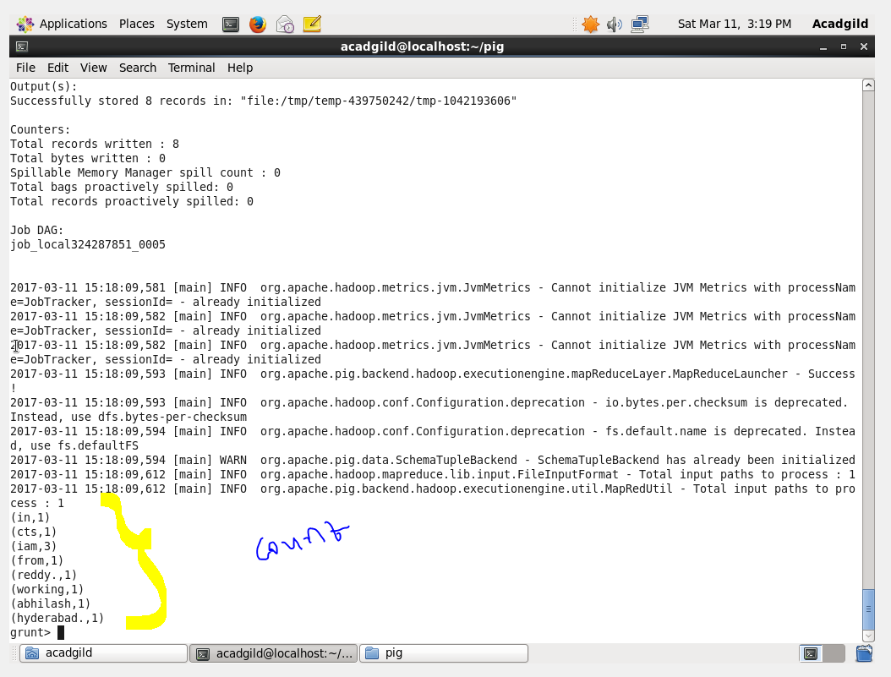

1. I am loading the data (wordcount.txt) into relation ‘a’ and tuple name as ‘lines’.
2. Using TOKENIZE keyword ,splitting the ‘lines’ ,then each lines will convert into bag. Then using

FLATTEN iam converting bag into tuples and storing in ‘words’.

1. Grouping the ‘words’ relation by word and storing it in ‘grp’;
2. Counted using ‘COUNT’ keyword ,to happen it for each tuple I used keyword ‘FOREACH’ and stored in ‘count’.