Creating table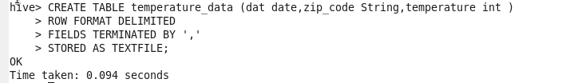

DATABASES

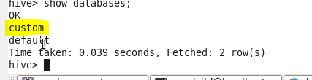

LOADING the data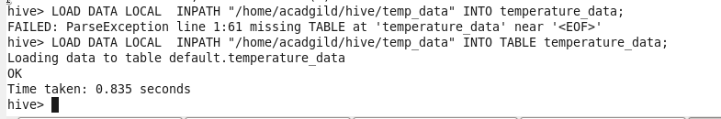

Table temperature

