Fetch date and temperature from temperature_data where zip code is greater than 300000 and less than 399999.

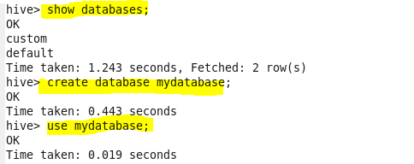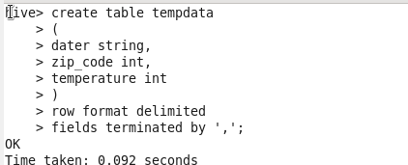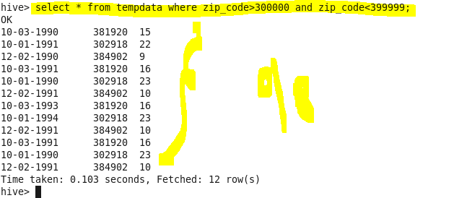

Calculate maximum temperature corresponding to every year from temperature_data table. 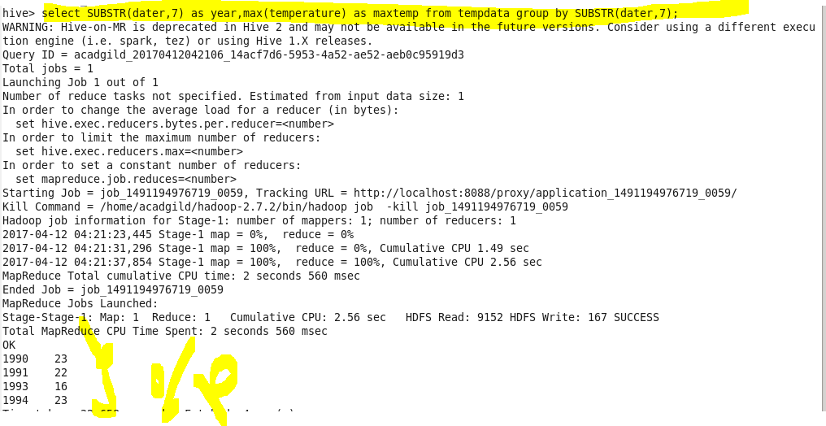 Calculate maximum temperature from temperature_data table corresponding to those years which have at least 2 entries in the table. 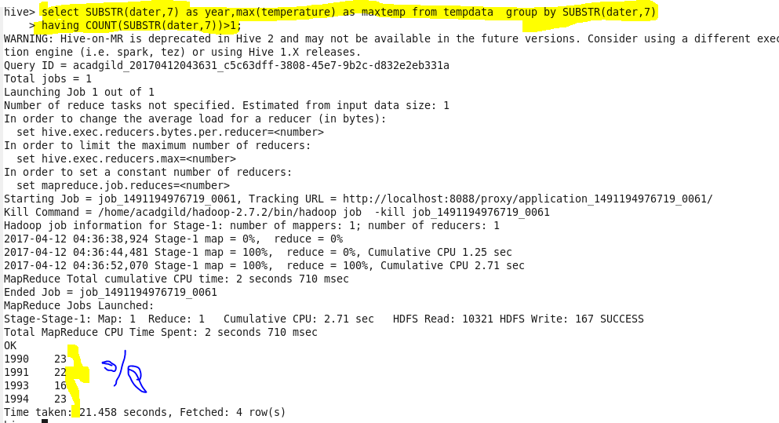

Create a view on the top of last query, name it temperature_data_vw. 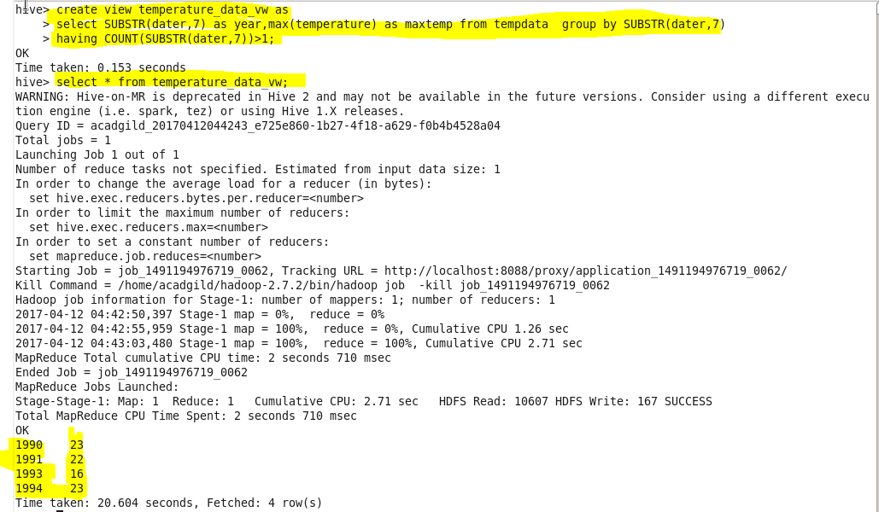

export contents from temperature_data_vw to a file in local file system, such that each file is '|' delimited.