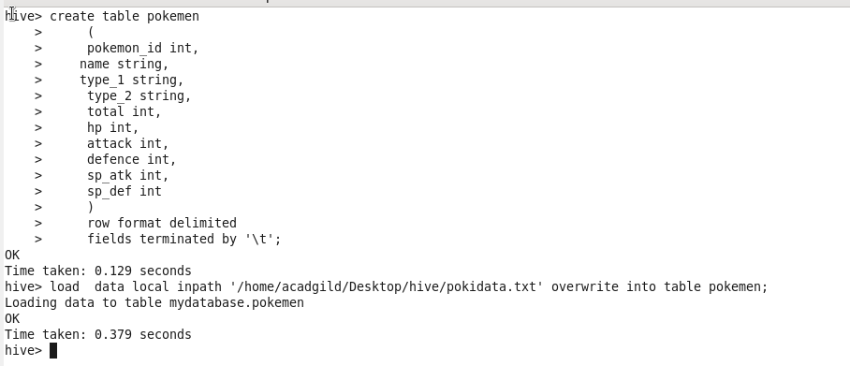

1. Find out the average HP (Hit points) of all the Pokémons

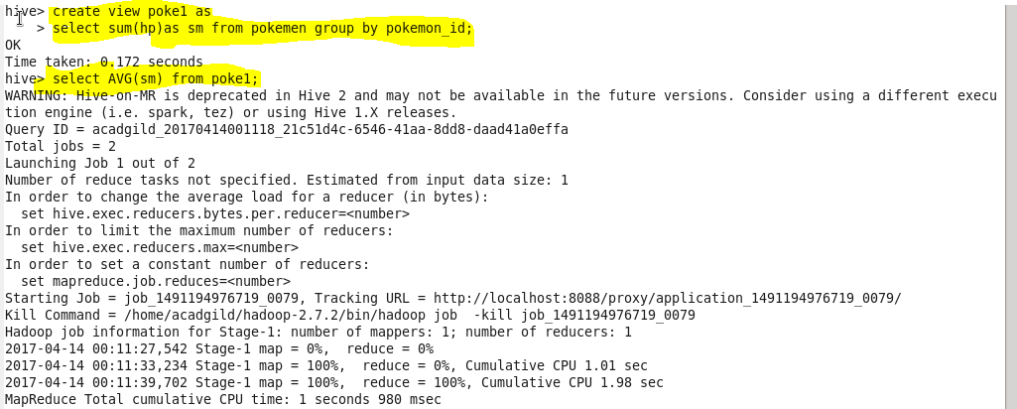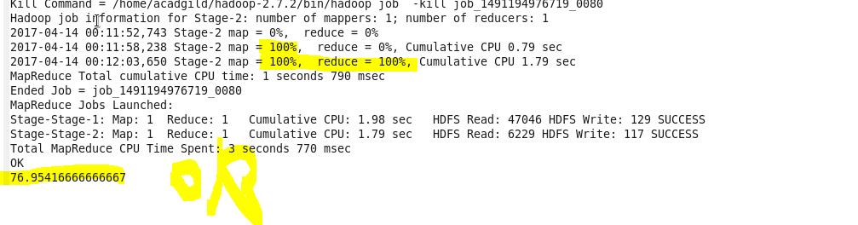

2. Find out the average Defense of all the pokemon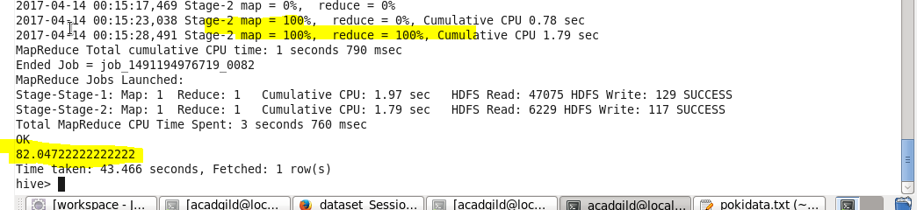3. Find out the average Sp.Atk of all the pokemons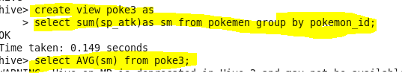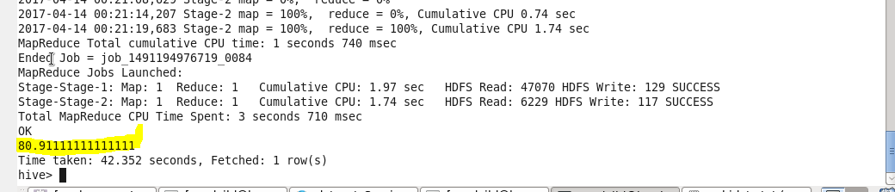4. Find out the average sp.Def of all the pokemons 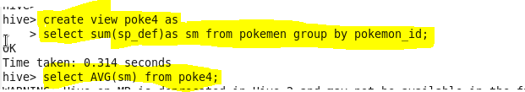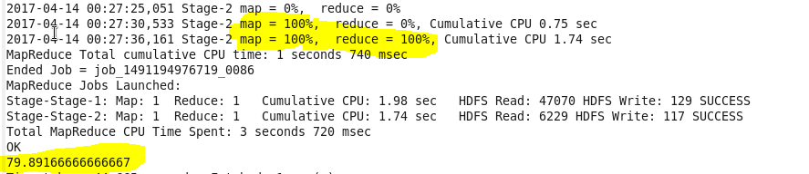

5. Find out the average Speed of all the pokemons