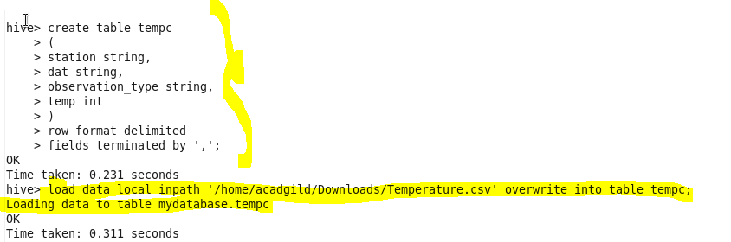

1.Write a hive query to find the minimum temperature observed in a given weather station in a particular year.

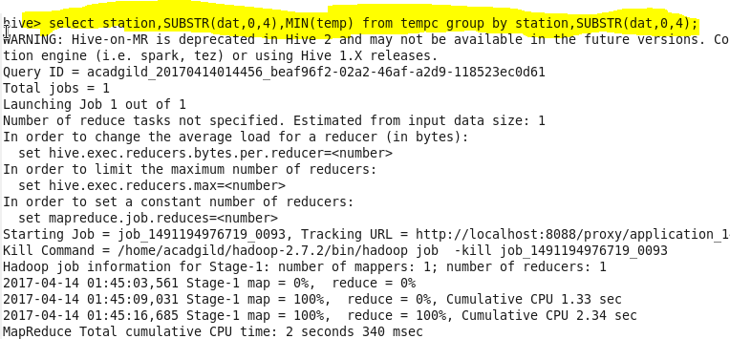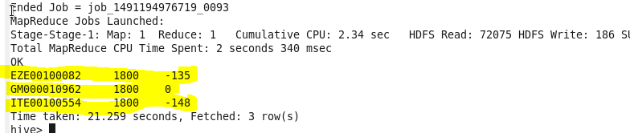

2. Write a hive query to find the maximum temperature observed in a given weather station in a particular year.

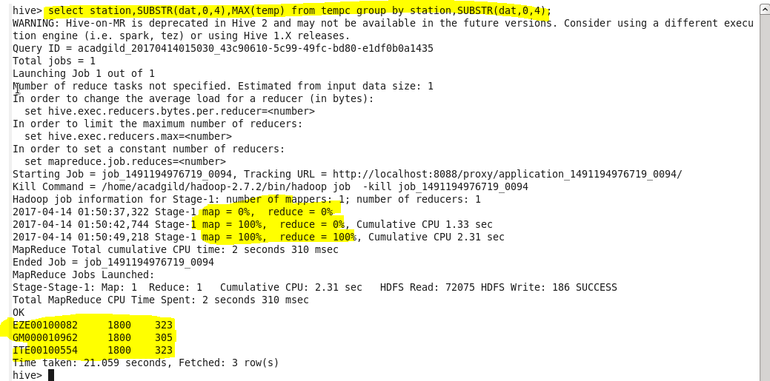

3. Write a hive query to find the number of readings given by each weather station according to the dataset.

