Explain the following in brief by using the below datasets and their uses

I loaded data into 2 tables using below commands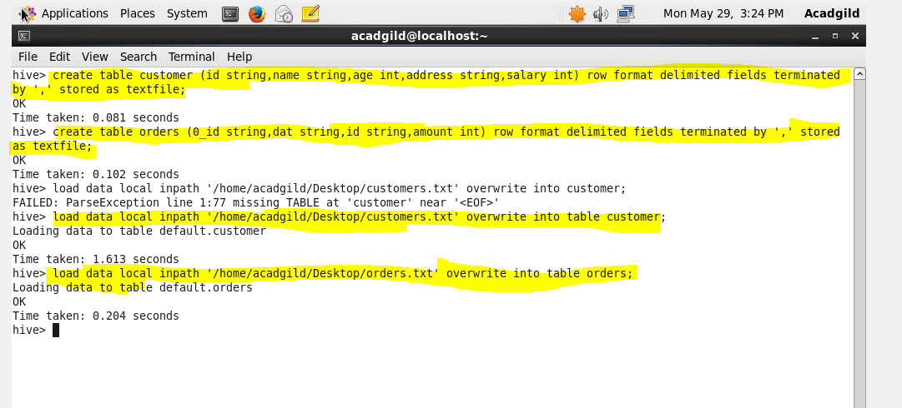

INNER JOIN

when we use inner join it will show common data from both tables

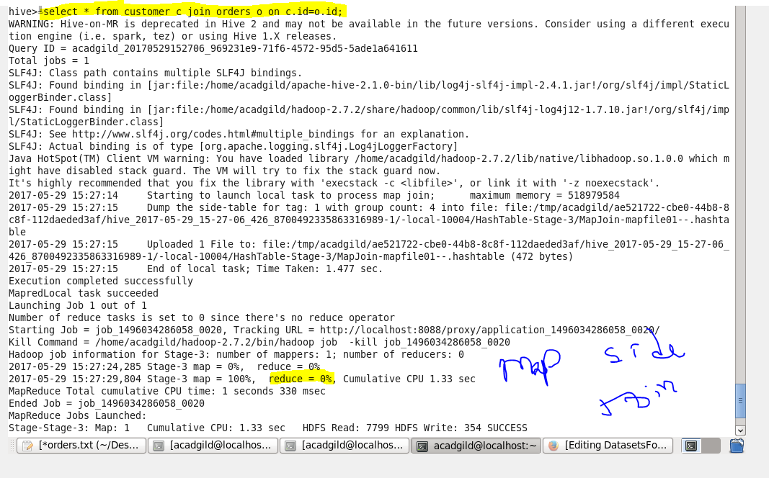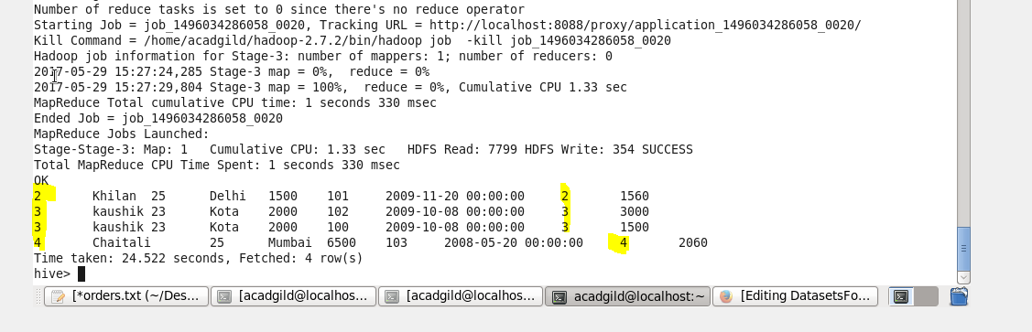

LEFT JOIN

it will show all record from customer tables and common or matched data from orders table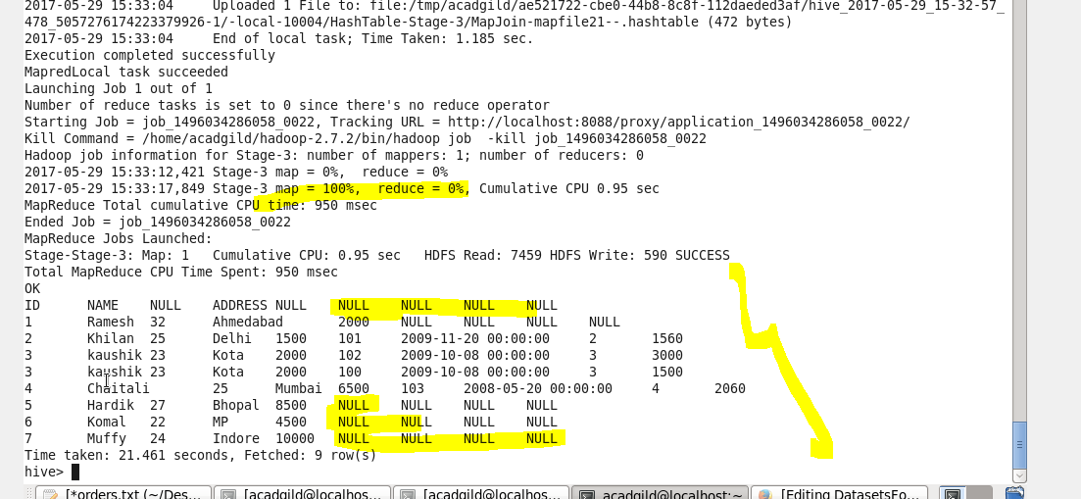FULL JOIN

it will show both common data and uncommon data from both tables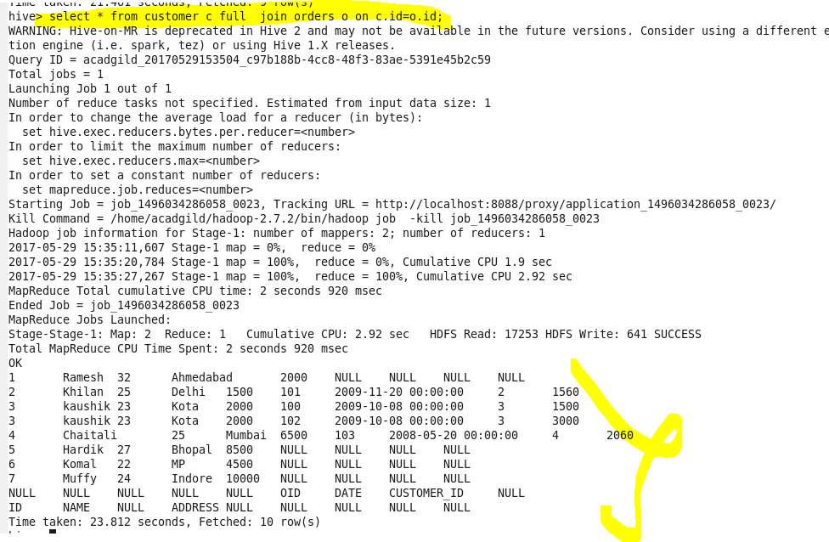

RIGHT JOIN

it will show all record from order table and common or matched data from customer table 

