● Create a employee table in Mysql and columns as Emp_id, Emp_name, Dept_name(Hadoop Developer), Emp_sal.

Creating table



● Import the employee table contents into the HDFS directory using Sqoop.

Added 3 rows into table

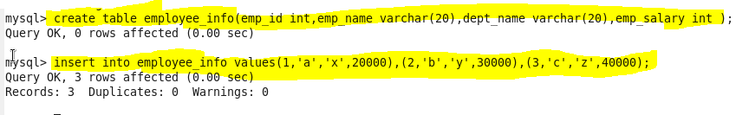

Importing into hdfs

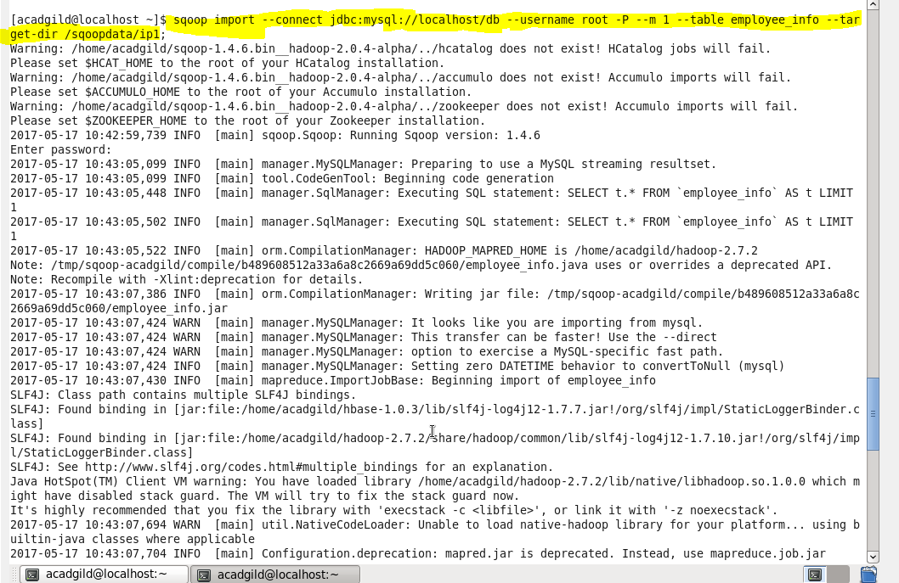

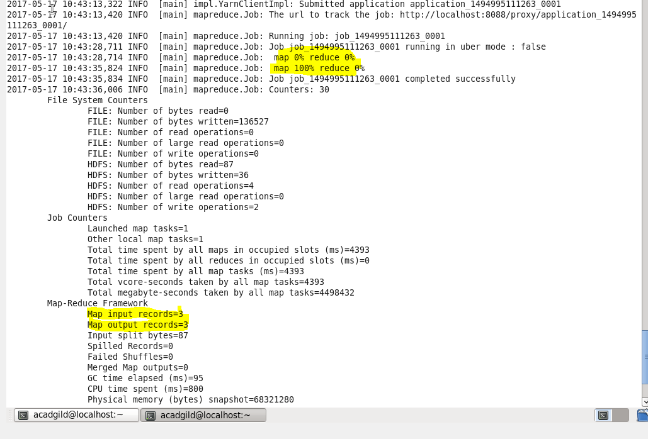

Checking whether imported or not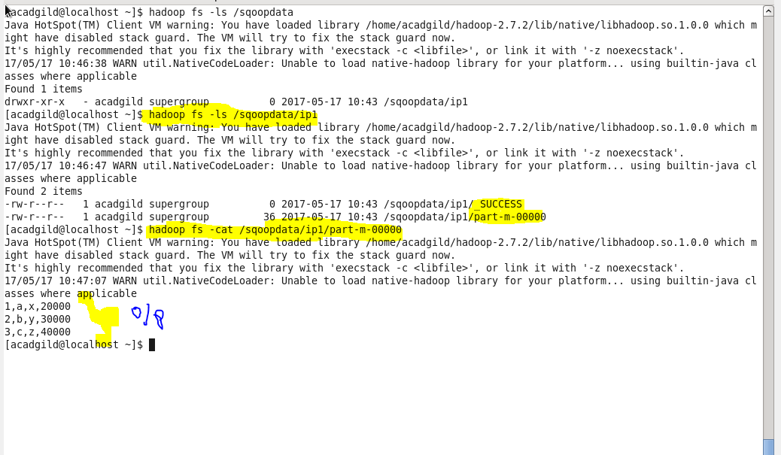

● Create a employee2 table in Mysql and Export employee details file from HDFS directory to Mysql table employee2 using Sqoop.

Creating another table in mysqlexporting from hdfs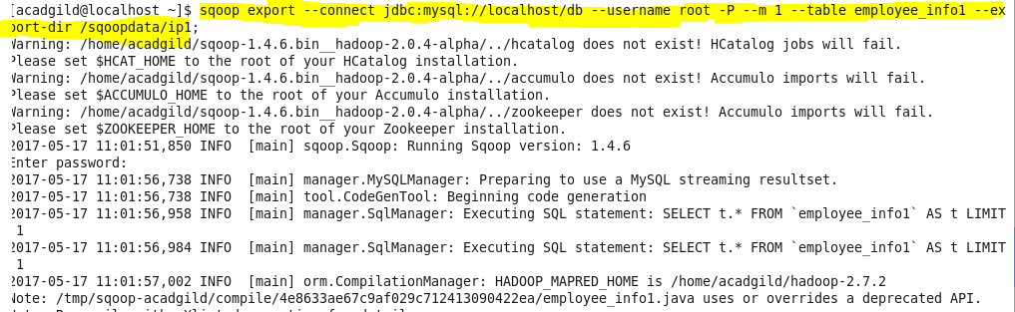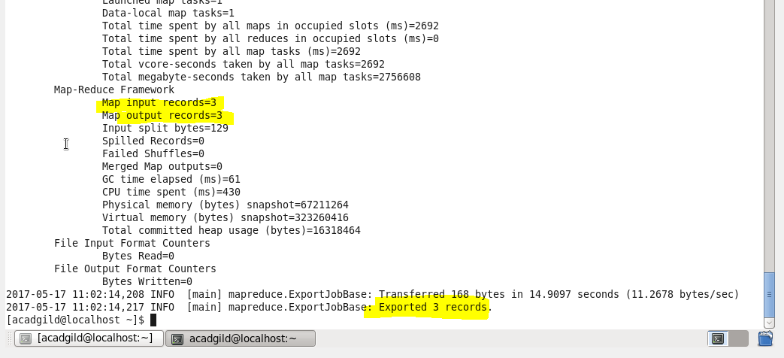

Checking 