● Explain and perform Sqoop Incremental Import operation to load data from Mysql To HDFS using Sqoop

Previous data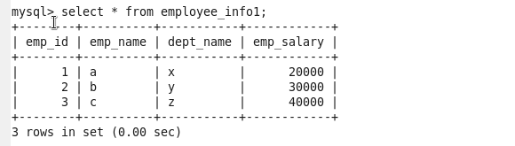

Added two rows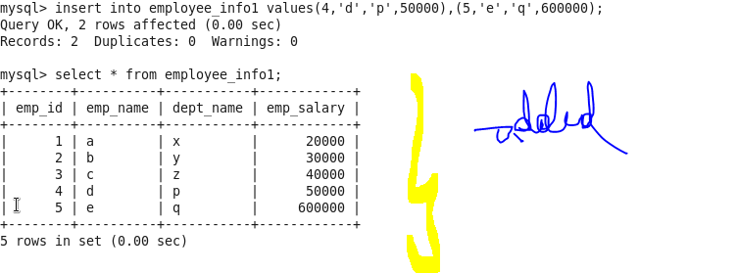previous data present in hdfs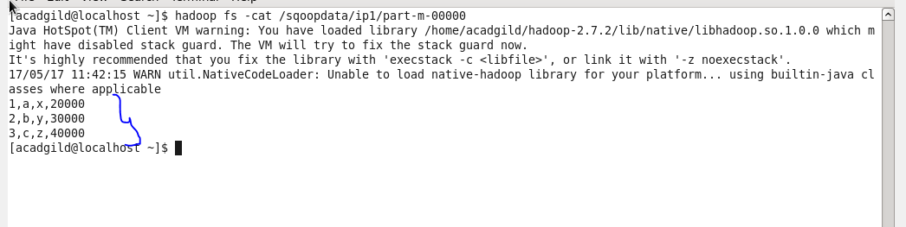

Importing new data using incremental mode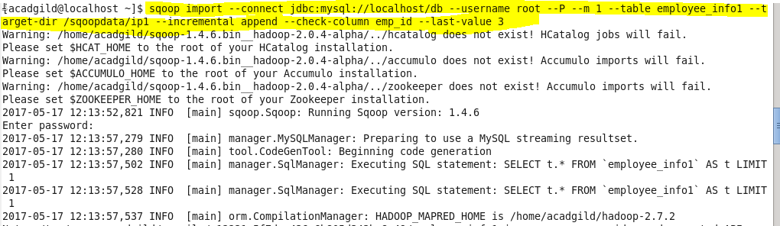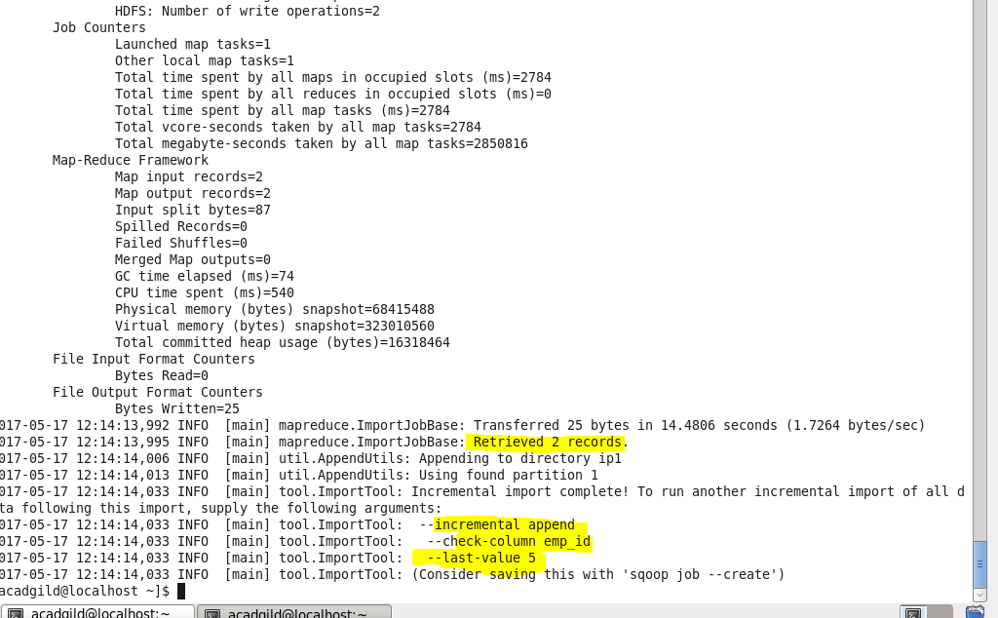new data