Problem statement 1: Find out how many people has chosen their destination as MIA and MCO Problem

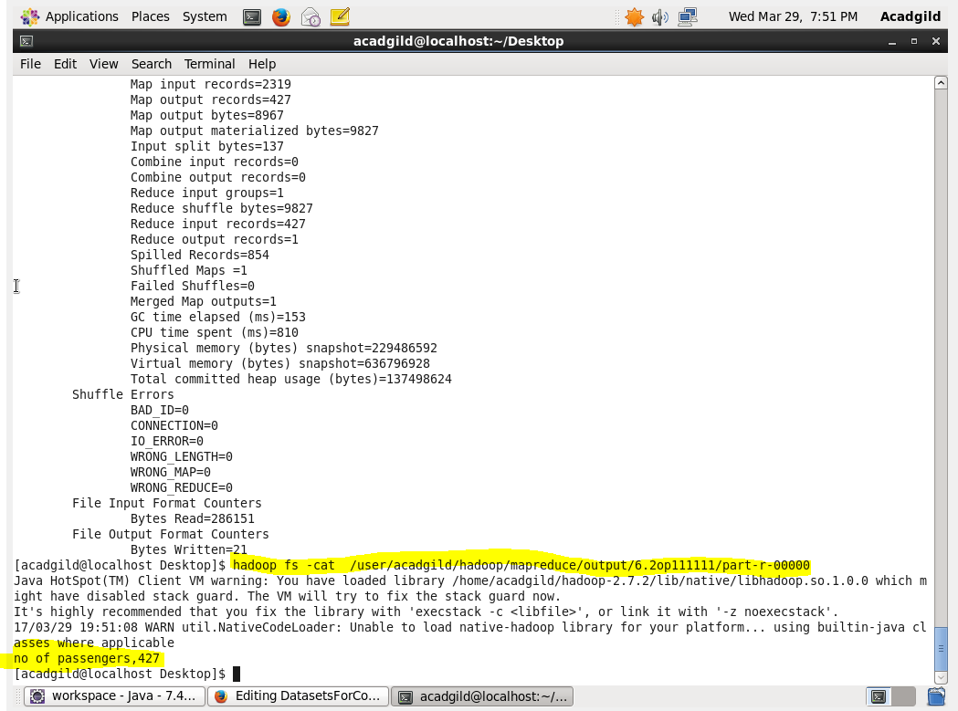

statement 2: Find out the number of people undertaken the trips from the places MIA and HOU

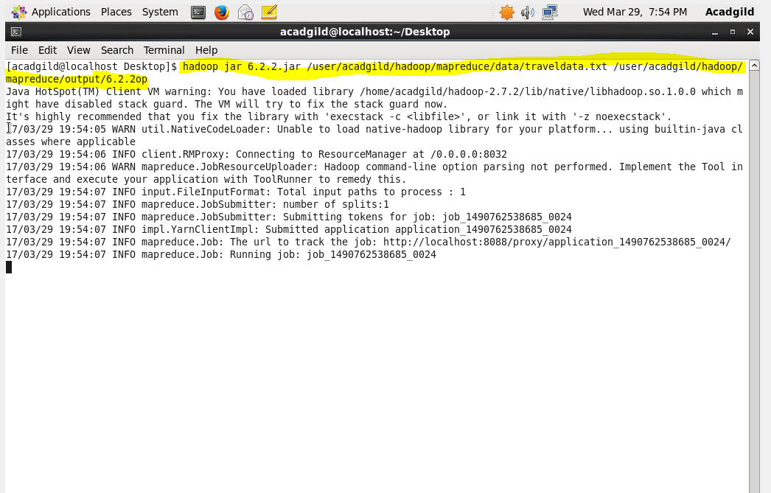

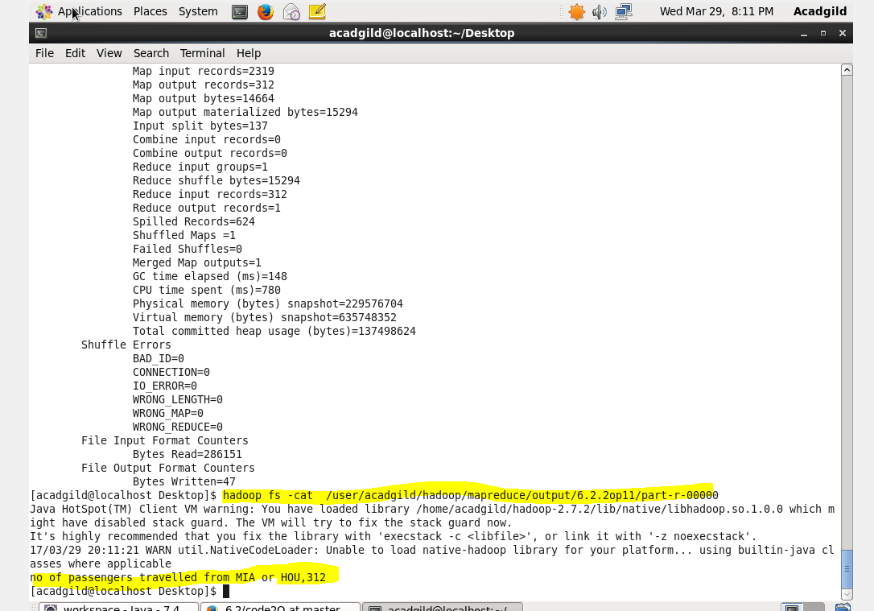

Problem statement 3: Find out how many people has chosen airline mode of travel for the places LAS and LAX

