Problem statement

Write a custom key to evaluate the number of people who died and the number of people who survived, along with their genders.

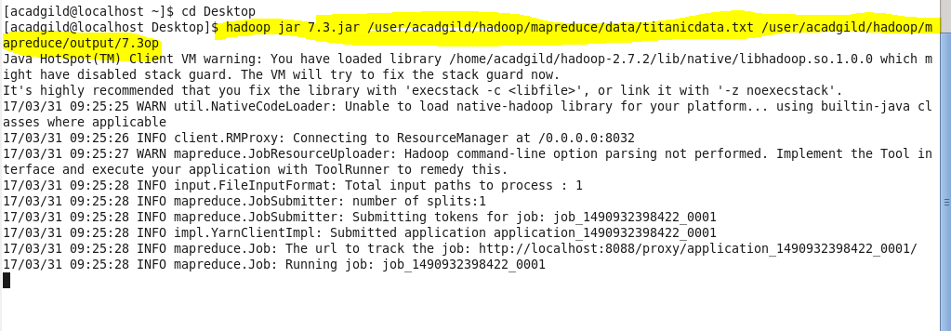

output