1. Write a mapreduce program to find the total amount of petrol in volume sold by every distributor.

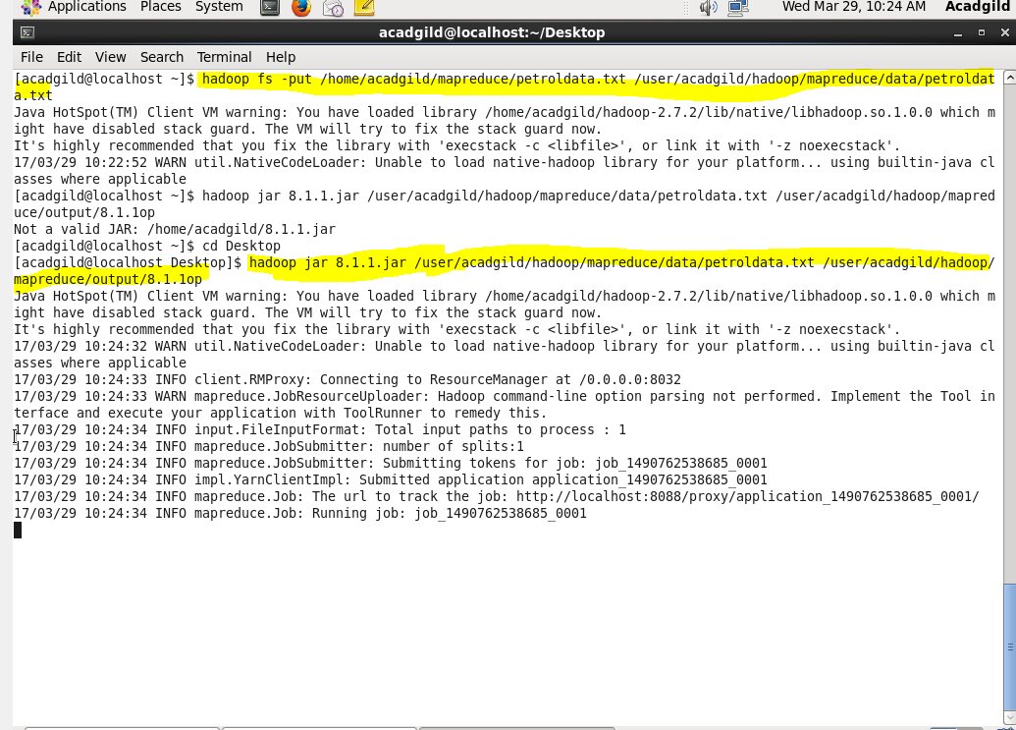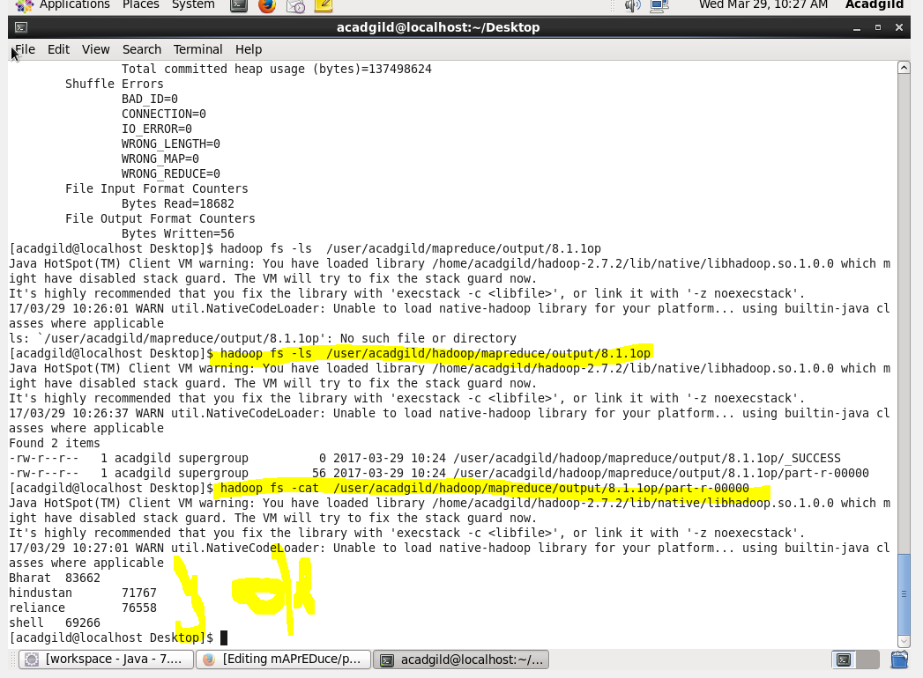

2.Write a mapreduce program to find which are the top 10 distributors ID's for selling petrol and also display the amount of petrol sold in volume.

