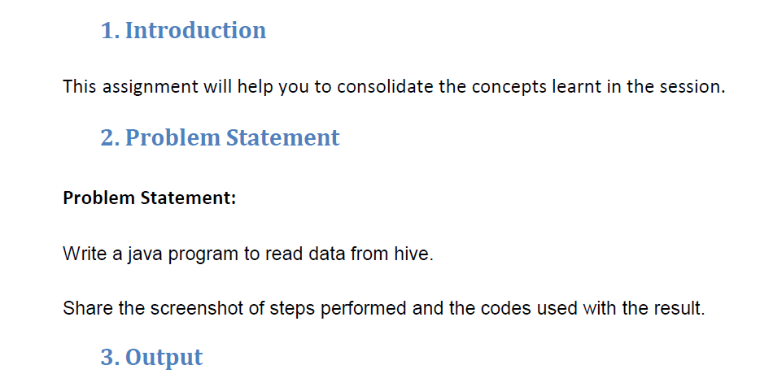

**Q.1. Write a java program to read data from hive.**

**In order to read data from hive using java we should first add sql connector jar and sl4j binding jar and in order to connect to hive we must start hiveserver2 which will BE Used for connecting hive through JDBC**

**Input to be Read**

**I am Having arry_table as shown below which I am going to read**

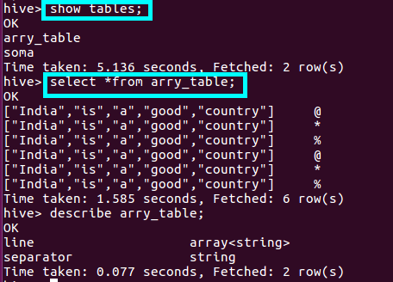

**JAVA CODE TO READ**

**Step1 :Defining a driver and the Class.forName(driver) method returns the Class object associated with the class or interface with the given string name, using the given class loader.**

**Step2: creating connection using driver.getconnection()**

**Step3: we are using createstatement() method to create a statement instance for sending SQL statements to the database. Here, Statement is an interface that represents an SQL statement.**

**Step4:** **in order to execute an SQL query, we should use executequery() method of the interface statement.Using Resultset to display the results of a querry**

**Since I want to read data from arry_table I am using select statement and using object of resultset to diplay the result by using getstring() Method of resultset class**

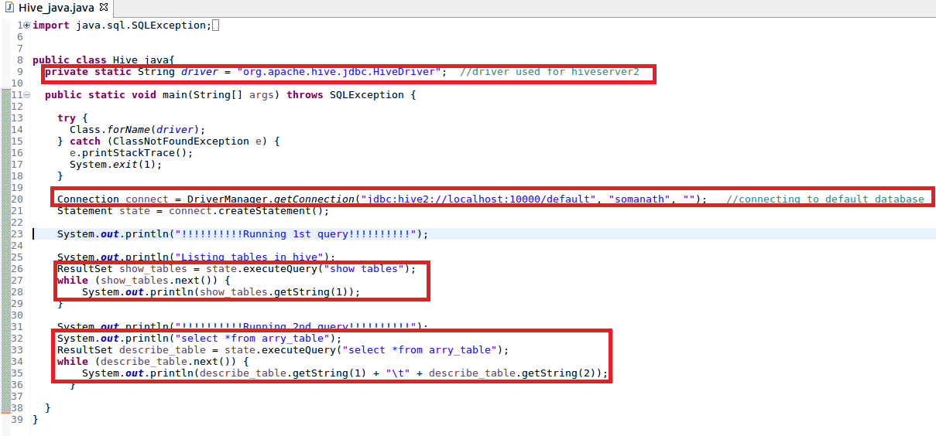

**Output:**

**We have successfully read data from Hive**

