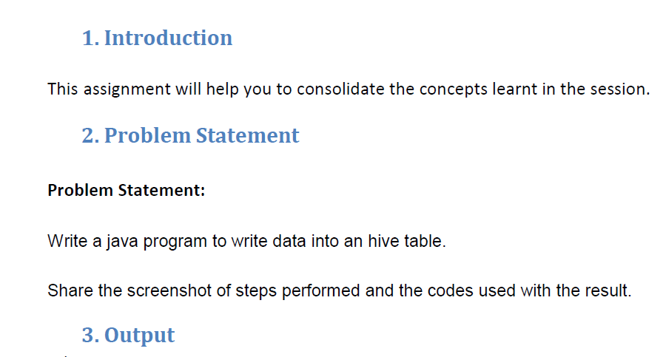

**Q.1. Write a java program to write data into an hive table**

**In order to write data from hive using java we should first add sql connector jar and sl4j binding jar and in order to connect to hive we must start hiveserver2 which will BE Used for connecting hive through JDBC**

**Logic: In order to write I am creating a “hivewrite_table” and writing data using executeUpdate() Method**

**JAVA CODE TO WRITE**

**Step1 :Defining a driver and the Class.forName(driver) method returns the Class object associated with the class or interface with the given string name, using the given class loader.**

**Step2: creating connection using driver.getconnection()**

**Step3: we are using createstatement() method to create a statement instance for sending SQL statements to the database. Here, Statement is an interface that represents an SQL statement.**

**Step4:** **in order to execute an SQL query, we should use executequery() method of the interface statement.Using Resultset to display the results of a querry**

**Step5:execute() method and created a table**

**Step6:executequery() to describe the table**

**Step7: Used executeUpdate() method to load the data and used sysout() to confirm the process finished**

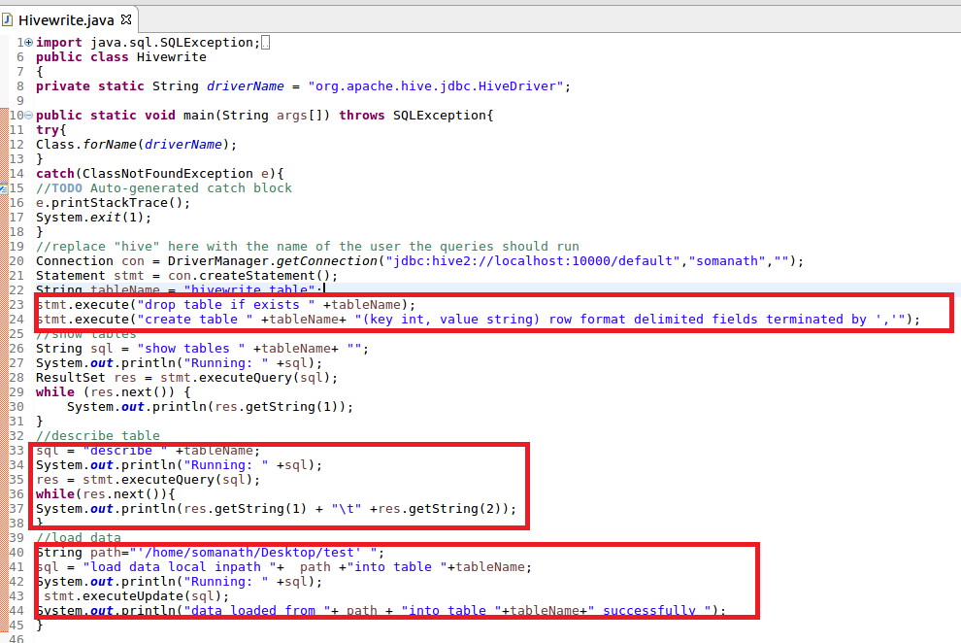

**Output**

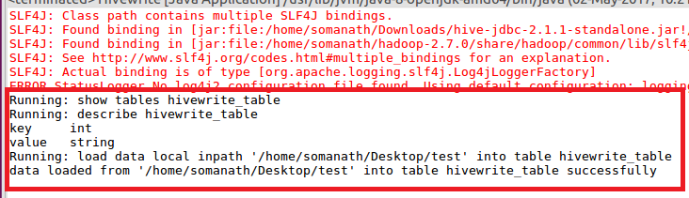

**Verifying that the table is created and data is loaded**

