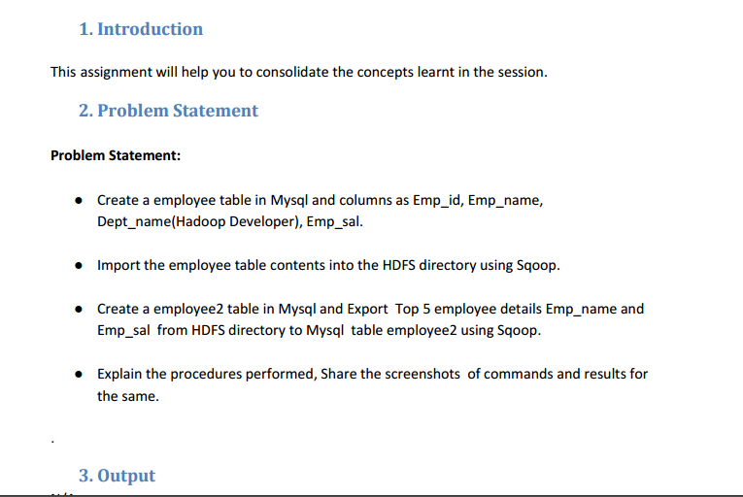

**Using use command**

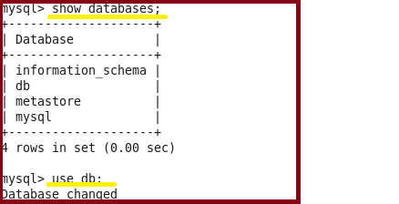

**Using insert command**

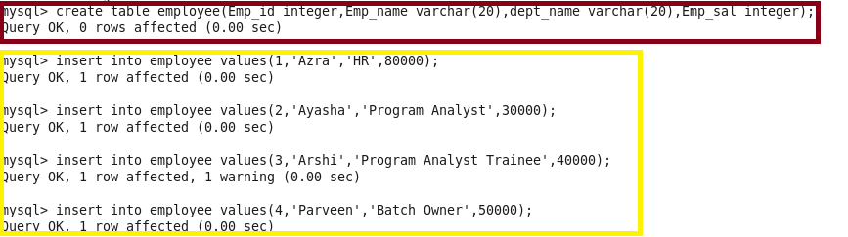

**Performing select operation to display contents of table**

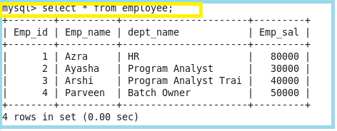

**Importing the data from mysql to hdfs**

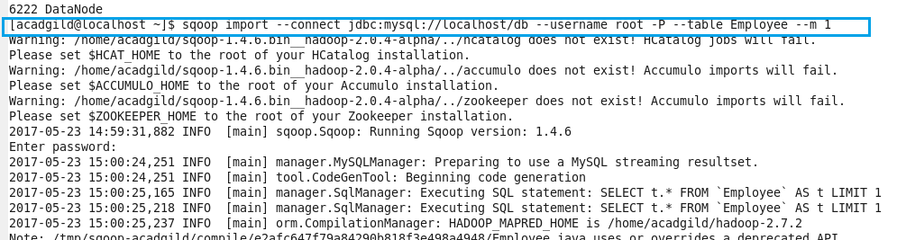

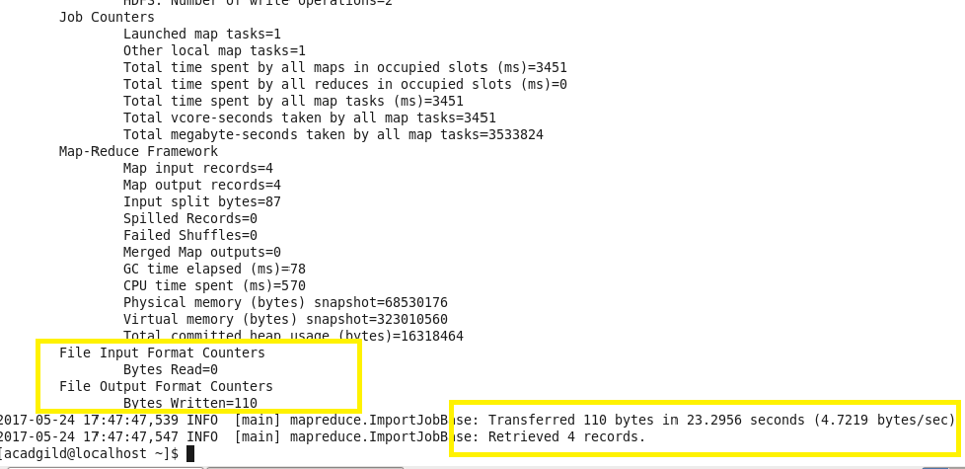

**Checking the files are imported and displaying the contents**

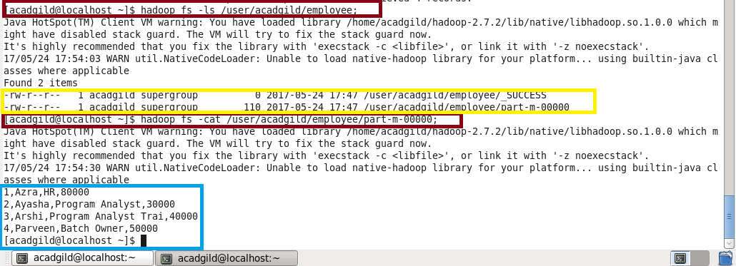

**Creating new table as Employee1 and no data is inserting into it so as to export it from hdfs to mysql**

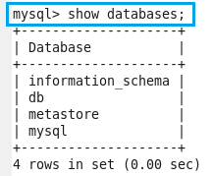

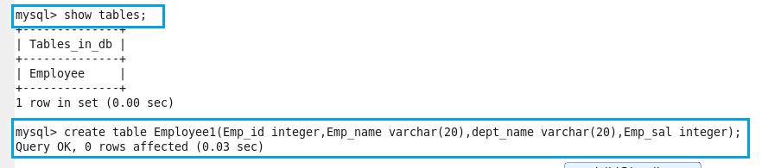

**Here we can see that there is no data present in table Employee1**

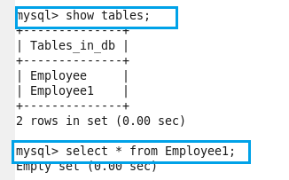

**Exporting table from hdfs to mysql**

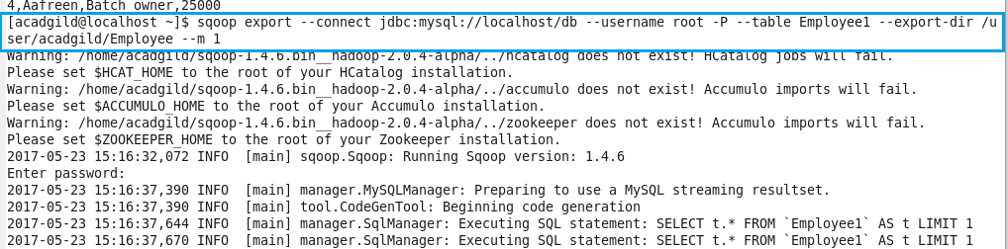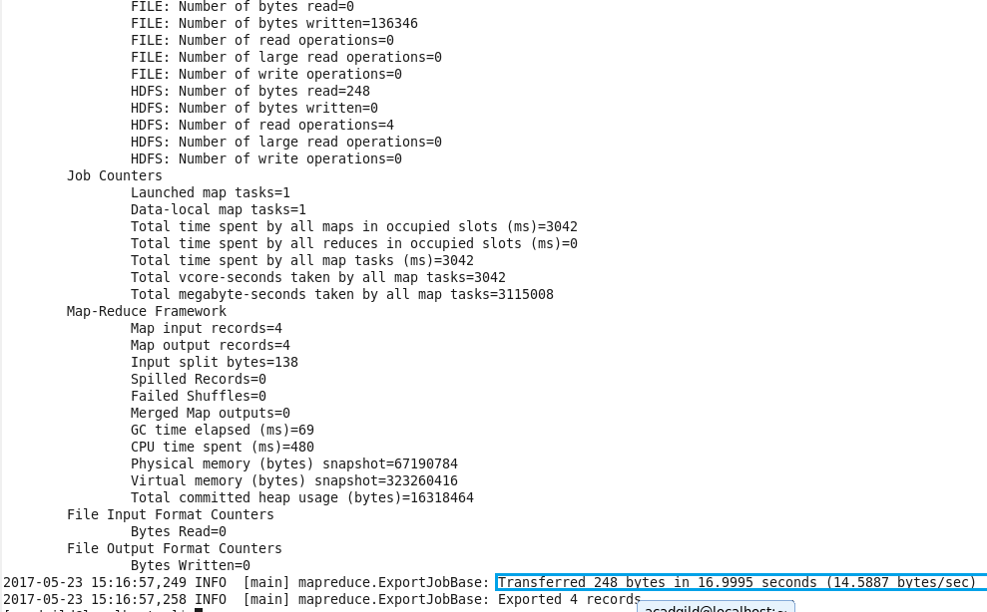

**Exported table**

