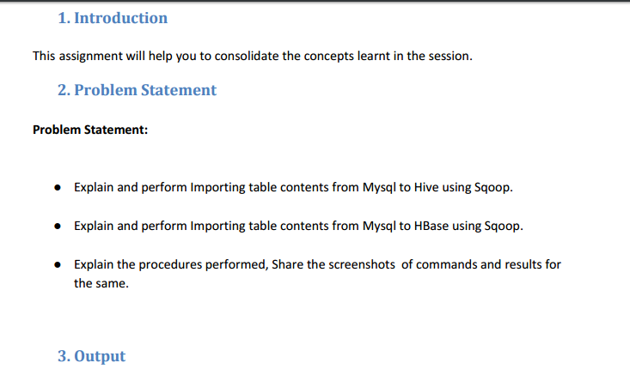

**Q.1. Explain and perform Importing table contents from Mysql to Hive using Sqoop.**

Using employee table we created earlier with data as

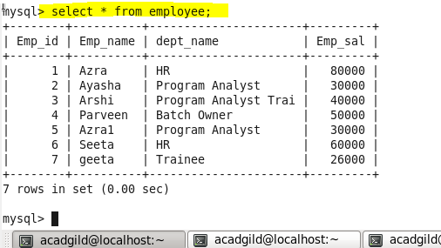

**PERFORMING IMPORT USING SQOOP**

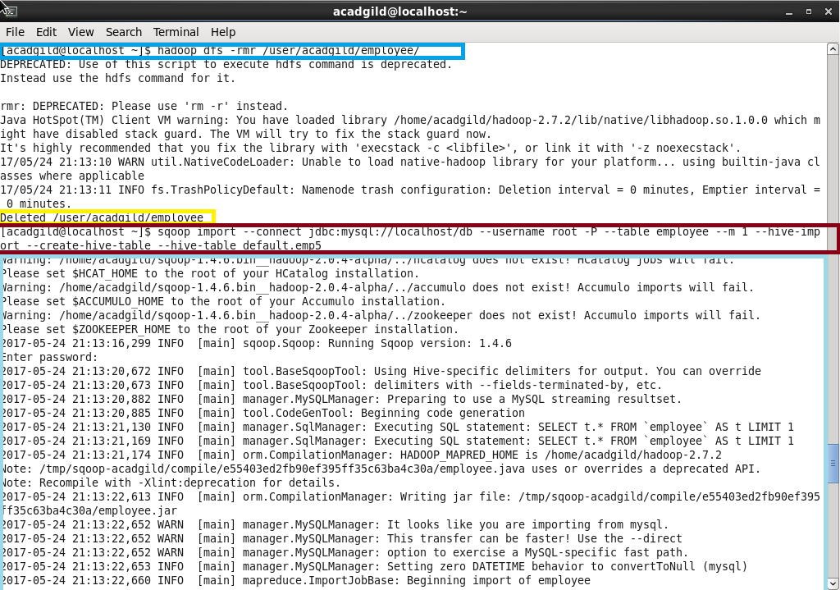

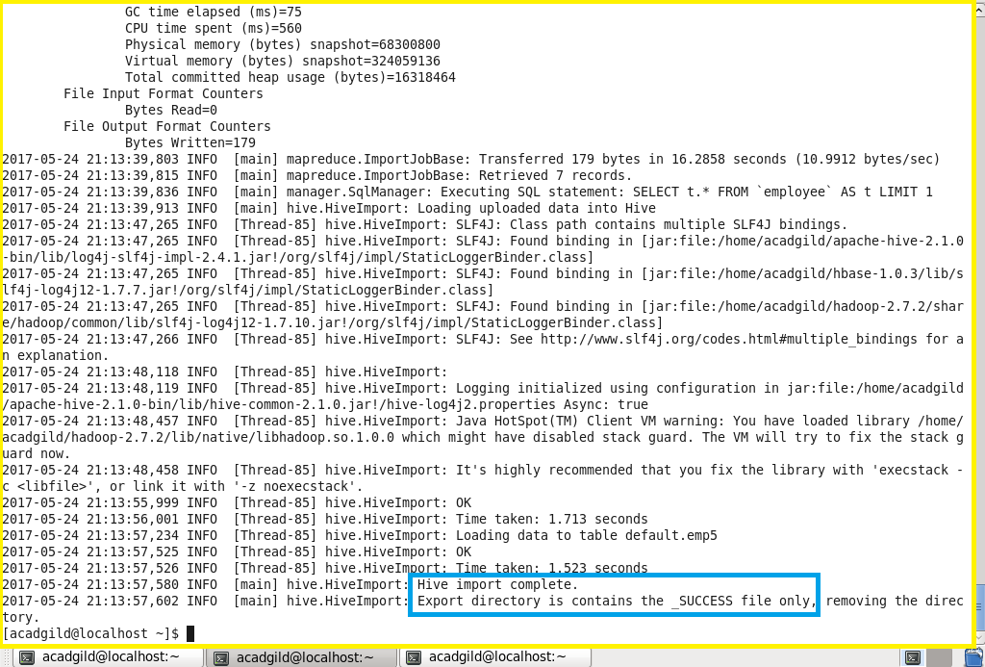

**So a table with name emp5 will be created and the data from employee table in mysql will be imported into that , we can see down**

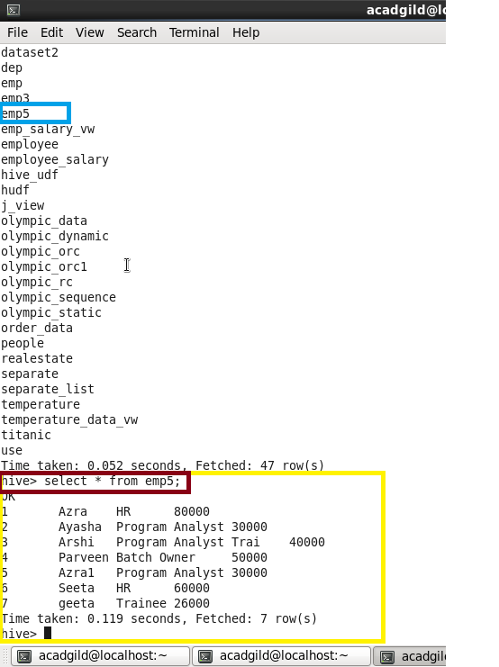

**Same data as in employee table in mysql**

**Q.2. Explain and perform Importing table contents from Mysql to HBase using Sqoop.**

**Open hbase and create a table “hivesql” with “Detail” as column family in HBASE**

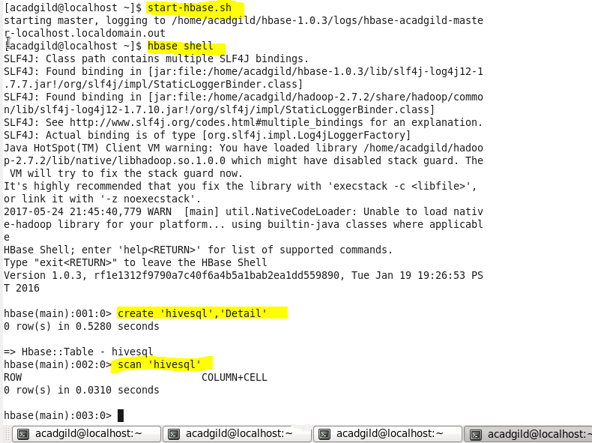

**Performing import from mysql to hbase**

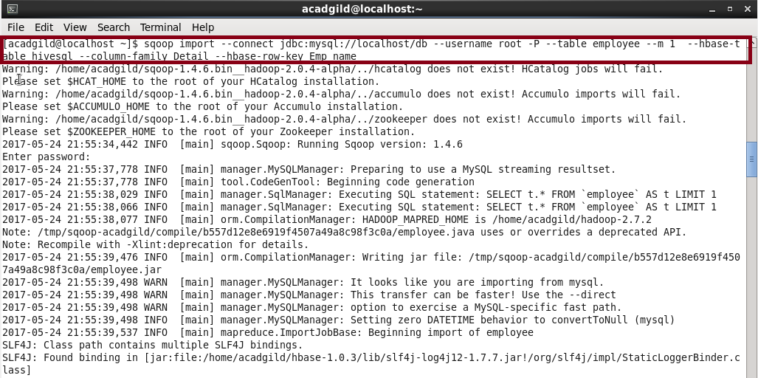

**Successfully transferred data from mysql to hbase**

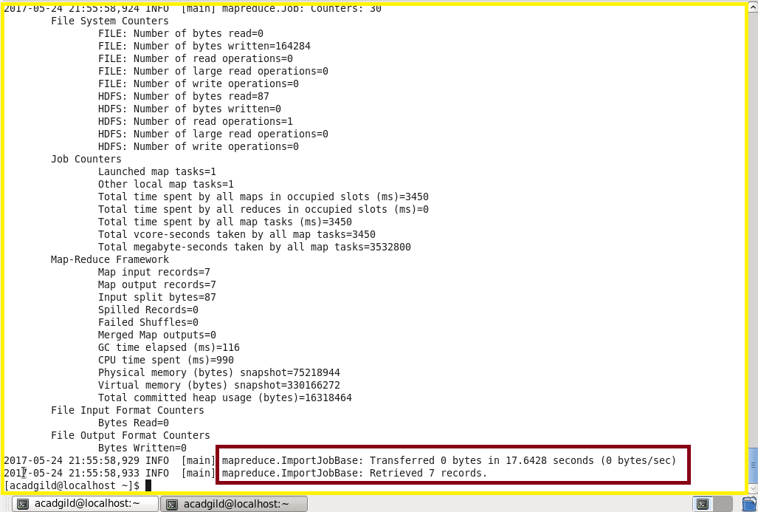

**Output**

**scan hivesql gives the full details about the table**

**We can see that the table is imported into HBase using sqoop with Emp_name as rowkey**

