|  |  |
| --- | --- |
| **问题提示** | com.mysql.cj.jdbc.exceptions.CommunicationsException: Communications link failure  The last packet sent successfully to the server was 0 milliseconds ago. The driver has not received any packets from the server. |
| **解决方案** | 数据库重启（数据库连接问题） |
|  |  |

问题：

org.apache.ibatis.binding.BindingException: Invalid bound statement (not found)问题，即在mybatis中dao接口与mapper配置文件在做映射绑定的时候出现问题，简单说，就是接口与xml要么是找不到，要么是找到了却匹配不到

解决方案：

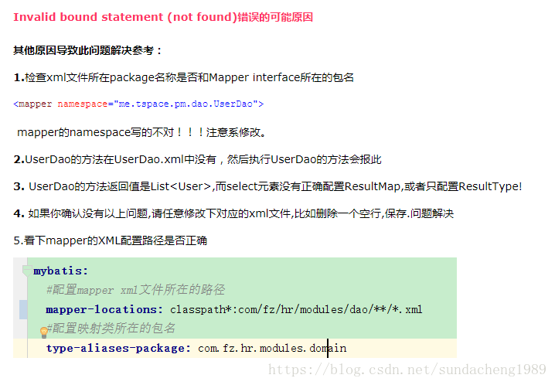

问题：org.apache.ibatis.reflection.ReflectionException: There is no setter for property named 'id' in 'class com.wqm.step.pojo.UUser'

at org.apache.ibatis.reflection.Reflector.getSetInvoker(Reflector.java:372)

at org.apache.ibatis.reflection.MetaClass.getSetInvoker(MetaClass.java:174)

at org.apache.ibatis.reflection.wrapper.BeanWrapper.setBeanProperty(BeanWrapper.java:167)

at org.apache.ibatis.reflection.wrapper.BeanWrapper.set(BeanWrapper.java:57)

at org.apache.ibatis.reflection.MetaObject.setValue(MetaObject.java:133)

解决方案：查看mapper.xml文件中的id是否正确，property属性后面一定要与实体类中定义的属性一致，就可以了。