XPath / CSS

Task 1: Locating Elements by Basic Attributes
Xpath:
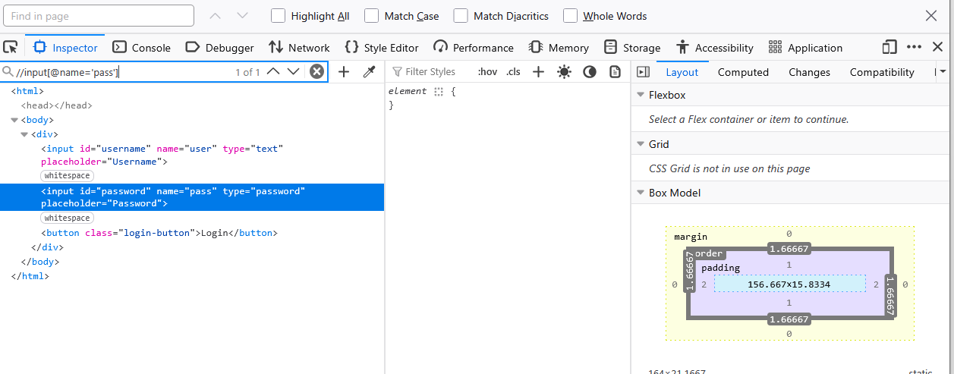
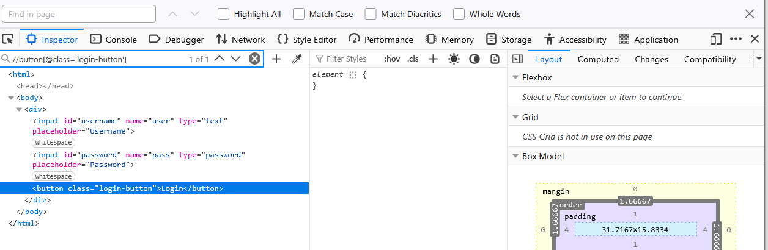


CSS Selector:
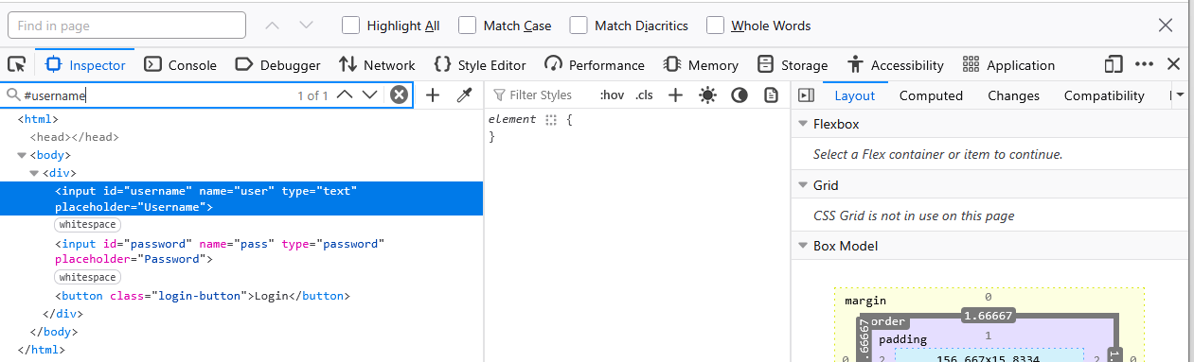

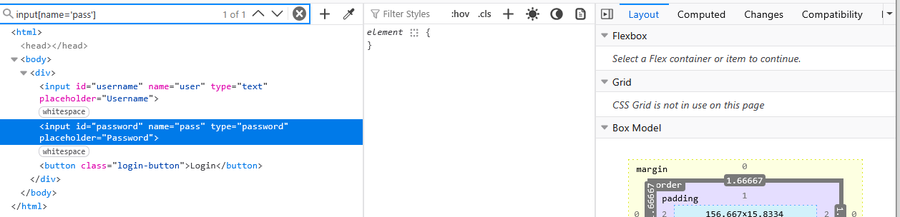

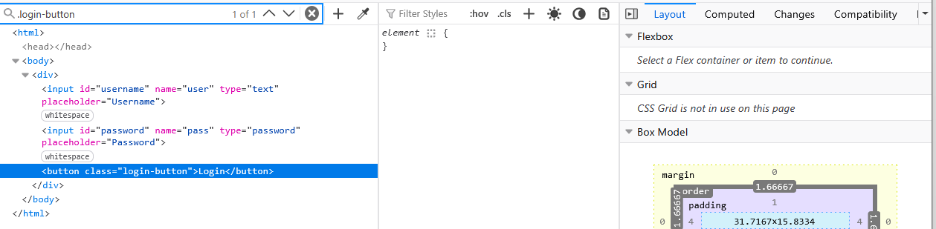

Task 2: Handling Dynamic Elements
Xpath:
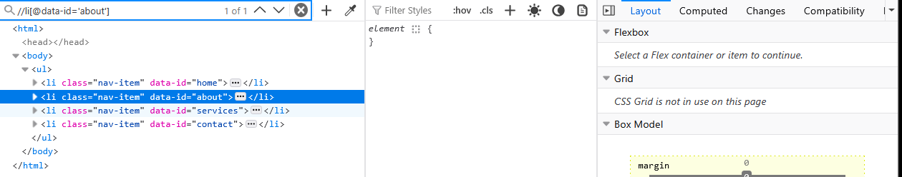
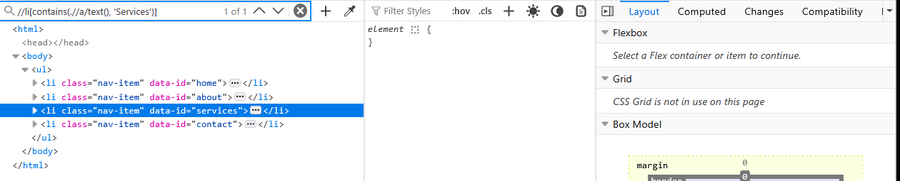
CSS Selector:
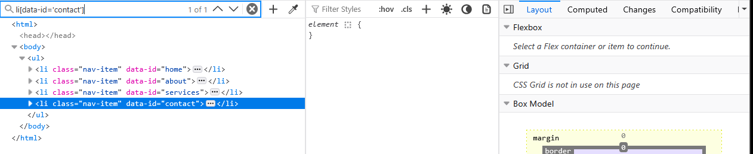

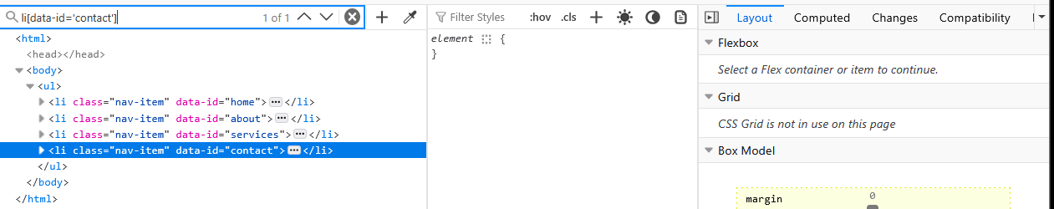

Task 3: Using XPath Axes to Navigate the DOM
Xpath:
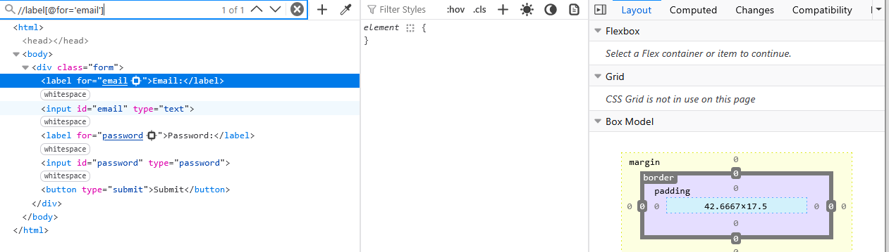
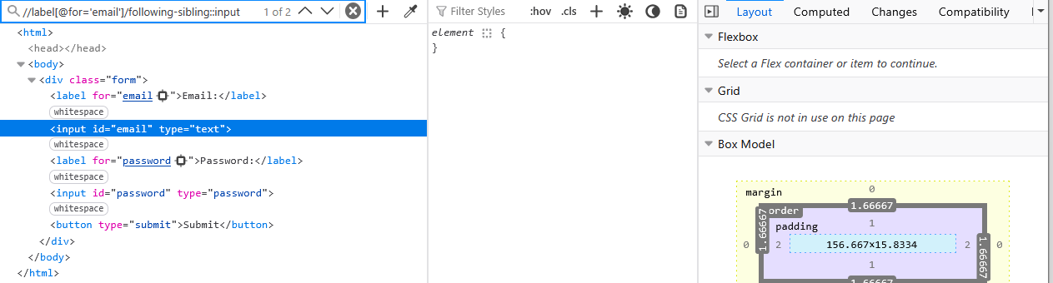
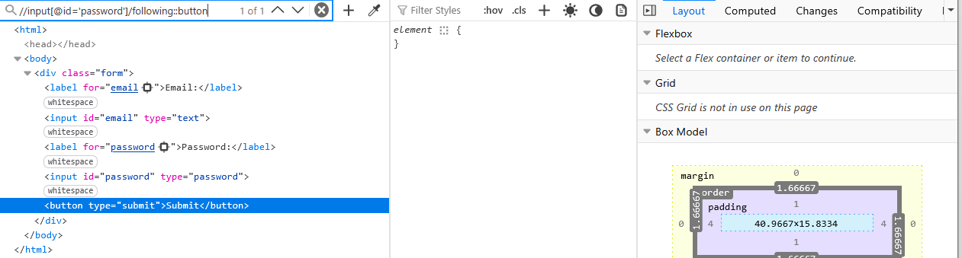

Task 4: Writing CSS Selectors with Pseudo-Classes
CSS Selectors:
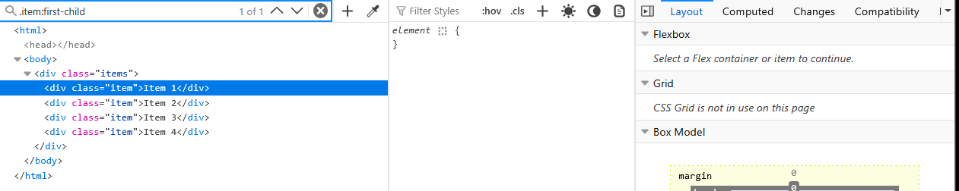
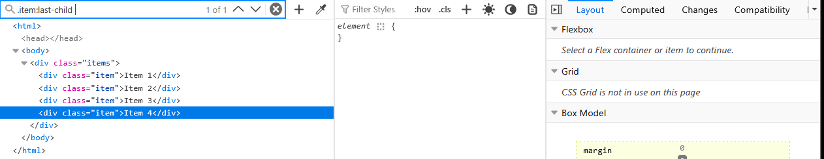
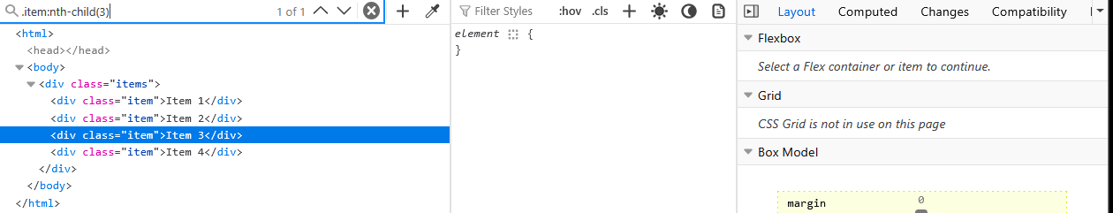

Task 5: Using XPath with Wildcards and Functions
Xpath:
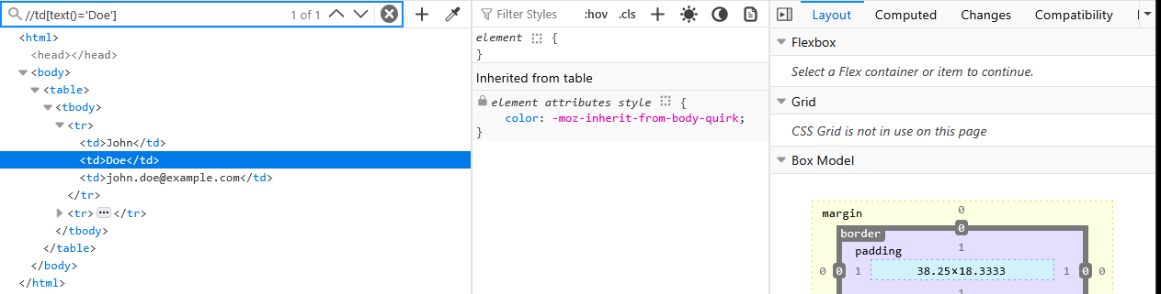
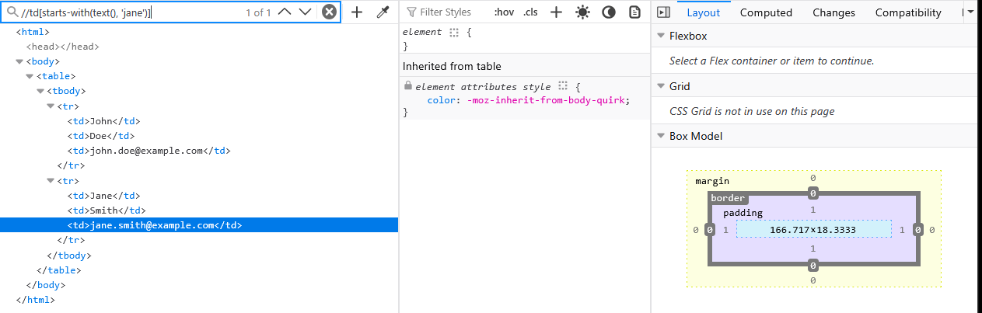
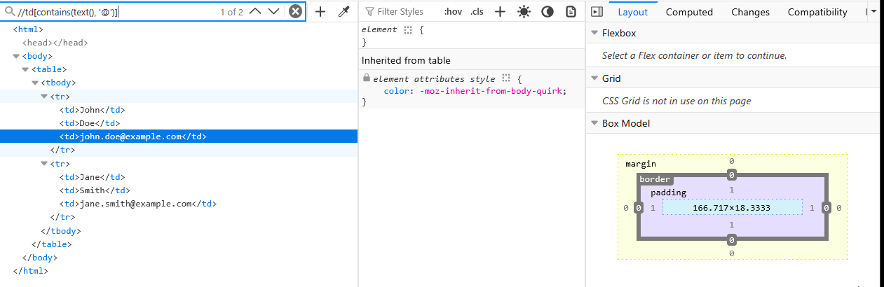

Task 6: Handling Elements with Multiple Classes
XPath:
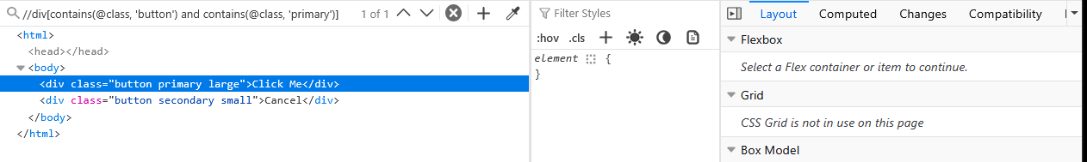

CSS Selectors:
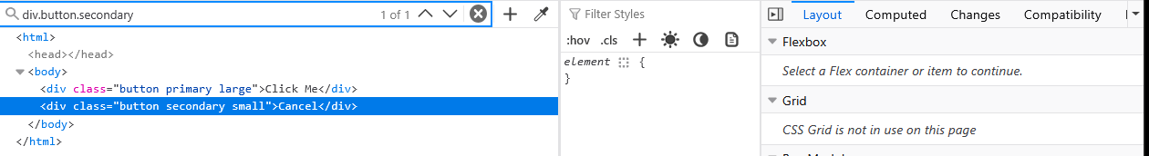

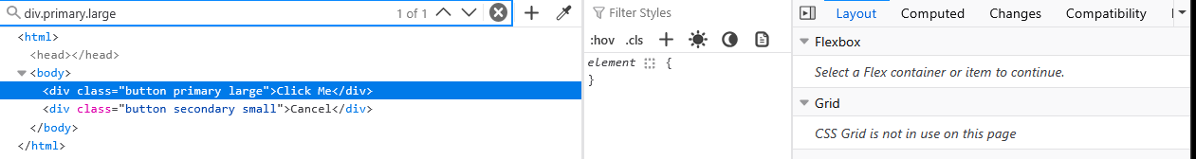

Task 7: Locating Elements Using Contains and Starts-With
Xpath:
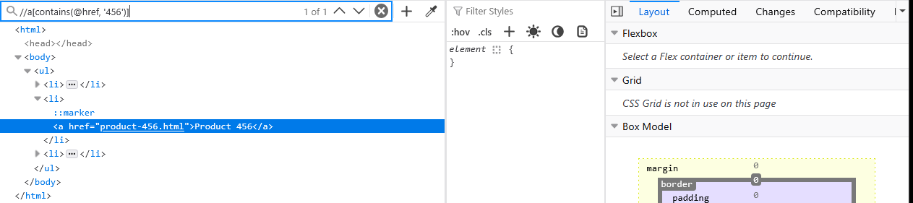
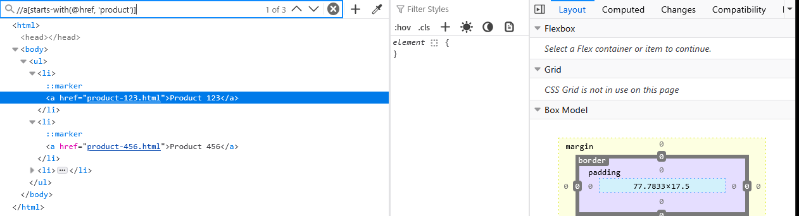
CSS Selectors:
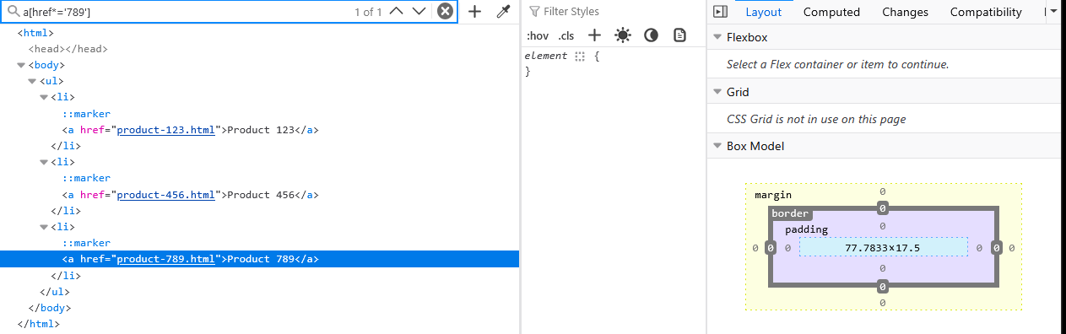

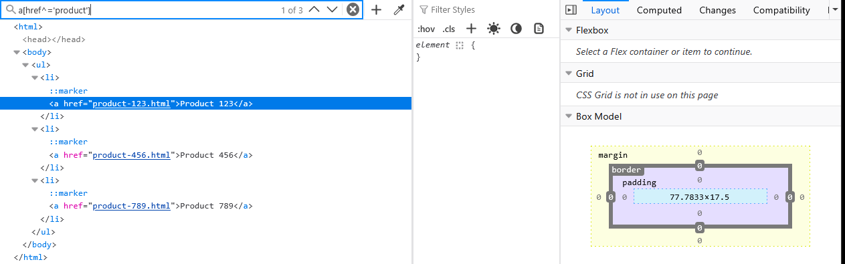

Task 8: Dynamic Element Handling in Automation Scripts
Xpath:
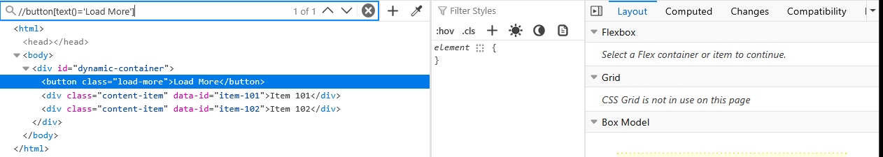
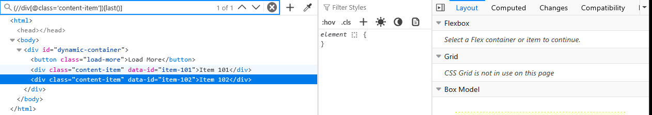
CSS Selectors:
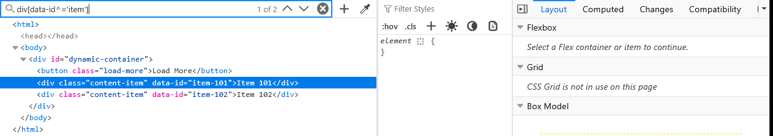

RegEx

Task 1: Basic RegEx Pattern Matching
Username validation:
^[a-zA-Z0-9]+$
Password validation:
^[a-zA-Z0-9]{8}$

Task 2: Matching Email Addresses
Email validation:
^[a-zA-Z0-9._%+-]+@[a-zA-Z0-9.-]+\.[a-zA-Z]{2,}$

Task 3: Extracting Data from Log Files
To extract timestamps:
\[(\d{4}-\d{2}-\d{2} \d{2}:\d{2}:\d{2})\]

Task 4: Validating Phone Numbers
Phone number validation for both variants:
^(\(\d{3}\) \d{3}-\d{4}|\d{3}-\d{3}-\d{4})$

Task 5: Parsing URLs
To validate URLs:
^https?:\/\/[a-zA-Z0-9.-]+\.[a-zA-Z]{2,}(:[0-9]+)?(\/.*)?$
To extract the domain name:
https?:\/\/([a-zA-Z0-9.-]+)

Task 6: Extracting Dynamic Data from HTML Content
To exctract the product data:
data-id="(\d+)".*?\$(\d+)

Task 7: Validating Dates
Date validation:
^\d{4}-\d{2}-\d{2}$

