**Extracted Watermark Visualization:** To better visualize and comprehend the extracted watermarks, the images were compared to the original watermark that was to be embedded. By putting the two against one another, extracted pixel values were put into four sets: True Positives, False Positives, False Negatives, and True Negatives. The error sets were then mildly tweaked so that would be apparent in the image; false positive intensities were slightly decreased (from the predicted 255 to 170), while false negatives were increased by the same amount (from 0 to 85). The images can be found within the **extracted** directory.

**Adaptive**  **Rate:** The adaptive rate is calculated by first measuring the smoothness of the patch. To do so, we calculate the ratio of the magnitude of the DC coefficient of the patch to the sum of the magnitudes of all the DCT coefficients. This ratio would approach 1 for smoother images and get close to zero when the high-frequency components of the patch are more prominent. Given the fact that lower rates cause less distortions, this parameter is set to the complement of the ratio explained above.

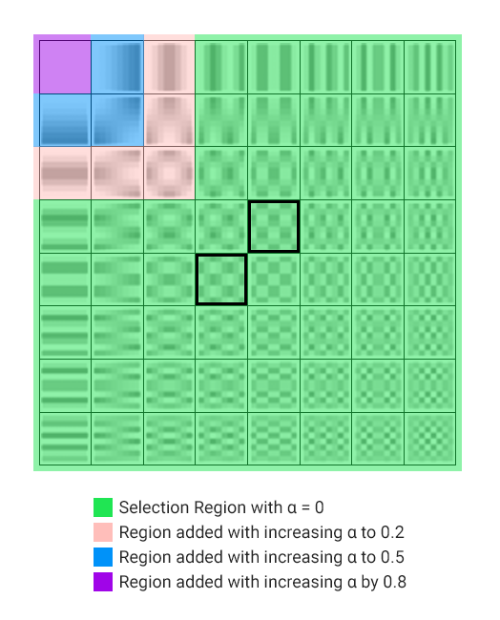**DCT Adjustments:** In order to cause the least amount of distortions within the blocks, we filled the target coefficients of the DCT with the maximum and minimum values found within a special region of the patch. The selection of this region is governed by the rate, which can be any value within the range . The larger becomes, the more low-frequency components the selection region includes. The figure below illustrates this process with an example.

* In rare cases where we’re dealing with a perfectly black patch, for which all DCT coefficients will be equal to zero, some value is drawn from the range and used for the target coefficient that must be larger. The other target will simply be filled with zero. How large this number gets is again controlled by the alpha rate.
* Furthermore, when the minimum and the maximum values of the selection region are the same, the maximum is either doubled or halved, according to the sign of the values.

|  |  |  |  |  |  |
| --- | --- | --- | --- | --- | --- |
| **Block Size: 8, A: 4** | | | | | |
| Alpha | PSNR | NC after JPEG Compression | | | |
| 40% | 60% | 80% | 100% |
| 0.0 | 36.97 | 0.51 | 0.55 | 0.69 | 0.99 |
| 0.1 | 33.35 | 0.54 | 0.58 | 0.71 | 0.99 |
| 0.5 | 28.58 | 0.59 | 0.63 | 0.75 | 0.99 |
| 1.0 | 11.45 | 0.72 | 0.73 | 0.79 | 0.99 |
| *Adaptive* | 28.70 | 0.52 | 0.56 | 0.70 | 0.99 |

|  |  |  |  |  |  |
| --- | --- | --- | --- | --- | --- |
| **Block Size: 8, A: 5** | | | | | |
| Alpha | PSNR | NC after JPEG Compression | | | |
| 40% | 60% | 80% | 100% |
| 0.0 | 40.50 | 0.47 | 0.52 | 0.57 | 0.99 |
| 0.1 | 37.23 | 0.48 | 0.55 | 0.60 | 0.99 |
| 0.5 | 33.17 | 0.51 | 0.56 | 0.63 | 0.99 |
| 1.0 | 11.26 | 0.74 | 0.75 | 0.75 | 0.99 |
| *Adaptive* | 30.32 | 0.51 | 0.57 | 0.61 | 0.99 |

|  |  |  |  |  |  |
| --- | --- | --- | --- | --- | --- |
| **Block Size: 10, A: 5** | | | | | |
| Alpha | PSNR | NC after JPEG Compression | | | |
| 40% | 60% | 80% | 100% |
| 0.0 | 38.89 | 0.61 | 0.68 | 0.80 | 0.99 |
| 0.1 | 35.84 | 0.63 | 0.68 | 0.82 | 0.99 |
| 0.5 | 32.41 | 0.65 | 0.71 | 0.81 | 0.99 |
| 1.0 | 11.41 | 0.77 | 0.79 | 0.84 | 0.99 |
| *Adaptive* | 28.93 | 0.66 | 0.70 | 0.81 | 0.99 |

|  |  |  |  |  |  |
| --- | --- | --- | --- | --- | --- |
| **Block Size: 10, A: 6** | | | | | |
| Alpha | PSNR | NC after JPEG Compression | | | |
| 40% | 60% | 80% | 100% |
| 0.0 | 41.68 | 0.54 | 0.59 | 0.72 | 0.99 |
| 0.1 | 39.05 | 0.55 | 0.61 | 0.75 | 0.99 |
| 0.5 | 32.51 | 0.60 | 0.67 | 0.76 | 0.99 |
| 1.0 | 11.28 | 0.76 | 0.77 | 0.80 | 0.99 |
| *Adaptive* | 31.20 | 0.59 | 0.64 | 0.75 | 0.99 |

|  |  |  |  |  |  |
| --- | --- | --- | --- | --- | --- |
| **Block Size: 12, A: 6** | | | | | |
| Alpha | PSNR | NC after JPEG Compression | | | |
| 40% | 60% | 80% | 100% |
| 0.0 | 40.39 | 0.59 | 0.70 | 0.82 | 0.99 |
| 0.1 | 37.76 | 0.60 | 0.70 | 0.82 | 0.99 |
| 0.5 | 31.93 | 0.65 | 0.74 | 0.83 | 0.99 |
| 1.0 | 11.40 | 0.80 | 0.80 | 0.84 | 0.99 |
| *Adaptive* | 30.19 | 0.64 | 0.72 | 0.82 | 0.99 |

|  |  |  |  |  |  |
| --- | --- | --- | --- | --- | --- |
| **Block Size: 12, A: 7** | | | | | |
| Alpha | PSNR | NC after JPEG Compression | | | |
| 40% | 60% | 80% | 100% |
| 0.0 | 42.67 | 0.55 | 0.60 | 0.73 | 0.99 |
| 0.1 | 40.46 | 0.56 | 0.61 | 0.74 | 0.99 |
| 0.5 | 35.35 | 0.60 | 0.65 | 0.77 | 0.99 |
| 1.0 | 11.33 | 0.76 | 0.77 | 0.82 | 0.99 |
| *Adaptive* | 32.08 | 0.61 | 0.66 | 0.76 | 0.99 |