Experiment Report
Course: Computer Programming
Experiment 1: C++ Basics & Expressions
Class:
Name:
Student ID:

Instructor:
Date: 2026.5.21

Experiment 1: Basics & Expressions

I. Objectives and Content
This experiment aims to practice C++ basics, which are the chapters 2-3 of the textbook.
The detailed goals of this experiment are as follows.
• Syntax Mastery: Understand preprocessor directives, main function structure, and namespace usage.
• Data Integrity: Distinguish between variables and constants, and understand memory allocation for different data types.
• Logic Development: Master operator precedence, associativity, and the side effects of assignment expressions.
• Precision Control: Learn to handle data type conversions (implicit and explicit) and format console output for readability.
Complete the following 8 programming tasks. Ensure all code includes proper documentation and follows the specific technical requirements for each problem.

II. Preparation
- Install Visual Studio Code.
- Install Compiler.
- Open a folder and terminal in Visual Studio Code.
- Set up the project folder.
- Create .cpp files.
- Compile and run.

III. Project Results

Task 1: Basic Structure & Documentation
- Description: Detailed descriptions of the code.
- Use a Block Comment to display Author, Date, Description.
/*
* Author: XXX
* Date: 2026-05-21
* Description: This program displays the user's name, department, and student ID on three separate lines.
*/
- Output name line.
// Output name line
cout << "Name: XXX" << endl; // Displays the name
- Output department line.
// Output department line
cout << "Department: School of Fundamental Studies" << endl; // Displays the department
- Output student ID line.
// Output student ID line
cout << "Student ID: XXXXXXXXXX" << endl; // Displays the student ID

- Flow Diagram:
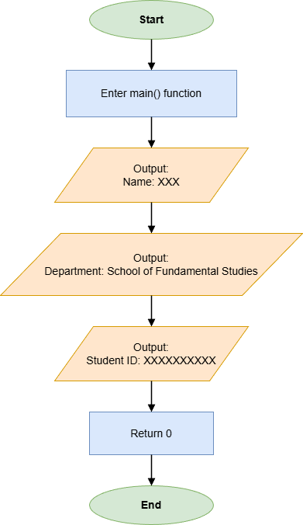

- Results (Output Screenshot): The screenshot of the output of the code.
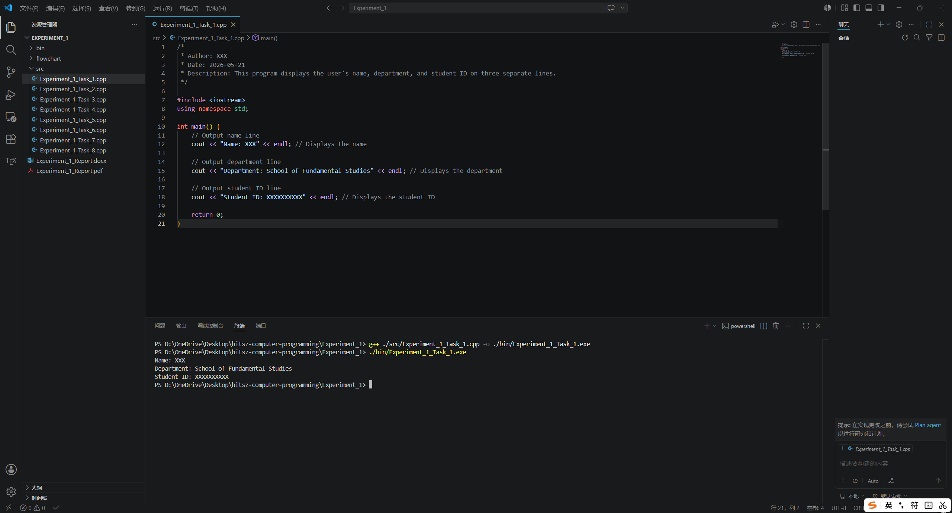

Task 2: Coin Value Calculator
- Description:
- Define each coin's value as a const unsigned int.
const unsigned int quarter = 25;
const unsigned int dime = 10;
const unsigned int nickel = 5;
const unsigned int penny = 1;
- Use unsigned int for coin counts and unsigned long for the totalValue.
unsigned int numQuarters, numDimes, numNickels, numPennies;
unsigned long totalValue = 0;
- Input the number of quarters, dimes, nickels and pennies.
cout << "Enter number of quarters: ";
cin >> numQuarters;
cout << "Enter number of dimes: ";
cin >> numDimes;
cout << "Enter number of nickels: ";
cin >> numNickels;
cout << "Enter number of pennies: ";
cin >> numPennies;
- Calculate totalValue and print it.
totalValue = (numQuarters * quarter) + (numDimes * dime) + (numNickels * nickel) + (numPennies * penny);
cout << "Total value in pennies: " << totalValue << " cents" << endl;

- Flow Diagram:
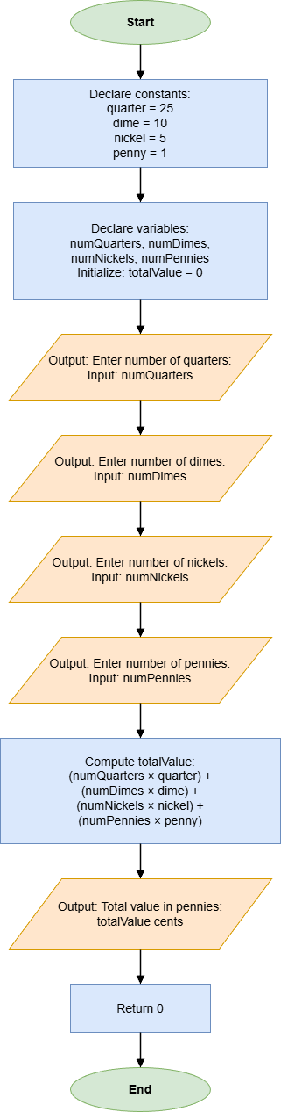
- Results (Output Screenshot):
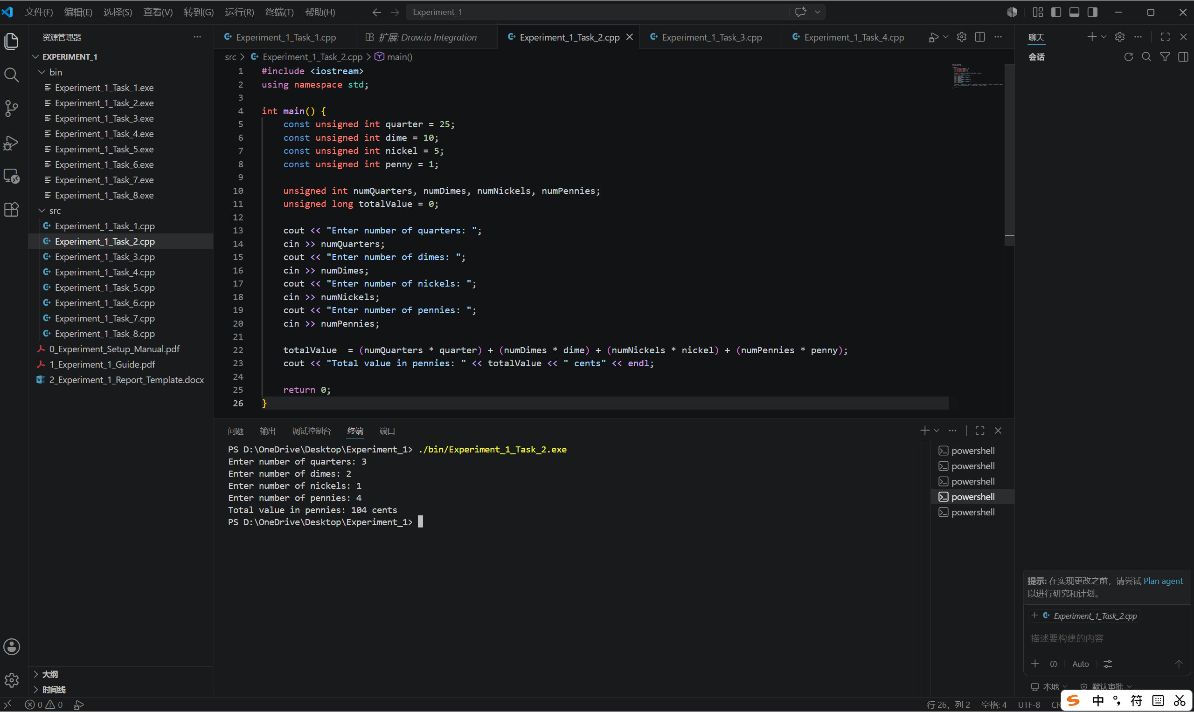

Task 3: Memory Size Analysis
- Description:
- Use the sizeof operator to print the memory size of different data types.
cout << "Size of bool is " << sizeof(bool) << " bytes" << endl;
cout << "Size of char is " << sizeof(char) << " bytes" << endl;
cout << "Size of int is " << sizeof(int) << " bytes" << endl;
cout << "Size of float is " << sizeof(float) << " bytes" << endl;
cout << "Size of double is " << sizeof(double) << " bytes" << endl;

- Flow Diagram:
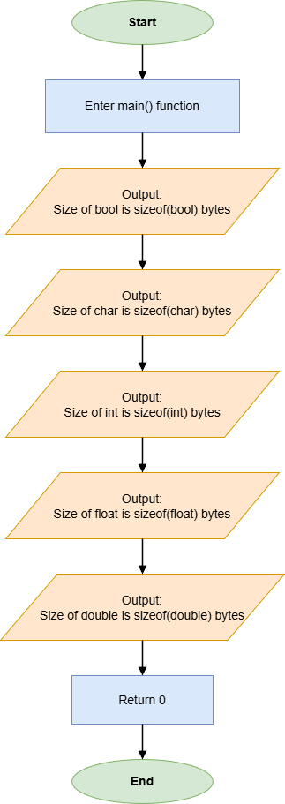
- Results (Output Screenshot):
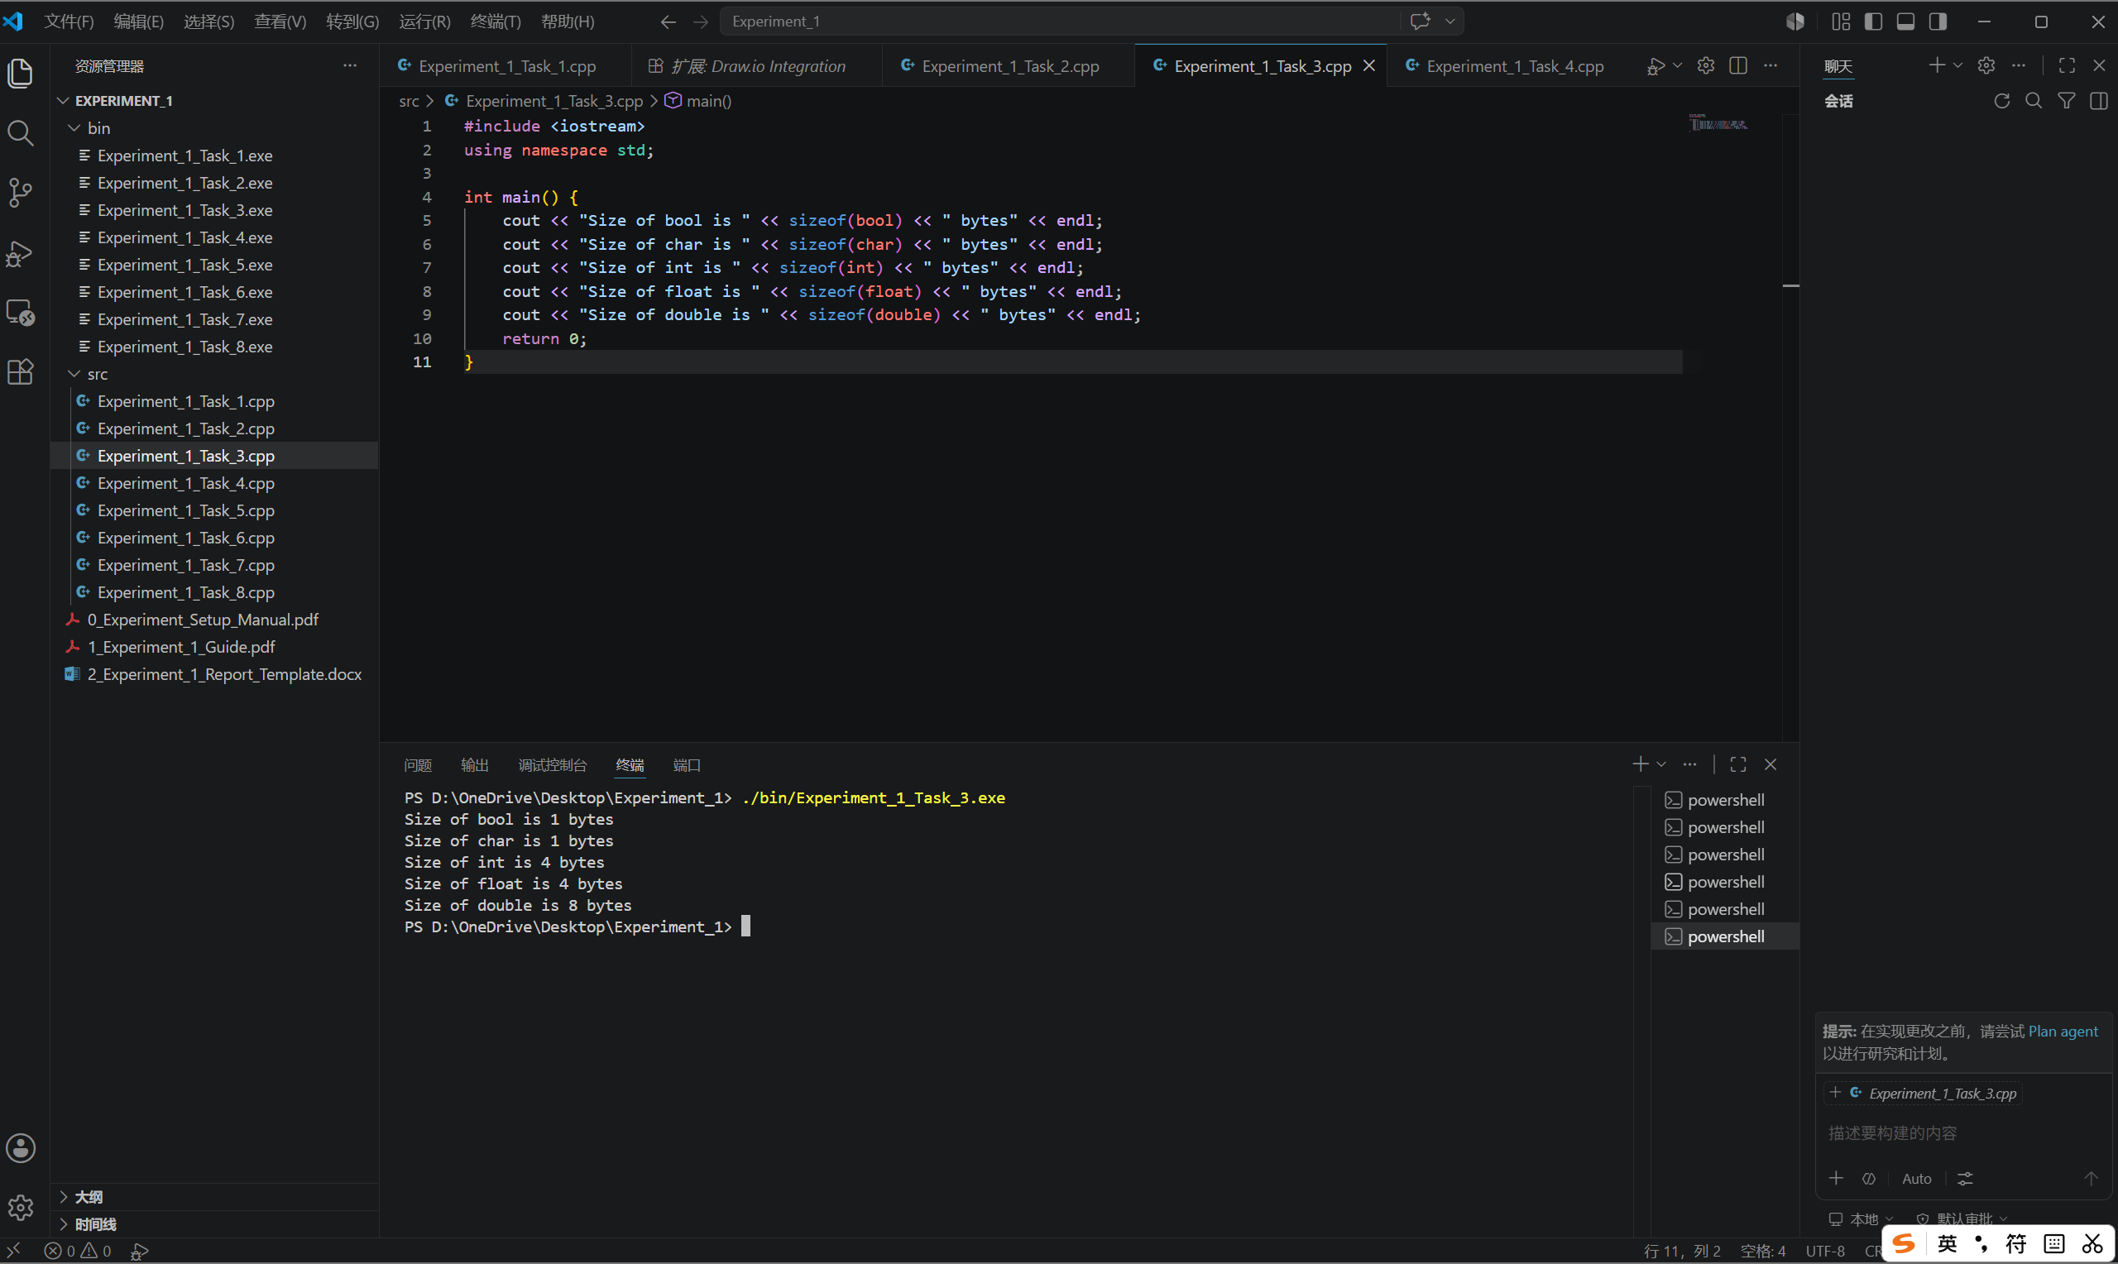

Task 4: Character and ASCII Interaction
- Description:
- Store the input in a char variable.
char character = 0;

cout << "Enter a character: ";
cin >> character;
- Display that character's decimal ASCII value using static_cast<int>().
cout << "ASCII value of '" << character << "' is: " << static_cast<int>(character) << endl;

- Flow Diagram:
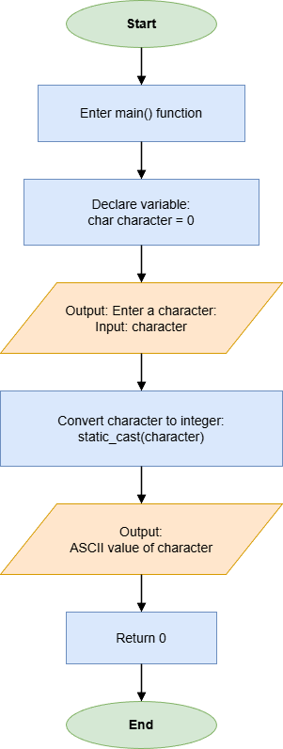
- Results (Output Screenshot):
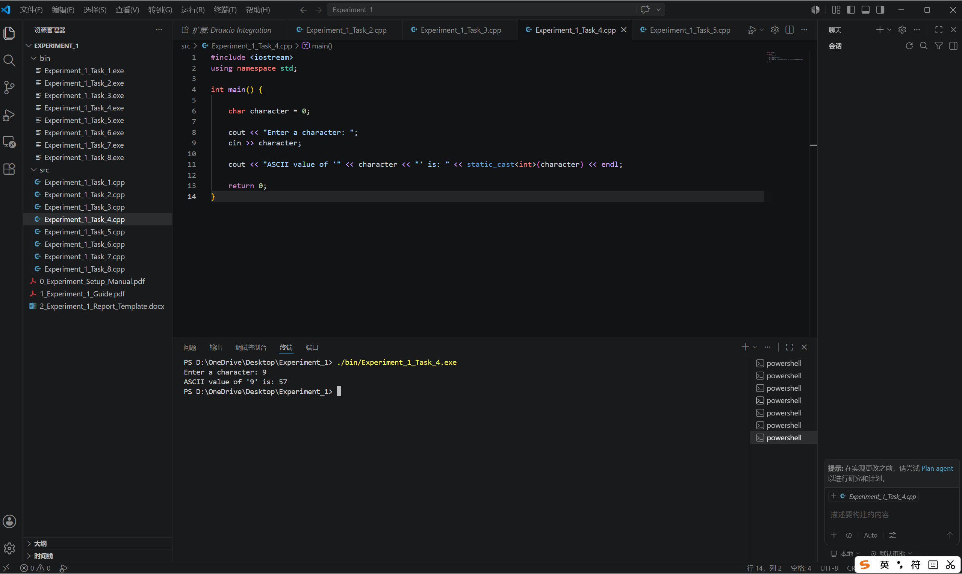

Task 5: Integer Division and Remainder Logic
- Description:
- Define the variables A and B.
int A = 0;
int B = 0;
- Input A and B.
cout << "Enter A: ";
cin >> A;
cout << "Enter B: ";
cin >> B;
- Print the Quotient and Remainder.
cout << "Quotient: " << A / B << endl;
cout << "Remainder: " << A % B << endl;

- Flow Diagram:
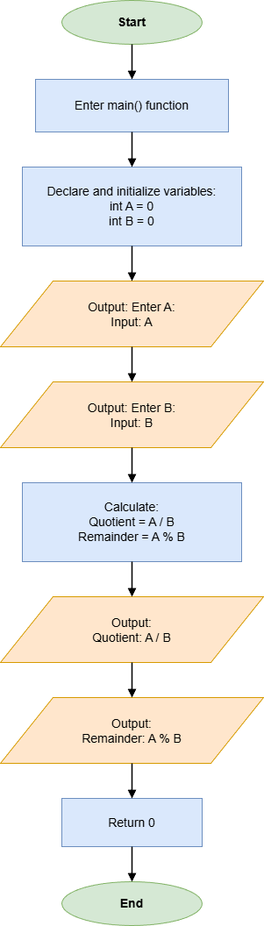
- Results (Output Screenshot):
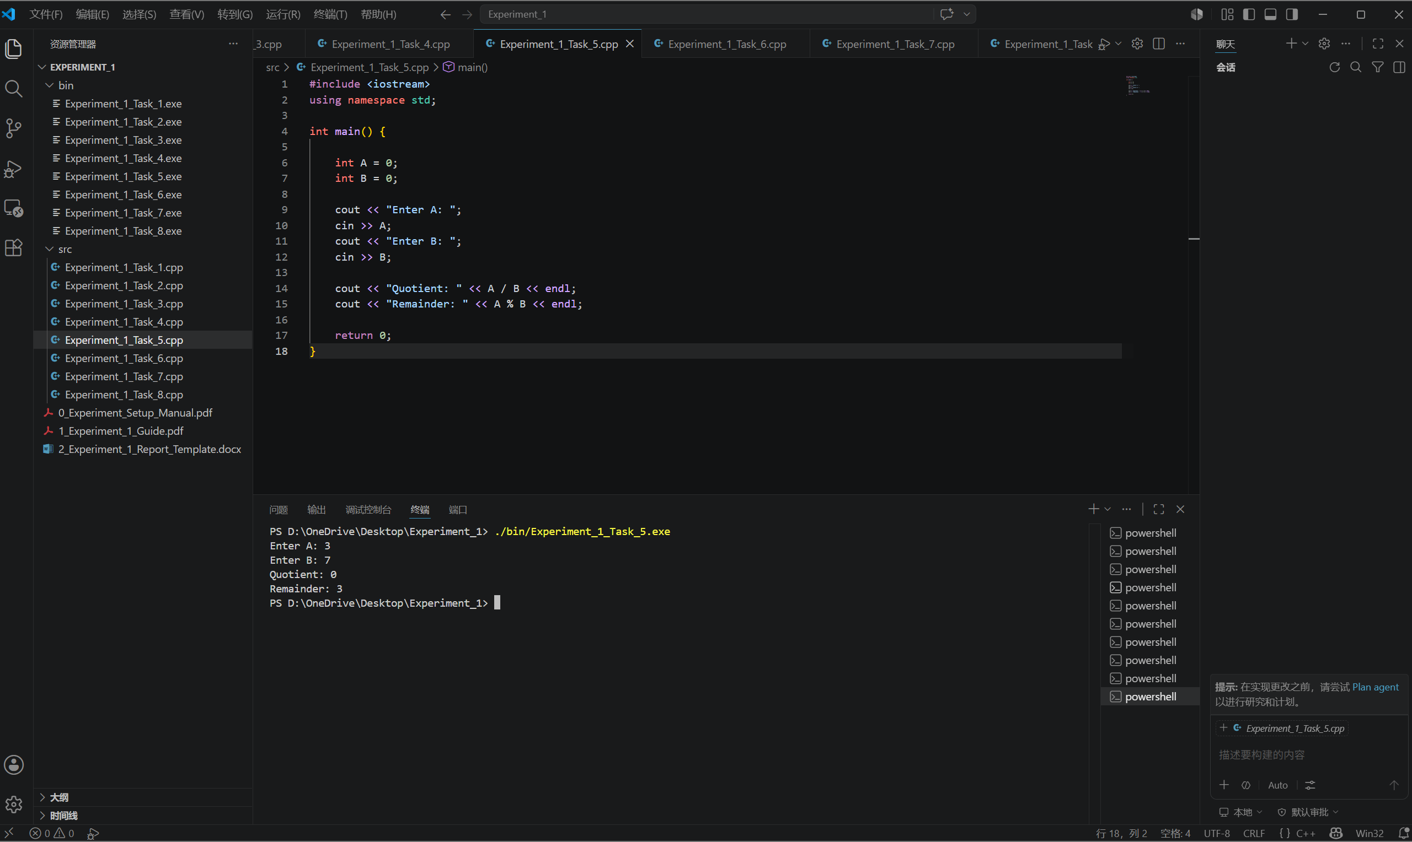

Task 6: Pythagorean Theorem
- Description:
- Input two sides of a right triangle.
int a = 0;
int b = 0;

cout << "Enter side a: ";
cin >> a;
cout << "Enter side b: ";
cin >> b;
- Calculate the hypotenuse and print it in double and int.
double H_d = sqrt(pow(a, 2) + pow(b, 2));
int H_i = static_cast<int>(H_d);

cout << "Hypotenuse (double): " << H_d << endl;
cout << "Hypotenuse (int): " << H_i << endl;

- Flow Diagram:
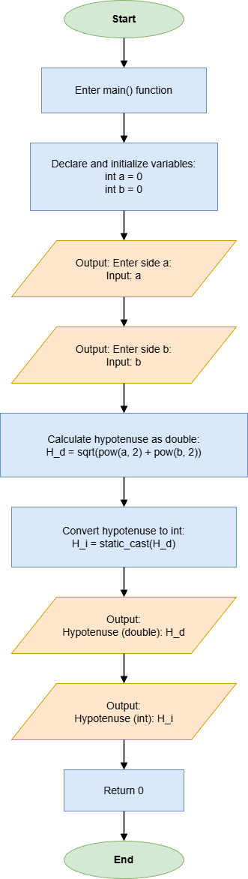
- Results (Output Screenshot):
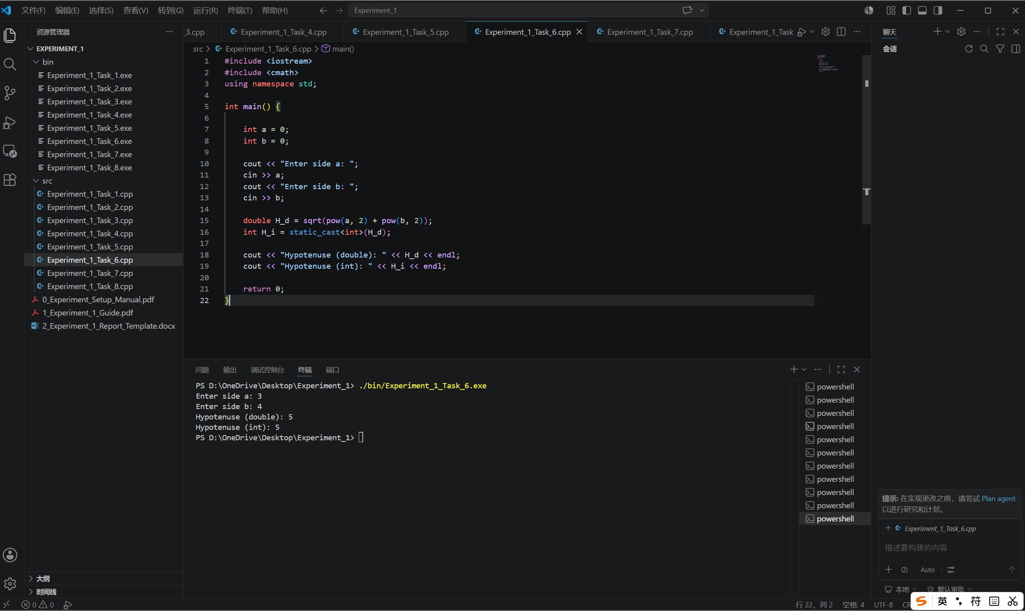

Task 7: Integer Overflow Observation
- Description:
- Initialize an unsigned int with the value 4294967295 and display it.
unsigned int max = 4294967295;

cout << "Initial value: " << max << endl;
- Add 1 to it and print the result.
max = max + 1;

cout <<"After adding 1: " << max << endl;

- Flow Diagram:
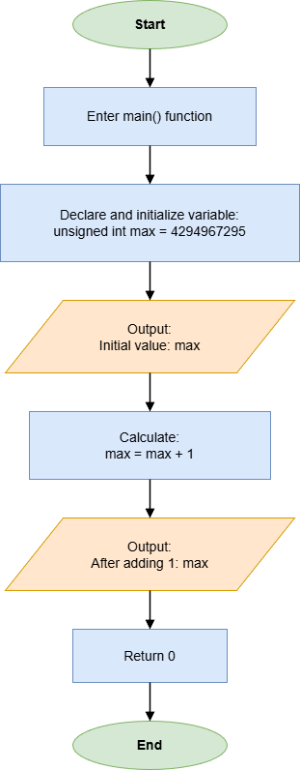
- Results (Output Screenshot):
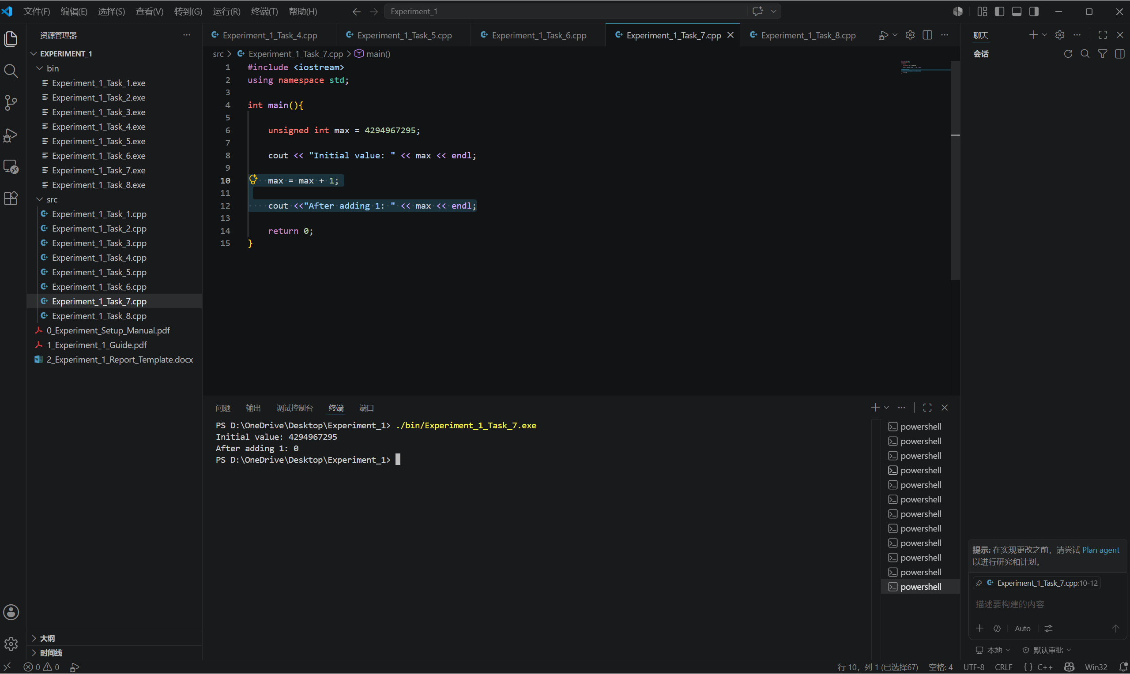

Task 8: Professional Invoice Formatting
- Description:
- Input the prices of three items.
double price1 = 0;
double price2 = 0;
double price3 = 0;

cout << "Enter prices of three items: ";
cin >> price1 >> price2 >> price3;
- Calculate subtotal, tax(8.5%), and total.
double subtotal = price1 + price2 + price3;
double tax = subtotal * 0.085;
double total = subtotal + tax;
- Format console output using <iomanip>.
cout << fixed << setprecision(2);
cout << left << setw(15) << "Item" << right << setw(15) << "Prices" << endl;
cout << left << setw(15) << "Item 1" << right << setw(15) << price1 << endl;
cout << left << setw(15) << "Item 2" << right << setw(15) << price2 << endl;
cout << left << setw(15) << "Item 3" << right << setw(15) << price3 << endl;
cout << left << setw(15) << "Subtotal" << right << setw(15) << subtotal << endl;
cout << left << setw(15) << "Tax(8.5%)" << right << setw(15) << tax << endl;
cout << left << setw(15) << "Total" << right << setw(15) << total << endl;

- Flow Diagram:
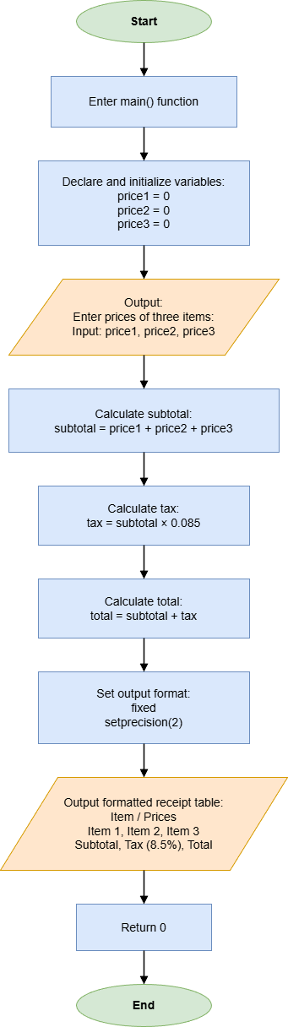
- Results (Output Screenshot):
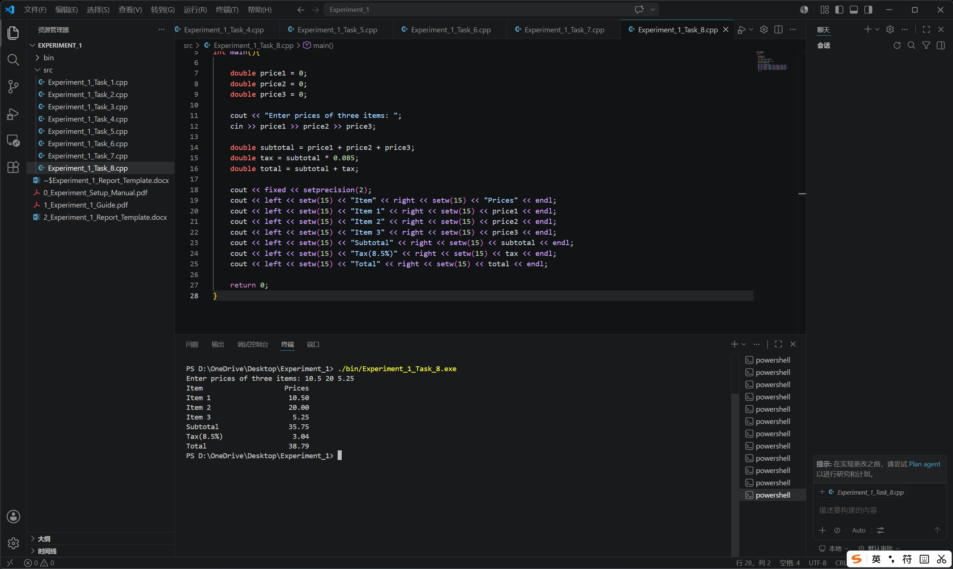

IV. Extended Questions
- In Task 5, when A = 3 and B = 7, why is the quotient 0?
Because A and B are both integers, C++ performs integer division. The mathematical result of 3 / 7 is approximately 0.4286, but integer division discards the fractional part instead of rounding it. Therefore, the quotient is 0 and the remainder is 3.
- In Task 7, why does the value become 0 after adding 1 to 4294967295?
The value 4294967295 is the maximum value of a 32-bit unsigned int. Adding 1 produces 4294967296 mathematically, but this value is outside the storage range. Unsigned integer arithmetic wraps around modulo 2³², so the result returns to 0.

V. Summary and Reflections
In this experiment, I practiced the basic knowledge of C++ programming, including program structure, comments, variables, constants, data types, operators, type conversion, mathematical functions, and formatted output. Through the eight tasks, I became more familiar with writing, compiling, running, and checking simple C++ programs.
In Task 1, I learned the basic structure of a C++ program and practiced using comments to make the code clearer.
In Task 2, I used constants and unsigned integer variables to calculate the total value of coins, which helped me understand the difference between constants and variables.
In Task 3, I used the sizeof operator to observe the memory size of different data types.
In Task 4, I converted a character to its ASCII value using static_cast<int>(), which helped me understand character storage and type conversion.
In Task 5, I practiced integer division and the remainder operator. I learned that integer division discards the fractional part.
In Task 6, I used the Pythagorean theorem with sqrt() and pow() to calculate the hypotenuse, and observed the difference between double and int results.
In Task 7, I observed unsigned integer overflow, which showed that computer arithmetic is limited by data type ranges.
In Task 8, I used <iomanip> to format an invoice output, making the result clearer and more professional.
During the experiment, the main difficulties I encountered were how to compile .cpp files correctly and how to use <iomanip> to control decimal places and format the output professionally. At first, I was not familiar with the compiling process in Visual Studio Code, so I needed to learn how to open the terminal, use the correct command, and run the generated program. In Task 8, I also spent time learning how to use fixed, setprecision(), setw(), left, and right to make the invoice output neat and readable. By testing the programs several times and asking AI, I gradually solved these problems. Overall, this experiment helped me build a basic foundation in C++ programming and improved my ability to write and run simple programs.

