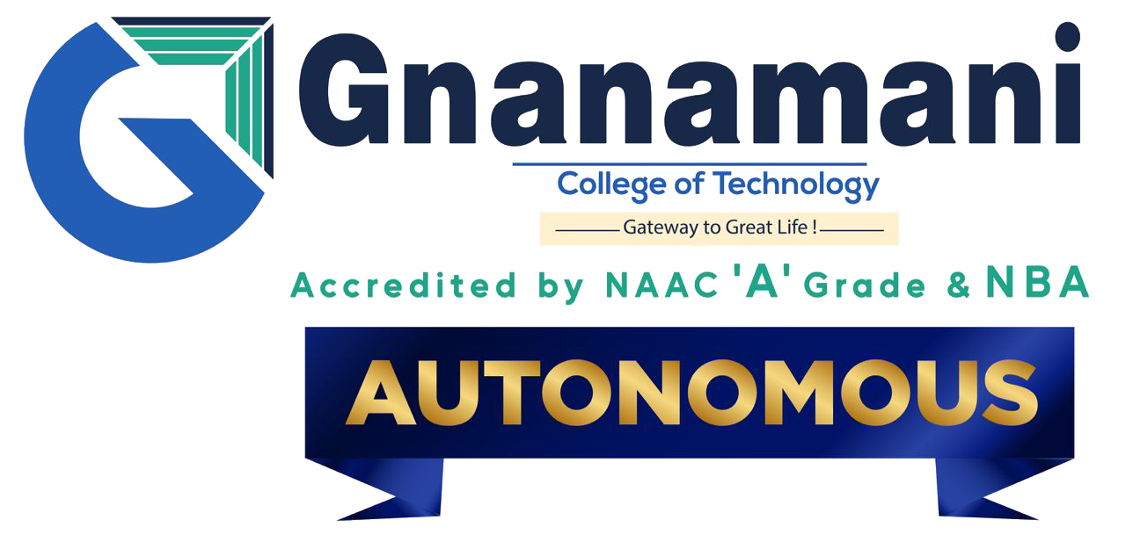

Department: BIO MEDICAL ENGINEERING

PHASE 5 PROJECT SUBMISSION

Year: III rd. YEAR

TOPIC: SMART WATER MANAGEMENT

Team members

1.Gowri Sankar. S

2.Kaushik. E

3.Jegan. S

4.Hari Krishnan.K

5.Gowtham. V

Presented by,

Gowtham V

**Abstract:**

**“IoT-based Smart Water Management is a technology-driven approach aimed at efficiently monitoring, controlling, and optimizing water usage in various applications. Leveraging interconnected devices, sensors, and data analytics, this system ensures the intelligent management of water resources. By collecting real-time data on consumption, leakages, and environmental conditions, IoT enables proactive decision-making, reducing wastage, and enhancing sustainability. The integration of IoT in water management systems holds the potential to address challenges in water conservation, improve infrastructure, and ensure a more efficient, responsive, and sustainable water supply.”**

**Introduction:**

**“In recent years, the convergence of the Internet of Things (IoT) with water management has paved the way for innovative solutions to address the increasing global concerns regarding water scarcity, quality, and sustainable usage. The integration of IoT technologies in water management systems has allowed for the development of smart solutions capable of real-time monitoring, data-driven decision-making, and efficient resource allocation. This introduction explores the fundamental concepts, the significance of IoT in water management, the challenges it addresses, and the potential benefits it offers in creating more resilient, adaptive, and sustainable water systems.”**

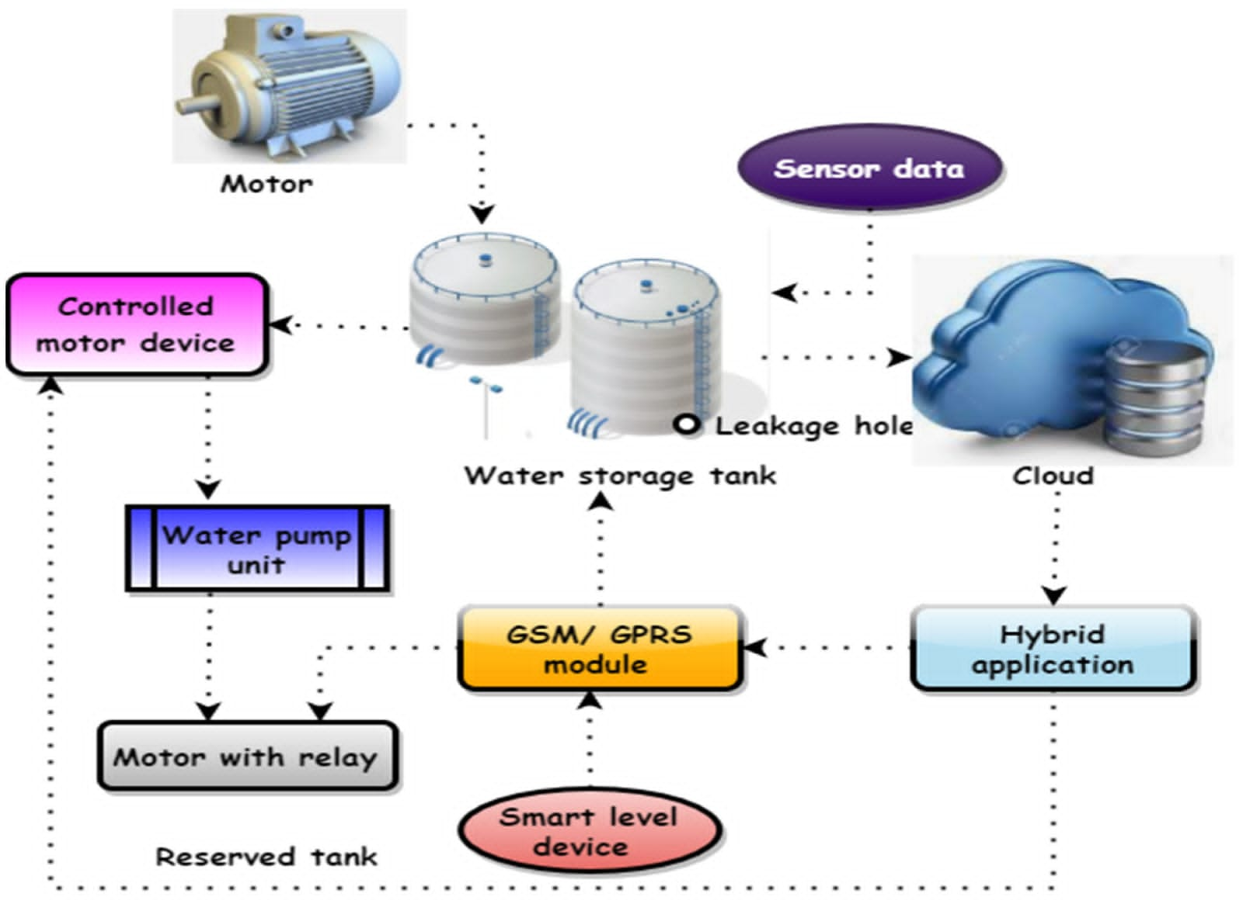

**Problem** **Statement**:

* The growing demand for water resources coupled with inefficient usage, leakages, and inadequate monitoring has led to the need for an innovative solution that can effectively manage, monitor, and optimize water usage in both residential and industrial settings. The goal is to create a comprehensive IoT-based system that addresses these challenges by:

1. Real-time Monitoring: Develop a network of IoT sensors and devices to track water consumption, detect usage patterns, and identify anomalies or leaks promptly.
2. Data Analytics and Insights: Implement robust data analysis techniques to interpret the collected information, offering actionable insights and trends in water usage for efficient decision-making.
3. Remote Control and Management: Enable remote access and control of water systems via IoT-connected applications, allowing users to adjust usage, set preferences, and receive alerts for potential issues.
4. Water Quality Monitoring: Integrate sensors to assess water quality parameters, ensuring that the water meets safety and quality standards for various applications.
5. Scalability and Cost-effectiveness: Design the system to be scalable, cost-effective, and adaptable to various settings, from individual households to large industrial units.

**Methodology**

Certainly! The methodology for developing an IoT-based smart water management system involves two primary aspects: hardware development and app development**.**

**Hardware Development:**

1. Requirements Gathering: Understand the specific needs and constraints for sensor integration, considering water flow, quality monitoring, leak detection, and remote control capabilities.
2. Sensor Selection and Prototyping: Choose appropriate sensors and devices capable of measuring water parameters such as flow, quality, pressure, and leak detection. Create prototypes for testing.
3. Hardware Design and Integration: Develop the hardware components, integrating selected sensors, microcontrollers, communication modules, and power sources to create functional units.
4. Prototyping and Testing: Build prototypes and conduct thorough testing to ensure accuracy, reliability, and compatibility with the IoT network.
5. Manufacturing and Production: Once the prototypes are validated, move to production, ensuring the scalability and consistency of hardware units to meet demand.
6. Quality Assurance and Compliance: Ensure that the hardware meets quality standards, certifications, and regulatory compliance related to water monitoring and safety.

**App Development:**

1. Functional Requirements Gathering: Understand the user interface requirements, such as real-time data visualization, user control features, alerts, and analytics.
2. Design and Wireframing: Create wireframes and design the user interface for the application, considering ease of use, intuitive navigation, and information display.
3. Front-end Development: Develop the graphical interface using appropriate programming languages and tools, ensuring compatibility with various devices (mobile, web).
4. Back-end Development: Set up the server, database, and necessary APIs for seamless communication between the IoT hardware and the application.
5. Integration Testing: Integrate the developed app with the IoT hardware for testing the real-time data flow, remote control functionalities, and synchronization.
6. Security and Privacy Implementation: Implement robust security measures to protect user data and ensure secure communication between the app and the IoT system.
7. Testing and Debugging: Thoroughly test the application for usability, responsiveness, and functionality, addressing any bugs or issues that arise.
8. Deployment and Maintenance: Deploy the application to the intended platforms (App Store, Google Play, etc.), and ensure a maintenance plan for updates, bug fixes, and improvements.

**Working principle of prototype**

**1.** sensor Integration: The prototype incorporates selected sensors for measuring water flow, quality, pressure, and other relevant parameters. These sensors are connected to a microcontroller or IoT device.

2. Data Collection and Transmission: The sensors collect data regarding water usage, quality, and any anomalies (such as leaks). This data is processed and transmitted via a communication module, such as Wi-Fi, Bluetooth, or other IoT protocols.

3. Central System or Hub: The collected data is sent to a central hub or system. This system aggregates, stores, and processes the incoming data for analysis.

4. Data Processing and Analytics: The central system employs algorithms for data processing and analytics to identify patterns, anomalies, and trends in water usage or quality.

5. User Interface (App or Interface): A basic user interface (app or web-based) might be developed to visualize the data collected from the prototype. This interface provides users with a basic overview of the water-related parameters being monitored.

6. Testing and Validation: The prototype undergoes rigorous testing to ensure its functionality, accuracy, and reliability. It is tested for scenarios such as leak detection, remote control functionalities, and responsiveness of the system.

1. Feedback and Iteration: Based on the testing results and feedback, improvements and modifications are made to enhance the prototype's effectiveness and accuracy.

**Python program**

# Simulated sensor data collection

import random

import time

def collect_water_data():

# Simulating water flow, quality, and pressure data

water_flow = random.uniform(1.0, 20.0) # Simulated flow in liters per minute

water_quality = random.randint(0, 100) # Simulated water quality index

water_pressure = random.uniform(10.0, 100.0) # Simulated pressure in psi

return water_flow, water_quality, water_pressure

# Simulated data transmission to a central system

def transmit_data(flow, quality, pressure):

# Here, data would be transmitted to a central server or system in a real implementation

print(f"Data - Flow: {flow} L/min, Quality: {quality}, Pressure: {pressure} psi transmitted.")

# Main loop simulating continuous data collection and transmission

while True:

water_flow, water_quality, water_pressure = collect_water_data()

transmit_data(water_flow, water_quality, water_pressure)

time.sleep**(**5**) #** Simulating a time interval for data transmission (5 seconds)

**Results and observations**

The results and observations of an IoT-based smart water management system can yield several key insights and outcomes:

1. Real-time Monitoring: The system enables real-time monitoring of water usage, allowing users to track their consumption patterns and make informed decisions about their water usage habits.

2. Leak Detection and Alerts: Detecting leaks promptly can significantly reduce water wastage. The system's ability to identify anomalies and send alerts allows for immediate action to mitigate losses.

3. Water Quality Control: Continuous monitoring of water quality ensures that water meets safety standards. Observations may reveal trends in water quality fluctuations, helping in the identification of potential issues or necessary system improvements.

4. Data Analytics and Insights: Data collected over time allows for in-depth analysis. Insights derived from this data can highlight patterns, peak usage times, trends, and areas where improvements or optimizations can be made.

5. User Behavior Changes: The system's feedback and information provided to users can influence behavioral changes, encouraging more efficient water use, leading to potential conservation and cost savings.

6. System Efficiency and Performance: Observations will assess the system's overall efficiency and performance. It includes responsiveness, accuracy of data collected, and the system's reliability in detecting anomalies and providing alerts.

7. Environmental Impact and Sustainability: By optimizing water usage, the system contributes to sustainability efforts, potentially reducing environmental impact through decreased water wastage and more responsible resource utilization.

1. Cost Savings and Resource Optimization: Improved efficiency in water management can lead to cost savings, both for individual users and larger-scale applications. These savings could come from reduced water bills and optimized resource allocation
2. Scalability and Adaptabilit: Observations regarding the system’s scalability and adaptability will help assess its ability to be implemented across different environments and scaled to meet varying demands

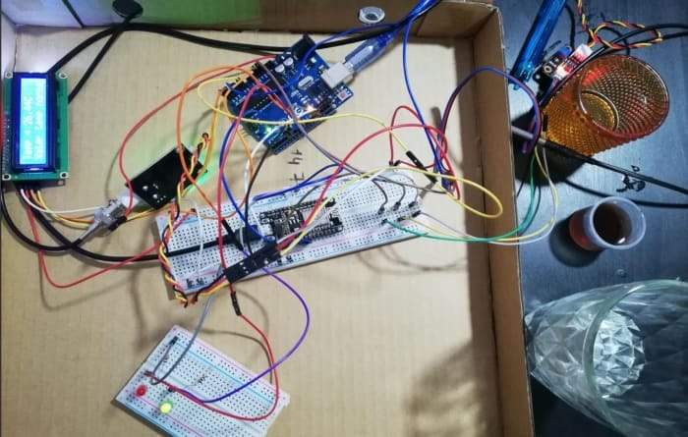

**Conclusion**

An IoT-based smart water management system offers real-time monitoring, data-driven insights, and automated controls, optimizing water usage, detecting leaks, and enhancing conservation efforts. This system empowers efficient resource management, reduces wastage, and facilitates proactive maintenance, ultimately contributing to sustainable and smarter water utilization.