Group 2 -Homework #3

Data 621 – Business Analytics

Logistic Regression

April 9, 2018

Group 2

Sharon Morris

Brian Kreis

Keith Folsom

Michael D’acampora

Valerie Briot

Contents

Objective 2

Approach 2

Dataset 2

Data Exploration 3

Basic Data Exploration and Statistic measures 3

Density and Box Plots 4

Outliers 5

Variable-to-Variable Analysis 6

Correlation between Variables 9

Multicollinearity 10

Data Preparation 10

Transformations 12

Model Building 13

Model 1 : Baseline using all Predictor Variables 13

Model 2 : Baseline using Transformed Variables 14

Model 3 : AIC Stepwise Variable Selection 16

Model 4 : Using VIF Reduction with Transformed Predictor Variables 17

Model 5 : Using BestGlm using Transformed Predictors 18

Model Selection and Evaluation 21

Model Selection 21

(i) Parsimony 21

(ii) Goodness-of-fit 21

(iii) Predictive accuracy 21

Evaluation 25

Load & Transformation of Data Set 25

Conclusion 26

Reference 26

Appendix - R Code: 27

# Objective

Our Data Analytics team has been tasked with the creation of a binary logistic regression model that will be used to predict whether a neighborhood will be at risk for high crime levels. This model could presumably be used to deploy the crime prevention resources of a municipality more effectively by targeting the most at risk neighborhoods.

Our objective is to predict whether a neighborhood will have a higher than median crime rate (1) or not (0). Since we are attempting to predict a binary outcome, we will build a binary logistic regression model on the provided data in order to predict whether the neighborhood will be at risk for high crime levels.

# Approach

The team met to discuss the project and organized ourselves into task groups in order to be able to produce the deliverable on time.

The following tasks were assigned:

**Data Exploration & Data Preparation**  
Since the data sets were provided, it was crucial that we understand the data set and determine whether any missing values are present.

**Model Building & Model Selection**  
We will develop multiple models and ensure that the model selections take into consideration the business requirements.

Github was used to manage the project. Using Github helped with version control and ensured each team member had access to the latest version of the project documentation.

Slack was used for daily communication during the project and for quick access to code and documentation. Meetings were organized at least twice a week and as needed using “Go to Meeting”.

**Team Members**  
- Sharon Morris

- Brian Kreis

- Keith Folsom   
- Michael D’acampora  
- Valerie Briot

# Dataset

For reproducibility of the results, the data was loaded to and accessed from a Github repository. The age variable was rounded to a whole number. The training data set has 13 variables (including the outcome variable) and 466 observations.

# Data Exploration

## Basic Data Exploration and Statistic measures

The following variables comprise the data set. The response variable (Target) is the variable of interest. The response variable is binary (0, 1) and identifies whether the crime rate is above the median crime rate. The remaining 12 variables are predictors. All variables are numeric.

|  |  |  |  |
| --- | --- | --- | --- |
| Variable Name | Definition | Variable Type | Data Type |
| zn | proportion of residential land zoned for large lots (over 25000 square feet) | Predictor | quantitative |
| indus | proportion of non-retail business acres per suburb | Predictor | quantitative |
| chas | a dummy var. for whether the suburb borders the Charles River (1) or not (0) | Predictor | categorical |
| nox | nitrogen oxides concentration (parts per 10 million) | Predictor | quantitative |
| rm | average number of rooms per dwelling | Predictor | quantitative |
| age | proportion of owner-occupied units built prior to 1940 | Predictor | quantitative |
| dis | weighted mean of distances to five Boston employment centers | Predictor | quantitative |
| rad | index of accessibility to radial highways | Predictor | quantitative |
| tax | full-value property-tax rate per $10,000 | Predictor | quantitative |
| ptratio | pupil-teacher ratio by town | Predictor | quantitative |
| lstat | lower status of the population (percent) | Predictor | quantitative |
| medv | median value of owner-occupied homes in $1000s | Predictor | quantitative |
| target | whether the crime rate is above the median crime rate (1) or not (0) | Response | Categorical |

Descriptive statistics were calculated to examine the basic features of the data. Each variable has 466 observations. At first glance, we do not have missing data.



From the skewness coefficient and the kurtosis, it appears that variables zn, chas, rad, and medv show some skewness. We will now look at the density plots and box plots for better insight into each variable distribution.

# Density and Box Plots

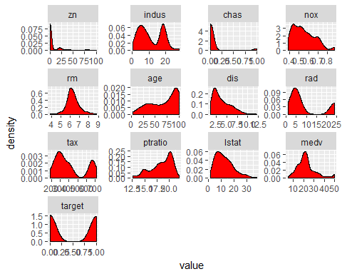

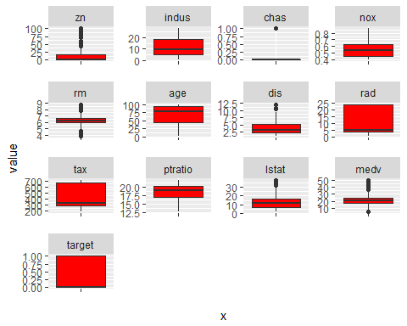

The density plot of predictor variables confirms that the zn, chas, dis, lstat predictor variables are hightly skewed. The rm variable is the only predictor that is normally distributed. The Box Plots also show the presence of some outliers.

We will take a closer look at the possible outliers for each variable.

## Outliers

**zn**

This variable is hightly skewed to the left. The range is from 85-100.

Outliers for zn : 100, 95, 90, 85, 82.5

**indus**

This predictor variable is bi-modal.

Outliers for indus : none

**nox**

This variable is skewed to the left.

Outliers for nox : none

**rm**

Outliers for rm : 8.78, 8.725, 8.704, 4.138, 3.863

**age**

Outliers for age : none

**dis**

Outliers for dis : 12.1265, 10.7103, 10.5857

**rad**

Outliers for rad : none

**tax**

Outliers for tax : none

**ptratio**

Outliers for ptratio : none

**lstat**

Outliers for lstat : 37.97, 36.98, 34.77, 34.41, 34.37

**medv**

Outliers for lstat :

This complete our univariate exploratory data anlaysis. We will now look at variables with respect to each other.

## Variable-to-Variable Analysis

We will now look at all the predictor variables compared to each other and the response, with red values showing observations where the crime rate exceeded the median.

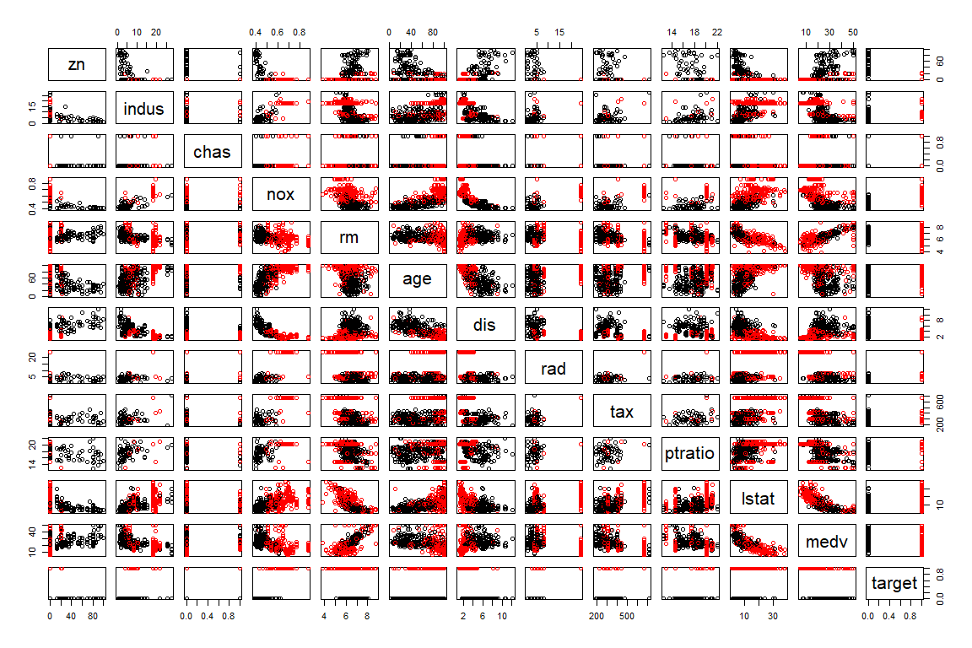

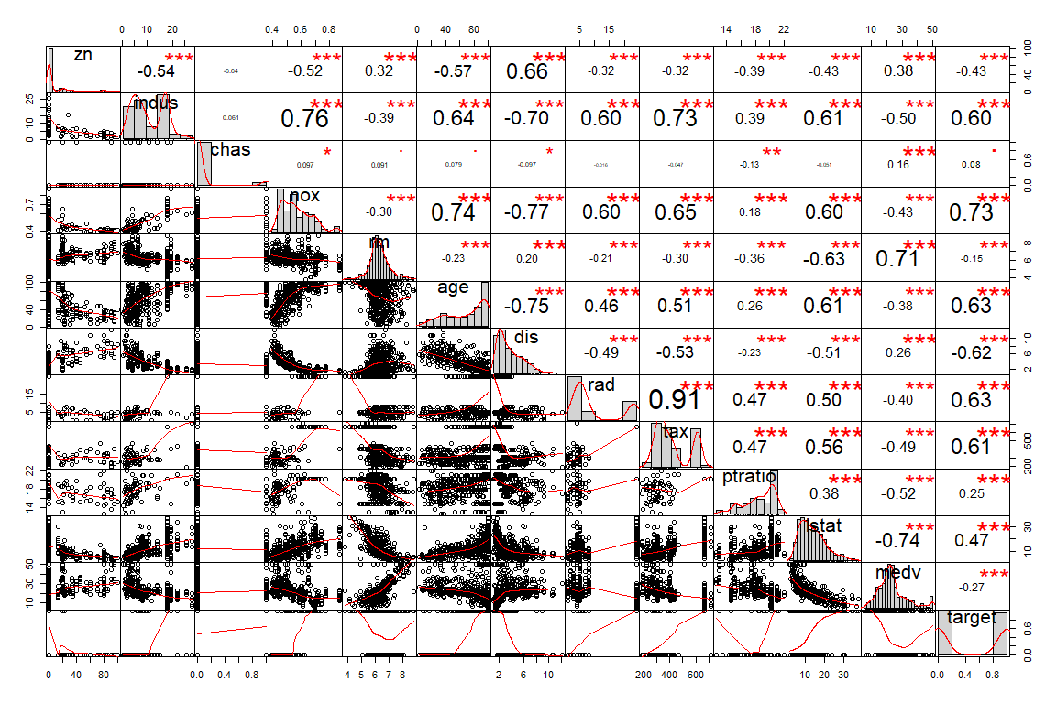

## Correlation between Variables

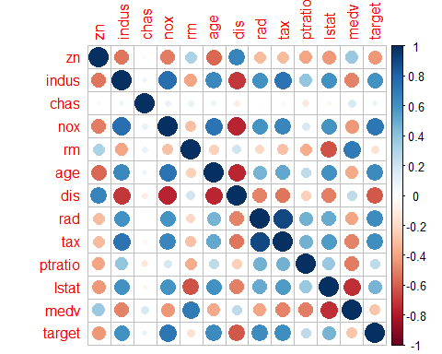

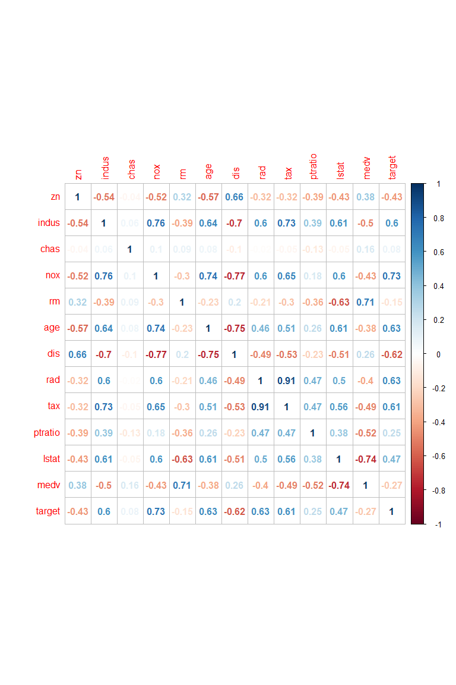

## Multicollinearity

This section will test the predictor variables to determine if there is correlation among them. Variance inflaction factor (VIF) is used to detect multicollinearity, specifically among the entire set of predictors versus within pairs of variables.

Testing for collinearity among the predictor variables, we see that the following variables may have a problem with collinearity based on their high VIF scores.

|  |  |
| --- | --- |
| Variable Name | VIF |
| tax | 9.217602 |
| nox | 4.504675 |
| dis | 4.243532 |
| lstat | 3.650759 |
| medv | 3.667409 |
| indus | 4.120617 |
| age | 3.142118 |
| ptratio | 2.013194 |

If we set our VIF threshold at 4, the following predictor variables are highly correlated.

|  |  |
| --- | --- |
| Variable Name | VIF |
| indus | 4.120617 |
| dis | 4.243532 |
| nox | 4.504675 |
| rad | 6.782250 |
| tax | 9.217602 |

# Data Preparation

There are no NA values in the data; however, it is possible that zero values in a particular data set may be equivalent to missing information. For instance, we would not expect to see any observation where the average number of rooms per dwelling is equal to zero. We look at the dataset to determine if there are zero values for each variable and check for reasonableness.

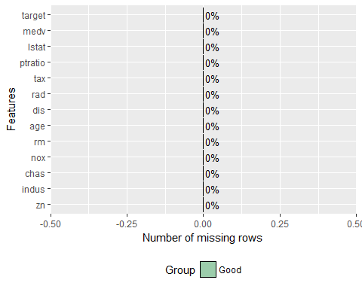

|  |  |
| --- | --- |
|  | Count of Zero Values |
| zn | 339 |
| indus | 0 |
| chas | 433 |
| nox | 0 |
| rm | 0 |
| age | 0 |
| dis | 0 |
| rad | 0 |
| tax | 0 |
| ptratio | 0 |
| lstat | 0 |
| medv | 0 |
| target | 237 |

It is reasonable that there could be no land zoned for large lots (zn) in a particular suburb. The chas variable is a binary variable that tells us whether a suburb borders the Charles river, with zero meaning no. The target variable is also binary. It is also feasible that the other variables would not necessarilly contain zero values. It appears that this data set did not contain any missing values.

### Transformations

In the case of logistic regression, transformations are not necessary as normality of predictors is not required. We can compare the independent variable itself to the dependent variable using marginal model plots to help us determine if transformation improves the fit between the predictor and response.

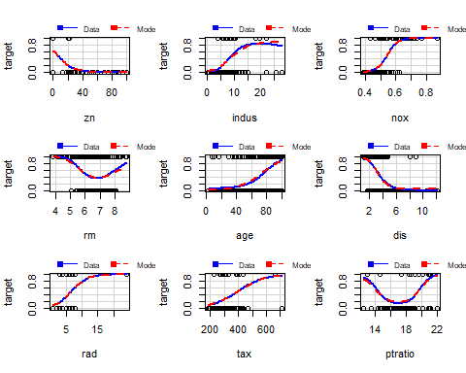

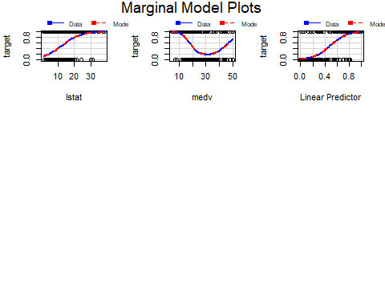

Two which stand out are rad (index of accessibility to radial highways) and tax (full-value property-tax rate per $10,000). Outliers seem to be having a large impact, with the majority of the data falling to the left side of the plots. We can transform and then compare the use of the transformed variable and the original in our models.

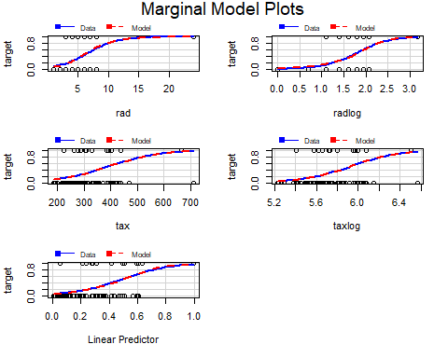

Above shows the marginal model plots before (left) and after (right) transformation. It appears that our fit has improved. We will determine if this improves the overall model in the next section.

# Model Building

### Model 1 : Baseline using all Predictor Variables

As a baseline, the first model build will be a logistic regression model using all predictor variables provided. No transformation has been performed on the predictor variables.

##   
## Call:  
## glm(formula = target ~ ., family = binomial(), data = dev_train)  
##   
## Deviance Residuals:   
## Min 1Q Median 3Q Max   
## -1.88220 -0.10094 -0.00031 0.00027 2.94182   
##   
## Coefficients:  
## Estimate Std. Error z value Pr(>|z|)   
## (Intercept) -49.184177 9.422981 -5.220 1.79e-07 ***  
## zn -0.076954 0.044453 -1.731 0.083427 .   
## indus -0.044532 0.064952 -0.686 0.492959   
## chas 1.226574 1.082934 1.133 0.257366   
## nox 52.509712 10.990233 4.778 1.77e-06 ***  
## rm -0.861188 0.913113 -0.943 0.345612   
## age 0.064011 0.019536 3.277 0.001051 **   
## dis 0.953227 0.295664 3.224 0.001264 **   
## rad 0.976962 0.228521 4.275 1.91e-05 ***  
## tax -0.007383 0.003829 -1.928 0.053857 .   
## ptratio 0.623825 0.180634 3.454 0.000553 ***  
## lstat -0.031103 0.064727 -0.481 0.630856   
## medv 0.214037 0.088075 2.430 0.015091 *   
## ---  
## Signif. codes: 0 '***' 0.001 '**' 0.01 '*' 0.05 '.' 0.1 ' ' 1  
##   
## (Dispersion parameter for binomial family taken to be 1)  
##   
## Null deviance: 453.24 on 326 degrees of freedom  
## Residual deviance: 118.33 on 314 degrees of freedom  
## AIC: 144.33  
##   
## Number of Fisher Scoring iterations: 9

As we can see in our first model, zn, indus, chas, rm, tax, and lstat are not statistically significant. As for the statistically significant variables, nox and rad have the lowest p-values suggesting a strong association between nitrogen oxide concentration and accessibility to radial highways with the probability of crime rates above the median.

Recall that the estimates from logistic regression characterize the relationship between the predictor and response variable on a log-odds scale. This suggests that for every one unit increase in nox, the log-odds of the crime rate increases signficantly in magnitude. Access to radial highways, while not nearly to the same magnitude, also increases the the log-odds of crime above the median.

It is interesting to note that that nox is a significant predictor of crime by orders of magnitude when compared to the other significant predictors. NOx (nitrogen dioxide and nitric oxide) are typcially associated with smog and acid rain pollution. NOx has been linked to adverse health effects in humans.

**AIC (Akaike Information Criterion) for Model 1** = 144.3266013  
**BIC (Bayesian Information Criterion) for Model 1** = 193.5960836

### Model 2 : Baseline using Transformed Variables

In the data preparation section, the log transformation of the the rad and tax predictor variables were determined to be potentially beneficial transformations. This model will use those transformed variables and repeat the modeling process in Model 1.

##   
## Call:  
## glm(formula = target ~ ., family = binomial(), data = dev_train_T)  
##   
## Deviance Residuals:   
## Min 1Q Median 3Q Max   
## -2.2127 -0.0724 0.0000 0.0314 4.0565   
##   
## Coefficients:  
## Estimate Std. Error z value Pr(>|z|)   
## (Intercept) -32.82833 11.11838 -2.953 0.00315 **   
## zn -0.07365 0.04891 -1.506 0.13216   
## indus -0.12025 0.06622 -1.816 0.06939 .   
## chas -0.25948 0.98736 -0.263 0.79270   
## nox 65.61314 12.79735 5.127 2.94e-07 ***  
## rm -0.45659 0.97326 -0.469 0.63898   
## age 0.06588 0.02044 3.223 0.00127 **   
## dis 0.71536 0.31357 2.281 0.02253 *   
## rad 4.36904 1.05771 4.131 3.62e-05 ***  
## tax -3.94655 1.59989 -2.467 0.01363 *   
## ptratio 0.44875 0.16876 2.659 0.00784 **   
## lstat -0.08538 0.08047 -1.061 0.28865   
## medv 0.11886 0.09095 1.307 0.19123   
## ---  
## Signif. codes: 0 '***' 0.001 '**' 0.01 '*' 0.05 '.' 0.1 ' ' 1  
##   
## (Dispersion parameter for binomial family taken to be 1)  
##   
## Null deviance: 453.24 on 326 degrees of freedom  
## Residual deviance: 117.83 on 314 degrees of freedom  
## AIC: 143.83  
##   
## Number of Fisher Scoring iterations: 8

Contrasting against model 1, we now see that nox, age, and rad (log-transformed) are now the most statistically significant variables with dis, tax (log-transformed), and ptratio showing some significance but to a lesser degree.

Model 2 sees an uptick in significance in the tax variable, and the new taxlog variable has one of the lowest p-values suggesting a strong association between property tax rate and crime rates. Of interest here is that this is the only predictor variable which is showing a log-odds decrease in crime for a unit increase in the tax rate.

ptratio, the pupil-teacher ratio by town, also saw an increase in significance when running model 2 with the transformed data.

**AIC (Akaike Information Criterion) for Model 2** = 143.8252129  
**BIC (Bayesian Information Criterion) for Model 2** = 193.0946951

#### Model 1 - Model 2 Comparison

Comparing the two models using a Chi-square test, there’s no significance difference detected between the two. However, we do see that Model 2 resulted in a slightly lower AIC value. Consequently, further modeling will be based on the transformed dataset.

## Analysis of Deviance Table  
##   
## Model 1: target ~ zn + indus + chas + nox + rm + age + dis + rad + tax +   
## ptratio + lstat + medv  
## Model 2: target ~ zn + indus + chas + nox + rm + age + dis + rad + tax +   
## ptratio + lstat + medv  
## Resid. Df Resid. Dev Df Deviance Pr(>Chi)  
## 1 314 118.33   
## 2 314 117.83 0 0.50139

### Model 3 : AIC Stepwise Variable Selection

The third model used was a stepwise regression, and we chose to use both the “forward” and “backward” methods to obtain the optimal model. As mentioned previously, we have chosen to use the transformed dataset going forward.

After starting from nothing and adding variables one at a time, then repeating the process backwards starting with a full dataset and subracting variables one at a time, the ideal model chosen included zn, indus, nox, age, dis, rad, tax, ptratio, and medv, with nox, age, and rad having the most statistical significance as shown by the summary below.

##   
## Call:  
## glm(formula = target ~ zn + indus + nox + age + dis + rad + tax +   
## ptratio + medv, family = binomial(), data = dev_train_T)  
##   
## Deviance Residuals:   
## Min 1Q Median 3Q Max   
## -2.1872 -0.0813 -0.0001 0.0296 3.9817   
##   
## Coefficients:  
## Estimate Std. Error z value Pr(>|z|)   
## (Intercept) -34.46743 10.67991 -3.227 0.001250 **   
## zn -0.08008 0.04784 -1.674 0.094155 .   
## indus -0.11946 0.06347 -1.882 0.059828 .   
## nox 63.02414 12.02294 5.242 1.59e-07 ***  
## age 0.05638 0.01594 3.537 0.000405 ***  
## dis 0.70251 0.29494 2.382 0.017223 *   
## rad 4.20004 0.97091 4.326 1.52e-05 ***  
## tax -3.79036 1.49790 -2.530 0.011391 *   
## ptratio 0.41386 0.15243 2.715 0.006627 **   
## medv 0.11537 0.05187 2.224 0.026132 *   
## ---  
## Signif. codes: 0 '***' 0.001 '**' 0.01 '*' 0.05 '.' 0.1 ' ' 1  
##   
## (Dispersion parameter for binomial family taken to be 1)  
##   
## Null deviance: 453.24 on 326 degrees of freedom  
## Residual deviance: 119.15 on 317 degrees of freedom  
## AIC: 139.15  
##   
## Number of Fisher Scoring iterations: 8

## Analysis of Deviance Table  
##   
## Model: binomial, link: logit  
##   
## Response: target  
##   
## Terms added sequentially (first to last)  
##   
##   
## Df Deviance Resid. Df Resid. Dev  
## NULL 326 453.24  
## zn 1 83.250 325 369.99  
## indus 1 53.372 324 316.62  
## nox 1 128.592 323 188.03  
## age 1 3.247 322 184.78  
## dis 1 4.104 321 180.68  
## rad 1 43.048 320 137.63  
## tax 1 8.686 319 128.94  
## ptratio 1 3.956 318 124.99  
## medv 1 5.840 317 119.15

**AIC (Akaike Information Criterion) for Model 2** = 139.1484546  
**BIC (Bayesian Information Criterion) for Model 2** = 177.0480563

### Model 4 : Using VIF Reduction with Transformed Predictor Variables

Since multicollinearity was detected during the EDA phase, Model 4 will select meaningful variables using VIF reduction. The presence of multicollinearity among predictors can lead to overfitting so this modeling approach will attempt to limit that by reducing the predictor variables to those with lower magnitude VIF.

Calculating and reviewing VIF for the predictor variables (below):

|  |  |
| --- | --- |
| Variable | VIF |
| medv | 7.713861 |
| rm | 5.607293 |
| nox | 4.525322 |
| tax | 3.592654 |
| rad | 2.975277 |
| indus | 2.968206 |
| dis | 2.940839 |
| lstat | 2.932736 |
| age | 2.596930 |
| ptratio | 2.214176 |
| zn | 1.599503 |
| chas | 1.367180 |

We see that nox, rm, and medv have the high variance inflation factor. However, knowing the signifcance of nox, we’ll keep this variable as a predictor and update the model to remove rm and medv.

In the summary of model 4, several variables are not statistically significant and will be dropped from the final model 4.

**Dropped Variables**  
* zn  
* chas  
* dis  
* ptratio  
* lstat

##   
## Call:  
## glm(formula = target ~ indus + nox + age + rad + tax, family = binomial(),   
## data = dev_train_T)  
##   
## Deviance Residuals:   
## Min 1Q Median 3Q Max   
## -2.2531 -0.1493 -0.0013 0.0376 3.2493   
##   
## Coefficients:  
## Estimate Std. Error z value Pr(>|z|)   
## (Intercept) -13.84525 6.08740 -2.274 0.02294 *   
## indus -0.12492 0.06029 -2.072 0.03828 *   
## nox 50.04512 10.67525 4.688 2.76e-06 ***  
## age 0.03943 0.01327 2.970 0.00297 **   
## rad 3.66138 0.76378 4.794 1.64e-06 ***  
## tax -3.59863 1.24154 -2.899 0.00375 **   
## ---  
## Signif. codes: 0 '***' 0.001 '**' 0.01 '*' 0.05 '.' 0.1 ' ' 1  
##   
## (Dispersion parameter for binomial family taken to be 1)  
##   
## Null deviance: 453.24 on 326 degrees of freedom  
## Residual deviance: 135.94 on 321 degrees of freedom  
## AIC: 147.94  
##   
## Number of Fisher Scoring iterations: 8

**AIC (Akaike Information Criterion) for Model 4** = 147.9402702  
**BIC (Bayesian Information Criterion) for Model 4** = 170.6800312

### Model 5 : Using BestGlm using Transformed Predictors

In the final model build the bestglm R package is used to determine the best set of predictors using both AIC and BIC as selection criteria.

#### Using Alkaike Information Criterion (AIC)

## Morgan-Tatar search since family is non-gaussian.

Looking at the top 5 best models based on lowest AIC, the variables zn, indus, nox, age, dis, rad, tax, ptratio, and medv are selected. AIC values for the top 5 models are shown below:

|  |  |
| --- | --- |
| Model | Criterion |
| 1 | 137.1485 |
| 2 | 138.1581 |
| 3 | 138.3375 |
| 4 | 138.5338 |
| 5 | 138.9625 |

The resulting model based on lowest AIC is not dissimilar from previous models. We see nox, age, and rad (again log-transformed) as the most significatn predictors.

##   
## Call:  
## glm(formula = y ~ ., family = family, data = Xi, weights = weights)  
##   
## Deviance Residuals:   
## Min 1Q Median 3Q Max   
## -2.1872 -0.0813 -0.0001 0.0296 3.9817   
##   
## Coefficients:  
## Estimate Std. Error z value Pr(>|z|)   
## (Intercept) -34.46743 10.67991 -3.227 0.001250 **   
## zn -0.08008 0.04784 -1.674 0.094155 .   
## indus -0.11946 0.06347 -1.882 0.059828 .   
## nox 63.02414 12.02294 5.242 1.59e-07 ***  
## age 0.05638 0.01594 3.537 0.000405 ***  
## dis 0.70251 0.29494 2.382 0.017223 *   
## rad 4.20004 0.97091 4.326 1.52e-05 ***  
## tax -3.79036 1.49790 -2.530 0.011391 *   
## ptratio 0.41386 0.15243 2.715 0.006627 **   
## medv 0.11537 0.05187 2.224 0.026132 *   
## ---  
## Signif. codes: 0 '***' 0.001 '**' 0.01 '*' 0.05 '.' 0.1 ' ' 1  
##   
## (Dispersion parameter for binomial family taken to be 1)  
##   
## Null deviance: 453.24 on 326 degrees of freedom  
## Residual deviance: 119.15 on 317 degrees of freedom  
## AIC: 139.15  
##   
## Number of Fisher Scoring iterations: 8

#### Using Bayesian Information Criterion (BIC)

Calculate the best set of predictors using Bayesian Information Criterion (BIC). The model with the loweset BIC will be selected.

## Morgan-Tatar search since family is non-gaussian.

Looking at the top 5 best models based on lowest BIC, the variables indus, nox, age, rad, and tax are selected. The BIC values for the top 5 models are shown below:

|  |  |
| --- | --- |
| Model | Criterion |
| 1 | 163.5534 |
| 2 | 163.8524 |
| 3 | 163.9032 |
| 4 | 164.8901 |
| 5 | 165.3483 |

It should be noted that this model based on BIC uses the fewest number of predictors compared to the other model builds. The inclusion of the indus variable has a marginal affect on BIC so for simplicity of the second best model will be used.

##   
## Call:  
## glm(formula = target ~ nox + age + rad + tax, family = binomial(),   
## data = dev_train_T)  
##   
## Deviance Residuals:   
## Min 1Q Median 3Q Max   
## -1.93712 -0.17367 -0.00171 0.06190 3.05710   
##   
## Coefficients:  
## Estimate Std. Error z value Pr(>|z|)   
## (Intercept) -5.43708 4.21211 -1.291 0.19677   
## nox 36.91089 6.98000 5.288 1.24e-07 ***  
## age 0.03843 0.01301 2.954 0.00313 **   
## rad 3.99417 0.77465 5.156 2.52e-07 ***  
## tax -4.13436 1.09974 -3.759 0.00017 ***  
## ---  
## Signif. codes: 0 '***' 0.001 '**' 0.01 '*' 0.05 '.' 0.1 ' ' 1  
##   
## (Dispersion parameter for binomial family taken to be 1)  
##   
## Null deviance: 453.24 on 326 degrees of freedom  
## Residual deviance: 140.74 on 322 degrees of freedom  
## AIC: 150.74  
##   
## Number of Fisher Scoring iterations: 8

The resulting BIC model uses nox, age, rad, and tax as the final set of predictors. All are statistically significant.

# Model Selection and Evaluation

## Model Selection

We will use a structured evaluation of the models on validation data set (we split our training data set between a training set and a model evaluation set) with regards to:  
* (i) parsimonious fit,  
* (ii) goodness-of-fit,  
* (iii) predictive accuracy, and  
* (iv) more subjectively satisfying business requirements

### (i) Parsimony

Parismonous models have optimal parsimony, or just the right amount of predictors needed to explain the model well. There is generally a tradeoff between goodness-of-fit and parsimony: low parsimony models tend to have a better fit than high parsimony models.

We will use Akaike’s Information Criterion (AIC) and Bayesian Information Criterion (BIC)

BIC = LN(number of observations) * number of variables in your model- 2 Log Likelihood  
AIC = 2*number of variables in your model = 2 Log Likelihood

### (ii) Goodness-of-fit

the Goodness-of-fit of a model describes how well it fits a set of observations. Measures of goodness of fit typically summarize the discrepancy between observed values and the values expected under the model in question.

We will use McFadden’s R2 and the Hosmer-Lemeshow test

McFadded’s R2: Higher value (0.2 to 0.4) indicates a good fit

Hosmer_Lemeshow Test: Small values with large p-values indicate a good fit to the data while large values with p-values below 0.05 indicate a poor fit.

### (iii) Predictive accuracy

Predictive accuracy of a model is how well a model is predicting correctly the outcome and also a measure of the incorrect predictions.

We will use Cohen’s Kappa (or Kappa), Youden’s Index, F1_Score, Percentage of False Positive, and AUC/ROC Curves

**Kappa**  
Kappa takes into account the accuracy that would be generated purely by chance. The form of the measure is:

Kappa takes on values from -1 to +1, with a value of 0 meaning there is no agreement between the actual and classified classes. A value of 1 indicates perfect concordance of the model prediction and the actual classes and a value of 0 indicates total disagreement between prediction and the actual

**Younden’s Index**

Youden’s index evaluates the ability of a classifier to avoid misclassifications. This index puts equal weights on a classifier’s performance on both the positive and negative cases.  
Thus:

We selected to look at False Positive instead of classification error rate since we think this measure is better aligned with the business requirements.

|  |  |  |  |  |  |  |  |  |  |  |  |
| --- | --- | --- | --- | --- | --- | --- | --- | --- | --- | --- | --- |
| Model | AIC | BIC | McFadenR2 | HL_Chi | HL_p | X. | Kappa | Youden | F1Score | FPPrct | AUC |
| Model1 | 144.327 | 193.596 | 0.739 | 327 | 0 | * | 0.755 | 0.757 | 0.872 | 7.19 | 0.956 |
| Model2 | 143.825 | 193.095 | 0.739 | 327 | 0 | * | 0.755 | 0.757 | 0.872 | 7.19 | 0.951 |
| Model3 | 139.148 | 177.048 | 0.739 | 327 | 0 | * | 0.755 | 0.757 | 0.872 | 7.19 | 0.955 |
| Model4 | 147.940 | 170.680 | 0.739 | 327 | 0 | * | 0.740 | 0.747 | 0.862 | 8.63 | 0.942 |
| Model5.AIC | 139.148 | 177.048 | 0.739 | 327 | 0 | * | 0.755 | 0.757 | 0.872 | 7.19 | 0.955 |
| Model5.BIC | 150.743 | 169.693 | 0.739 | 327 | 0 | * | 0.712 | 0.718 | 0.846 | 9.35 | 0.944 |



From the various measurements matrix, we noticed that some of the measures do not come into play since they do not diffrentiate any of our models: McFaren R2 and Hosmer-Lemeshow test.

The remaining measures clearly indicate that Model3 and Model5.AIC are superior models.

Let us now consider the ROC curves for all the models.

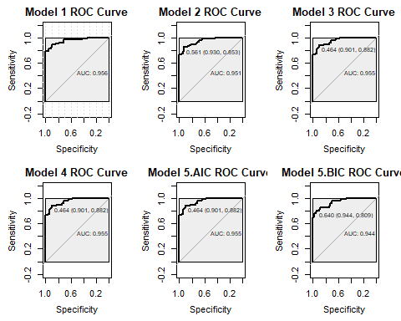

The side by side comparaison of the ROC curve is showing the trade-off between Sensitivity and Specificity. The closer the area under to 1, the better fit of the model. The ROC Curves plot support our selection of Model 3 or Model 5

We will compare the 2 models.

##   
## Call:  
## glm(formula = target ~ zn + indus + nox + age + dis + rad + tax +   
## ptratio + medv, family = binomial(), data = dev_train_T)  
##   
## Deviance Residuals:   
## Min 1Q Median 3Q Max   
## -2.1872 -0.0813 -0.0001 0.0296 3.9817   
##   
## Coefficients:  
## Estimate Std. Error z value Pr(>|z|)   
## (Intercept) -34.46743 10.67991 -3.227 0.001250 **   
## zn -0.08008 0.04784 -1.674 0.094155 .   
## indus -0.11946 0.06347 -1.882 0.059828 .   
## nox 63.02414 12.02294 5.242 1.59e-07 ***  
## age 0.05638 0.01594 3.537 0.000405 ***  
## dis 0.70251 0.29494 2.382 0.017223 *   
## rad 4.20004 0.97091 4.326 1.52e-05 ***  
## tax -3.79036 1.49790 -2.530 0.011391 *   
## ptratio 0.41386 0.15243 2.715 0.006627 **   
## medv 0.11537 0.05187 2.224 0.026132 *   
## ---  
## Signif. codes: 0 '***' 0.001 '**' 0.01 '*' 0.05 '.' 0.1 ' ' 1  
##   
## (Dispersion parameter for binomial family taken to be 1)  
##   
## Null deviance: 453.24 on 326 degrees of freedom  
## Residual deviance: 119.15 on 317 degrees of freedom  
## AIC: 139.15  
##   
## Number of Fisher Scoring iterations: 8

##   
## Call:  
## glm(formula = y ~ ., family = family, data = Xi, weights = weights)  
##   
## Deviance Residuals:   
## Min 1Q Median 3Q Max   
## -2.1872 -0.0813 -0.0001 0.0296 3.9817   
##   
## Coefficients:  
## Estimate Std. Error z value Pr(>|z|)   
## (Intercept) -34.46743 10.67991 -3.227 0.001250 **   
## zn -0.08008 0.04784 -1.674 0.094155 .   
## indus -0.11946 0.06347 -1.882 0.059828 .   
## nox 63.02414 12.02294 5.242 1.59e-07 ***  
## age 0.05638 0.01594 3.537 0.000405 ***  
## dis 0.70251 0.29494 2.382 0.017223 *   
## rad 4.20004 0.97091 4.326 1.52e-05 ***  
## tax -3.79036 1.49790 -2.530 0.011391 *   
## ptratio 0.41386 0.15243 2.715 0.006627 **   
## medv 0.11537 0.05187 2.224 0.026132 *   
## ---  
## Signif. codes: 0 '***' 0.001 '**' 0.01 '*' 0.05 '.' 0.1 ' ' 1  
##   
## (Dispersion parameter for binomial family taken to be 1)  
##   
## Null deviance: 453.24 on 326 degrees of freedom  
## Residual deviance: 119.15 on 317 degrees of freedom  
## AIC: 139.15  
##   
## Number of Fisher Scoring iterations: 8

Side to side comparaison reveals that these two model are actually the same. Since both models were built based on best AIC score, this is understandable.

We will recommand one of them as our best model; model5.AIC.

## Evaluation

We will now run our model against our evaluation data set. However, before we can do so, we need to transform our evaluation data set since Model5.AIC contains transformed predictors.

### Load & Transformation of Data Set

## zn indus chas nox   
## Min. : 0.000 Min. : 1.760 Min. :0.00 Min. :0.3850   
## 1st Qu.: 0.000 1st Qu.: 5.692 1st Qu.:0.00 1st Qu.:0.4713   
## Median : 0.000 Median : 8.915 Median :0.00 Median :0.5380   
## Mean : 8.875 Mean :11.507 Mean :0.05 Mean :0.5592   
## 3rd Qu.: 0.000 3rd Qu.:18.100 3rd Qu.:0.00 3rd Qu.:0.6258   
## Max. :90.000 Max. :25.650 Max. :1.00 Max. :0.7400   
## rm age dis rad   
## Min. :3.561 Min. : 7.00 Min. :1.202 Min. : 1.000   
## 1st Qu.:5.874 1st Qu.: 56.75 1st Qu.:2.041 1st Qu.: 4.000   
## Median :6.143 Median : 83.00 Median :3.373 Median : 5.000   
## Mean :6.214 Mean : 71.00 Mean :3.787 Mean : 9.775   
## 3rd Qu.:6.532 3rd Qu.: 93.00 3rd Qu.:4.527 3rd Qu.:24.000   
## Max. :8.247 Max. :100.00 Max. :9.089 Max. :24.000   
## tax ptratio lstat medv   
## Min. :188.0 Min. :14.70 Min. : 2.960 Min. : 8.40   
## 1st Qu.:276.8 1st Qu.:18.40 1st Qu.: 6.435 1st Qu.:16.98   
## Median :307.0 Median :19.60 Median :11.685 Median :20.55   
## Mean :393.5 Mean :19.12 Mean :12.905 Mean :21.88   
## 3rd Qu.:666.0 3rd Qu.:20.20 3rd Qu.:17.363 3rd Qu.:25.00   
## Max. :666.0 Max. :21.20 Max. :34.020 Max. :50.00

We will now run the prediction on our transformed evaluation data set and write the results to a .csv file.

Our predictions indicates that all of the neighborhoods represented in the evaluation set would be identified as low crime areas (below the median crime rate) based on our model.

# Conclusion

The data we were provided with was relatively straight forward, there was no missing data and we did not find that there were any additional variables that could be derived from the data. We applied two log transformations to improve the distribution of the most skewed predictors without making the final model too difficult to interpret.

We took measures to avoid possible overfitting with our inclusion of parsimonious measures in the model selection process and our use of AIC to guide our selection of variables.

Despite the somewhat unsettling result of predicting a low crime rate against our entire test set, we are confident in our model creation and selection process. We split the training data set to reserve a subset for model evaluation and used predictive measures to help select the best model. We are confident that we have done so, in spite of the results of the final prediction.

**Area for Further Study:**

One area of concern, is that our test-evaluation data set happened to provide results that are not applicable to another evaluation set. This could have been alleviated by adopting a K-Fold Cross Validation method with randomization to prevent overfitting.

# Reference

<https://www.researchgate.net/post/Should_I_transform_non-normal_independent_variables_in_logistic_regression>  
<http://www.statisticshowto.com/parsimonious-model/>  
<http://thestatsgeek.com/2014/02/16/the-hosmer-lemeshow-goodness-of-fit-test-for-logistic-regression/>  
<https://www.r-bloggers.com/logistic-regression-in-r-part-two/>  
<https://www.r-bloggers.com/evaluating-logistic-regression-models/>  
<http://support.sas.com/resources/papers/proceedings17/0942-2017.pdf>

# Appendix - R Code: