

Department of Computer Science & Engineering

# Problem Solving with C Laboratory-UE20CS152

Apr-Aug, 2021

# Mini - Project Synopsis

Date:17-06-2021

TITLE: *Examination Management System*

Objectives:

1. The file handling method is used to store the records of the students in a particular file.
2. Details of the students could be added/deleted.
3. Calculate the attendance percentage of the student
4. Set eligibility criteria for the student based on the his attendance
5. Allocates examination rooms for eligible students based on semester.
6. Displays the record of the students.

Description in points:

🡪We have used an individual function for each operation (add/delete/view..).

🡪By entering any key the user enters into the main menu.

🡪From the main menu instructions have been displayed on to procced if we have to add a specific student detail, modify the already existing list or view the list of students depending on the users choice.

🡪In the menu function we have used switch case statements to navigate to the required operations via performing necessary instructions mentioned on the main screen

🡪View function

🡪Delete function

🡪As of current implementation of our code we are able to navigate to the respective functions using instruction keys , if our desired task is completed we can exit the window with the exit function

🡪In the file handling part the data associated is unique with respect to each system ,each individual user can generate his or her own data of students separately

Current Status of Implementation:

2)View function:

The user will be able to view the details of students as and when the entry of details of students action is completed .We have used the concept of file handling and windows command are used to in order to set the display window of the view function . We have used specialized function (gotoxy) in order to make the cursor point to desired location and perform the action of displaying the data of users in a chronological sequence and also in a manner convenient for the user to read and comprehend the data. Since, we have opened the file in read mode and the file is in binary form we have used fread()function to conveniently display the data.

OUTPUTS:

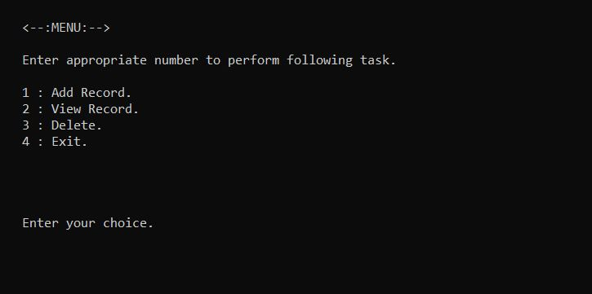

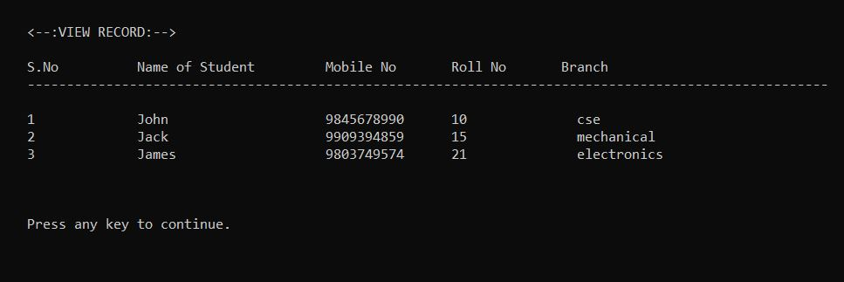

Team Details:

|  |  |  |  |  |
| --- | --- | --- | --- | --- |
| **#** | **Name** | **SRN** | **Signature of Student** | **Remarks by Faculty** |
| 1. | **GAUTHAM.D** | **PES1UG20CS152** |  |  |
| 2. | **G.CHIRAG** | **PES1UG20CS140** |  |  |
| 3. | **GAUTHAM R.A** | **PES1UG20CS151** |  |  |
|  |  |  |  |  |