Perses quickly start

What is Perses
It is an automation test platform for standard drive, include NVMe test, Testing of third-party tools.
Link: https://git.cnexlabs.com/cnex-sqa/perses.git
UI tool: \\172.29.190.1\nvme\SQA\UIApplication

The basic functions:
- Run test case of third part tool
- Run TestRail test case
- Upgrade firmware
- Benchmark testing

Support system:
- Windows
- Linux

Require python 3.0

Platform Architecture
It is a B/S structural framework, include server and client.
Server run on test environment, responsible for executing test cases, send result back to client.
Client run on office compute, it is the management software, send command and report result.
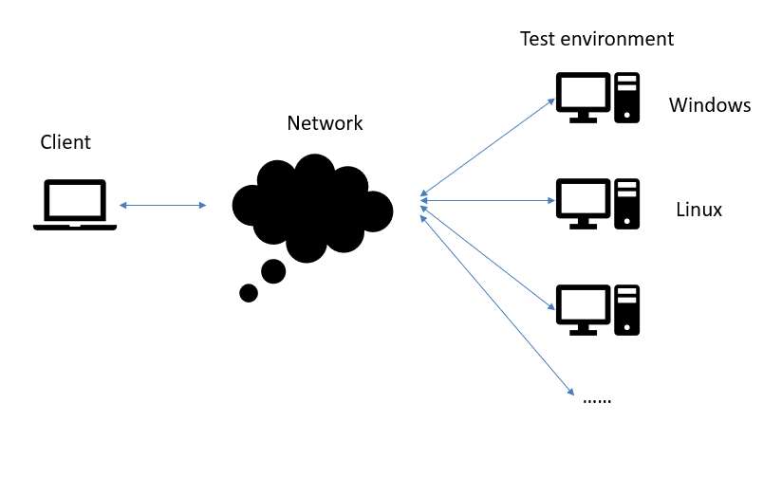

How to start

Start server on test environment
- Make sure python and pip is ready, recommend using python 3.8
- Download the production platform from Gitlab.
https://git.cnexlabs.com/cnex-sqa/perses.git
- If it is the first time run this platform, please install python related package, command: python install.py
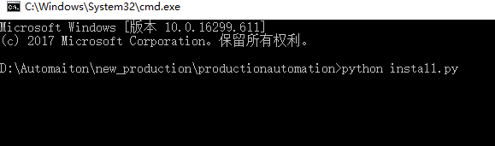
- Start server
If it is windows, please open CMD window with administrator, else use root in Linux.
Start server with command: prun start
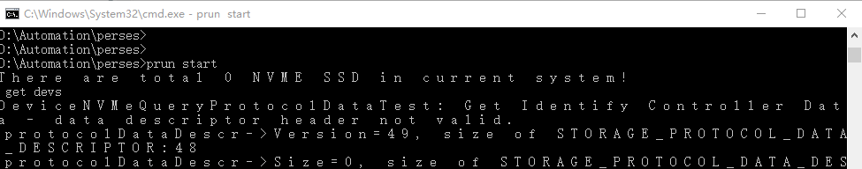

Start client
The client is a windows application, at: \\172.29.190.1\nvme\SQA\UIApplication
We can copy and run it to any windows compute.
There are six main functions in it:
- Scan environment
- Firmware upgrade
- Query history test record
- Execute test case
- Execute TestRail test case
- Execute benchmark test
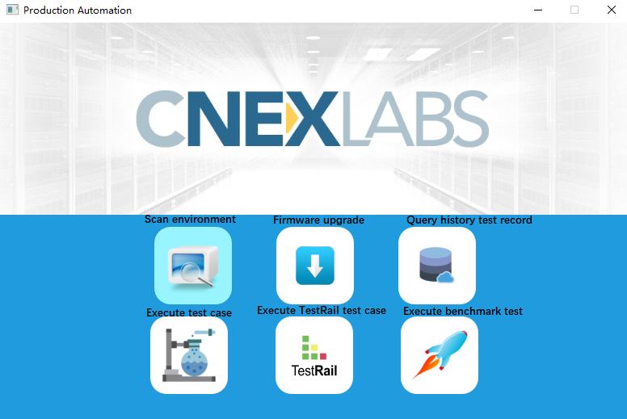

Scan test environment
Clink the environment icon, open environment dialog.
This step scans the corresponding network segment according to the given network address.
If you environment not in the list, you can scan your environment with the IP address.
e.g.: 172.29.130.137, 172.29.130.*, 172.20.*.*
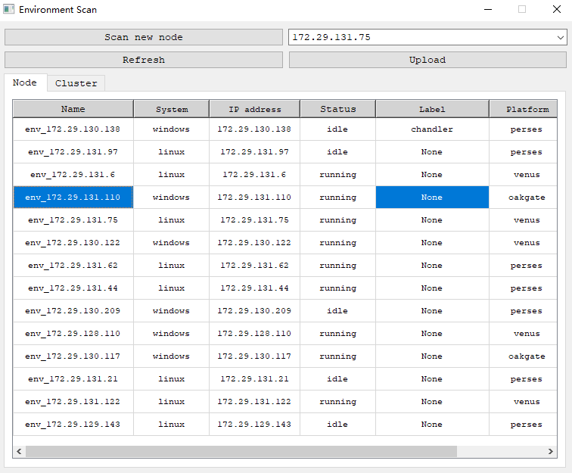

Firmware upgrade
This function only support upgrade firmware when SSD is alive.
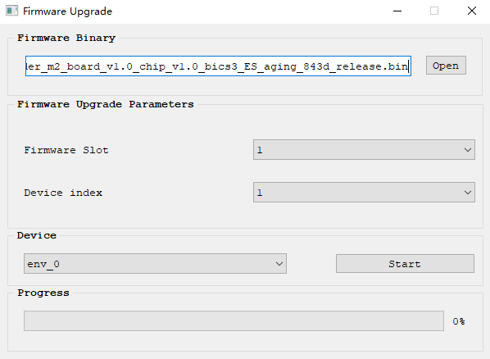

Query history test record
With this function, we can check the test history.
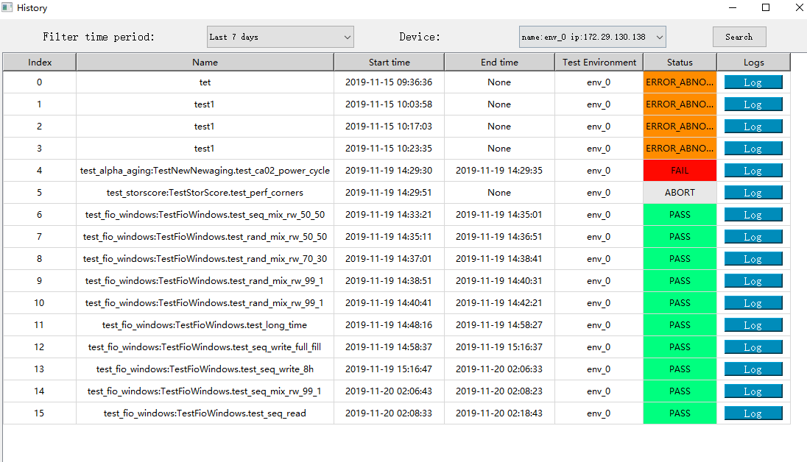

Execute test case
In this window, we can select test environment and execute tests.
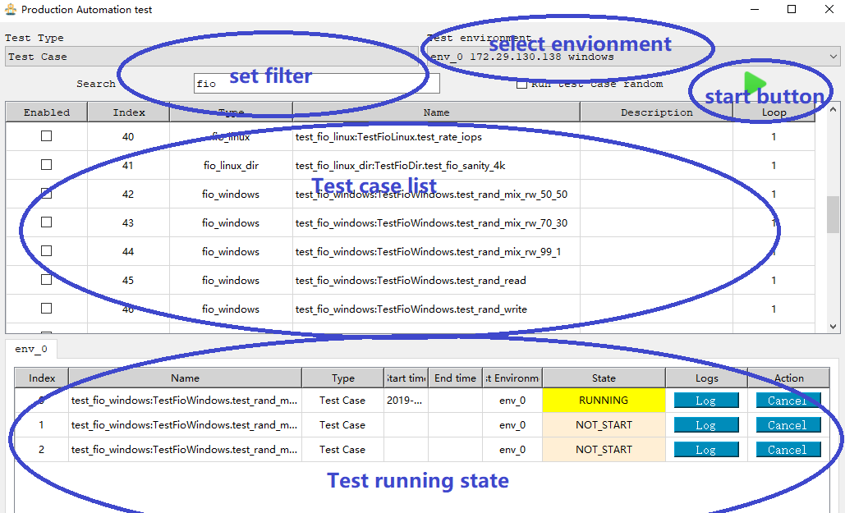

Execute TestRail test case
This function help testers pull test plan from TestRail, and execute tests in it
- Click TestRail icon, login TestRail dialog. Login with your TestRail account.
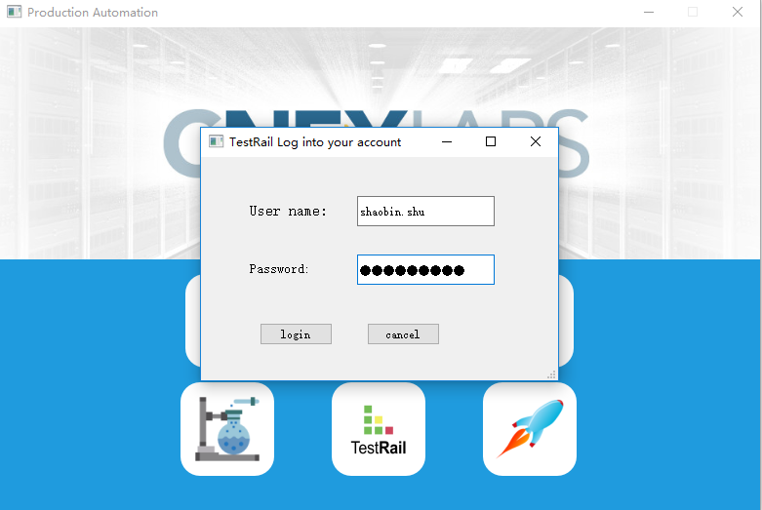
- Test environment setting, select the environment to run tests.
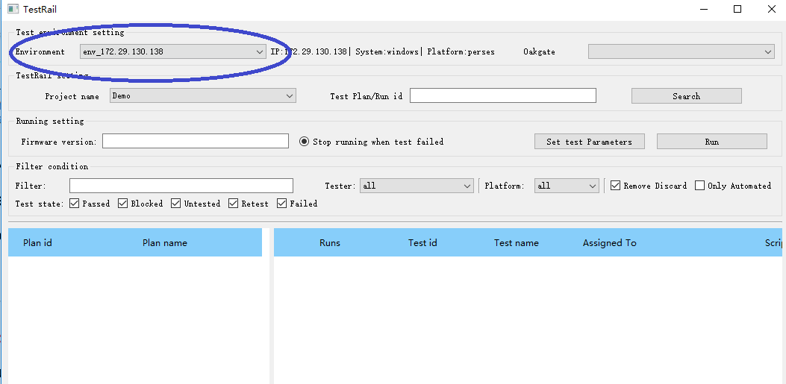
- Search test plan based on project name and test plan/run id.
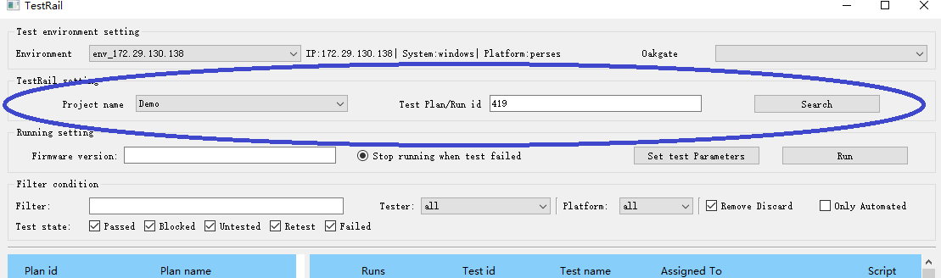
- Select test plan. Here we select the test plan that need to run.
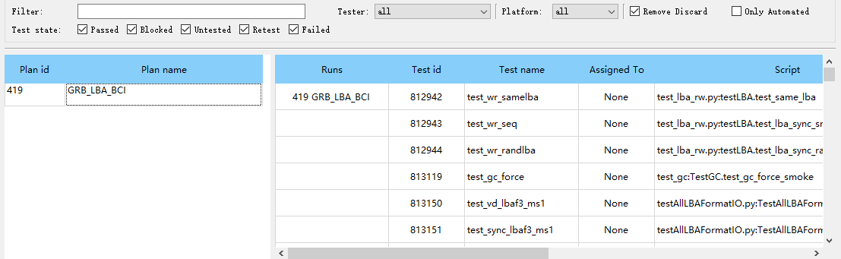
- Set parameters, click the “Set test parameters” button, set the test case needed parameters.
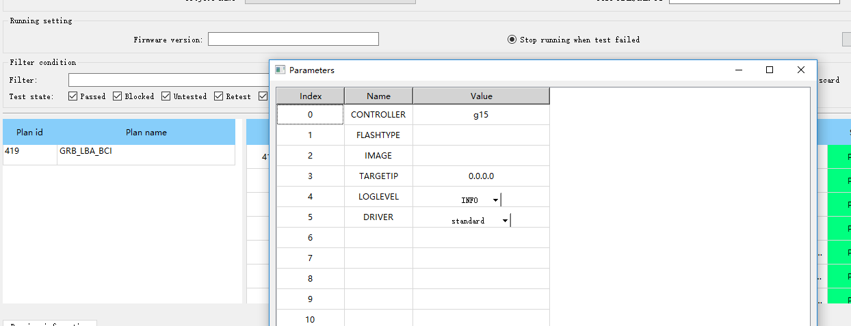
- Select tests. Filter tests with various filters, and select tests.
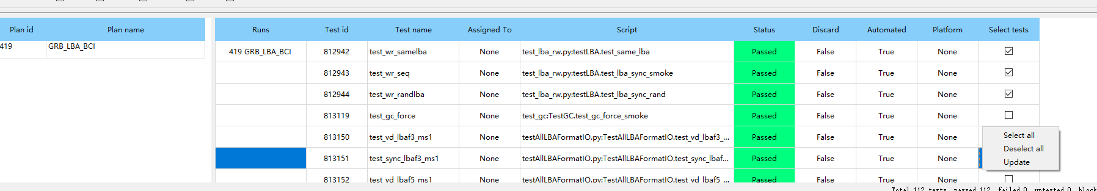
- Check result.
We can check result in the below table. And it will automated send test result back to TestRail.
We can also cancel the tests when it is running or not start.
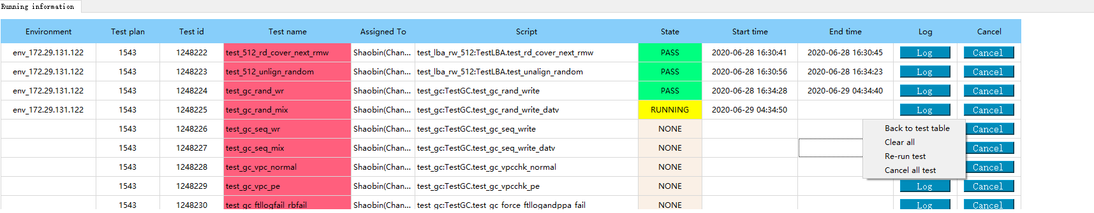

Execute benchmark test
About benchmark test, please see the attachment document.

