**Interpretation: Simulated CTR vs. % of Users Targeted**

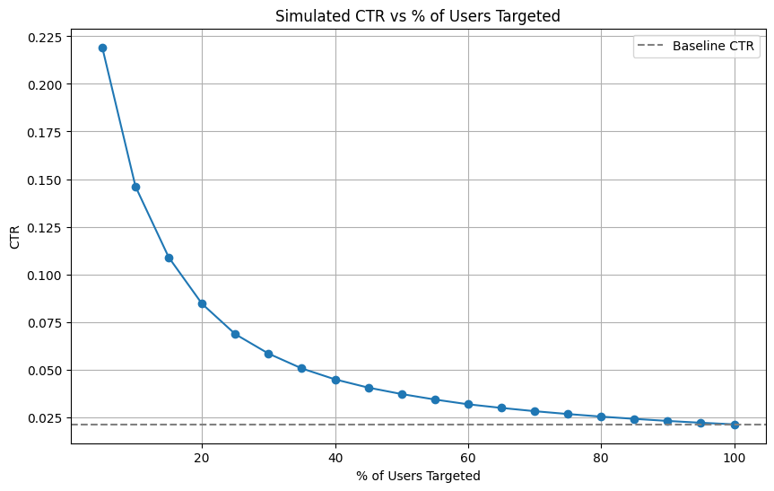

The chart illustrates how the **Click-Through Rate (CTR)** changes as we vary the **percentage of users targeted**, using the model’s predicted probabilities.

* The **x-axis** represents the **percentage of top users** (ranked by predicted click probability) selected for the campaign.
* The **y-axis** shows the **simulated CTR** achieved when sending to that group. **Key Insights:**
* **Higher CTR at smaller sizes**:  
  The **top 5–30% of users** show a **significantly higher CTR** than the campaign’s baseline.  
   This confirms that the model successfully identifies users who are more likely to click.
* **Diminishing returns after ~30–40%**:  
  As we include more users, the CTR starts to **drop toward the baseline**, because lower-ranked users are less likely to engage.
* **Full population ≈ baseline CTR**:  
  When we reach 100% of users, the CTR matches the baseline — which makes sense since this reflects the original random targeting.

**Strategic Recommendation:**

To **maximize campaign efficiency**, the marketing team should consider targeting only the **top 30–40%** of users based on the model’s scores.  
This approach would result in a **higher CTR**, better **ROI**, and reduced risk of email fatigue for disengaged users.

**Interpretation of Segment CTRs By Past Purchases**

| **Purchase History** | **CTR** |
| --- | --- |
| 0 | 0.05% |
| 1–3 | 1.43% |
| 4–10 | 2.98% |
| 10+ | 6.90% |

**Insight**:  
Users who made **10+ past purchases** clicked **>13x more** than users who never purchased. Even moderate buyers (4–10) clicked far more.

**Target**: Focus emails on users with **past buying behavior**.

**By Hour Sent**

| **Hour** | **CTR** |
| --- | --- |
| 23 | 4.14% |
| 24 | 2.90% |
| 10 | 2.82% |
| 11 | 2.71% |
| 9 | 2.58% |

**Insight**:  
Emails sent **late at night (11 PM – 12 AM)** and **mid-morning (9–11 AM)** have higher CTRs.  
 **Recommendation**: Try scheduling campaigns during these high-performing time windows.

**By Personalization**

| **Email Type** | **CTR** |
| --- | --- |
| Generic | 1.51% |
| Personalized | 2.73% |

**Insight**:  
**Personalized emails** (with user's name) perform almost **2x better** than generic greetings.  
 **Recommendation**: Use personalization in all future campaigns.

**By Email Length**

| **Email Length** | **CTR** |
| --- | --- |
| Long | 1.85% |
| Short | 2.39% |

**Insight**:  
**Short emails** perform better than long ones. Brevity likely increases engagement.  
 **Recommendation**: Favor concise, focused emails.

**By Country**

| **Country** | **CTR** |
| --- | --- |
| UK | 2.47% |
| US | 2.44% |
| ES | 0.83% |
| FR | 0.80% |

**Insight**:  
Users in **UK and US** are much more engaged than those in **Spain (ES)** and **France (FR)**.  
 **Recommendation**: Tailor messages or test translations for ES/FR users — their current version may not resonate.

**By Day of the Week**

| **Day** | **CTR** |
| --- | --- |
| Wednesday | 2.76% |
| Tuesday | 2.49% |
| Thursday | 2.44% |
| Monday | 2.29% |
| Saturday | 1.78% |
| Sunday | 1.68% |
| Friday | 1.40% |

**Insight**:  
**Midweek (Tue–Thu)** emails perform best. **Weekends and Fridays** have lower engagement.  
 **Recommendation**: Schedule campaigns **Tuesday to Thursday**.

**Overall Strategy**

If you want to maximize click-through rate, focus your campaign on:

* Users with **purchase history** (especially 4+ items)
* **Personalized** + **short** emails
* Send during **mid-morning or late night**
* Prioritize **UK/US** audience (and improve localization elsewhere)
* Run campaigns **midweek**