🧪 Lab: Exploring an ASA Firewall (GUI Only)
🎯 Objectives
- Understand how a firewall controls traffic
- Configure ASA
- Test connectivity before and after rules

🧰 Equipment
- Cisco Packet Tracer
- 1 ASA 5505
- 3 PCs
- (Optional) 1 switch

🌐 Topology
PC1,0 (Outside) → ASA → PC2 (inside)
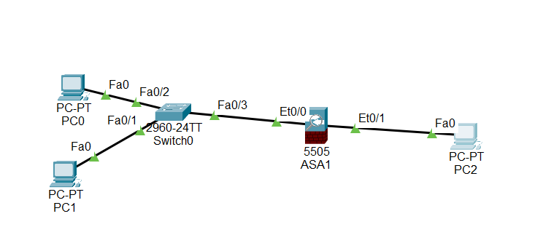

Step 1: Configure Interfaces
Go to Interfaces

- Configure a logical VLAN 1 interface for the inside network (192.168.1.0/24) and set the security level to the highest setting of 100.
CCNAS-ASA(config)# interface vlan 1
CCNAS-ASA(config-if)# nameif inside
CCNAS-ASA(config-if)# ip address 192.168.1.1 255.255.255.0
CCNAS-ASA(config-if)# security-level 100

- Configure a logical VLAN 2 interface for the inside network (10.10.10.1.0/24) and set the security level to the highest setting of 100.

CCNAS-ASA(config-if)# interface vlan 2
CCNAS-ASA(config-if)# nameif outside
CCNAS-ASA(config-if)# ip address 10.0.0.1 255.255.255.0
CCNAS-ASA(config-if)# security-level 0

Step 2: Assign Ports
Go to Ports (Ethernet)
- Ethernet0/1 → VLAN 1 (inside)
- Ethernet0/0 → VLAN 2 (outside)

💻 Part 3: Configure PCs
PC2 (Inside)
- IP: 192.168.1.10 & Gateway: 192.168.1.1
PC1 (Outside)
- IP: 10.0.0.10 & Gateway: 10.0.0.1

🔍 Part 4: Test Connectivity (Before Rules)
- Click PC2 → Desktop → Command Prompt
- Ping PC1: ping 10.0.0.10
👉 Expected: ❌ It may fail (depending on Packet Tracer behavior)

🔓 Part 5: Allow Traffic
conf t
ciscoasa(config)#class-map inspection_default
ciscoasa(config-cmap)#match default-inspection-traffic
ciscoasa(config-cmap)#exit
ciscoasa(config)#policy-map global_policy
ciscoasa(config-pmap)#class inspection_default
ciscoasa(config-pmap-c)#inspect icmp
ciscoasa(config-pmap-c)#service-policy global_policy global
Test Again:
Ping from PC2 to PC1
👉 Expected: ✅ Works

