弹片触点（BC-70-4P）

<https://item.taobao.com/item.htm?spm=a1z09.2.0.0.52ef2e8dRYIEN3&id=563475614793&_u=t1jfq1bb960>

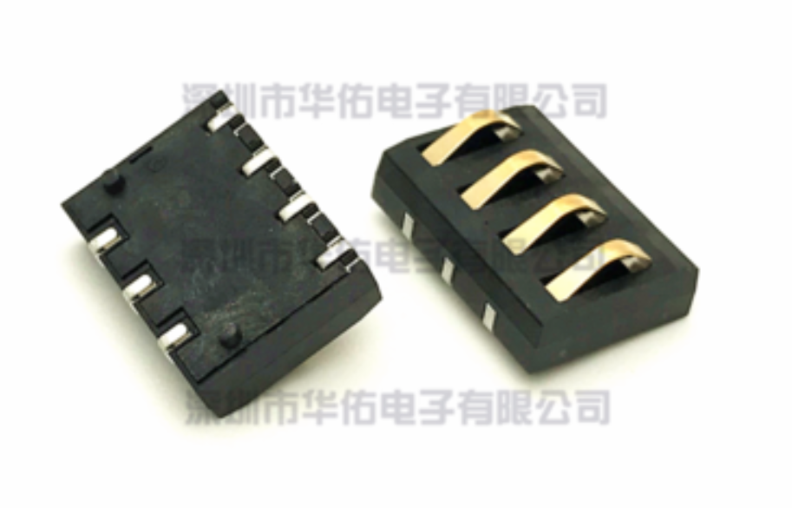

快慢机开关

<https://item.taobao.com/item.htm?spm=a1z09.2.0.0.67002e8dM7O4lW&id=10858970484&_u=t1jfq1bbef9>

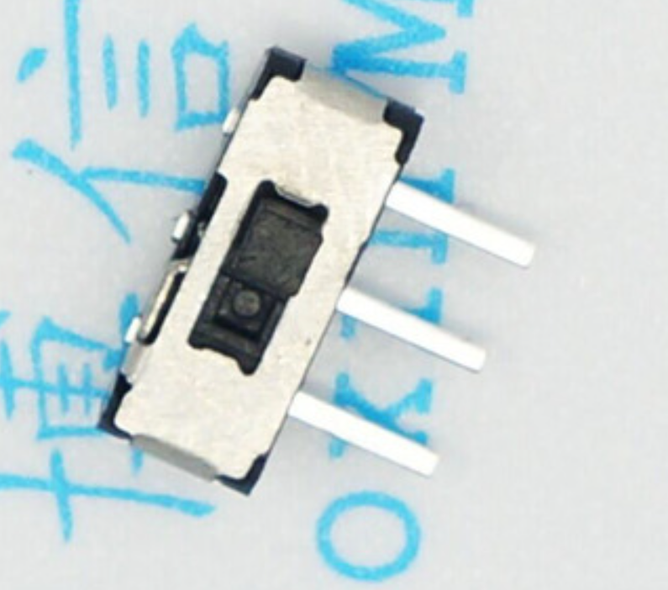

单发微动

<https://item.taobao.com/item.htm?spm=a1z09.2.0.0.67002e8dM7O4lW&id=39629135338&_u=t1jfq1b6623>

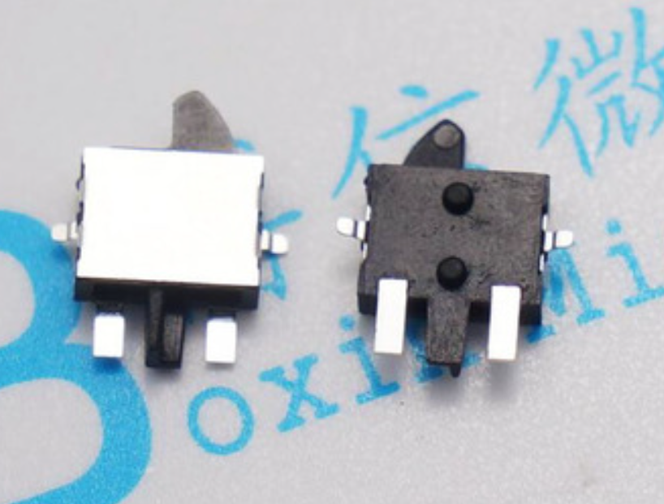

扳机微动（侧按耐温贴片*无锁）

https://item.taobao.com/item.htm?spm=a1z09.2.0.0.67002e8dM7O4lW&id=537056296045&_u=t1jfq1baecd

